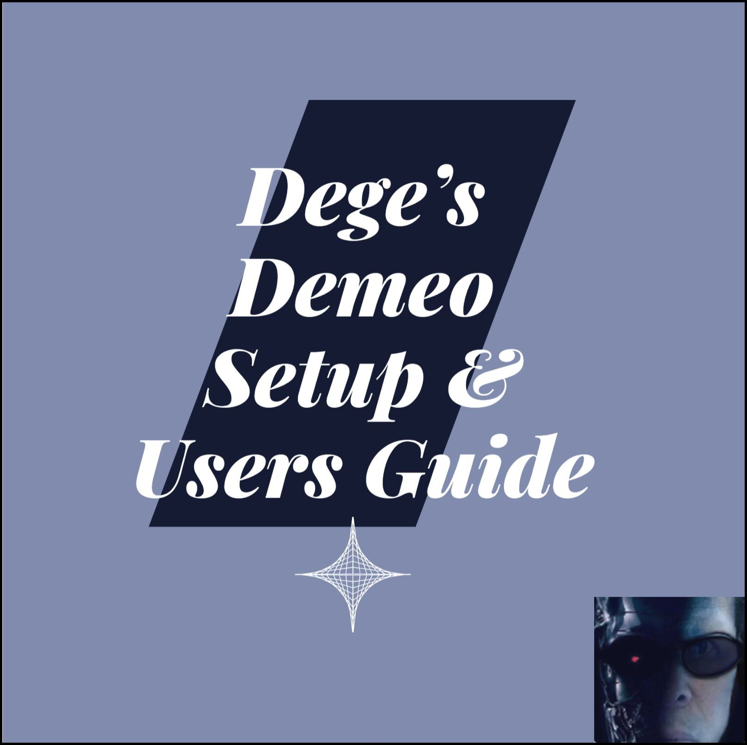

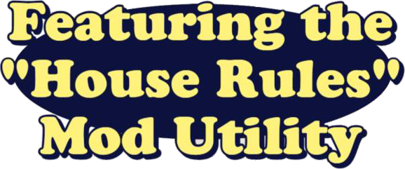

1. Overview 5

2. References 5

3. Install HouseRules - Ready to Go (RTG) 5

4. Manual Installation - House Rules 6

5. Modifications - HouseRules 8

5.1. Room Finder 8

5.2. Advanced Stats 9

5.3. Highlighter 9

5.4. Room Code 9

5.5. SkipIntro 10

5.6. FreeCamera 10

6. Running Demeo - After mods installed 10

6.1. Using the House Rules Application 11

6.2. Arachnophobia 13

6.3. LuckyDip 14

6.4. The Swirl 15

6.5. Beat The Clock 15

6.6. It’s A Trap 16

6.7. Hunter’s Paradise 16

6.8. Demeo Reloaded 17

6.9. Flipping Out! 18

6.10. Hoarders – Skirmish Only 18

6.11. Difficulty: Easy 19

6.12. Difficulty: Hard 19

6.13. Difficulty: Legendary 20

6.14. Earth Wind & Fire 20

6.15. 3x3 Potions and Buffs 21

6.16. Better Sorcerer 21

6.17. No Surprises 22

6.18. Quick and the Dead 22

6.19. Potion Commotion 22

6.20. Hardcore 23

6.21. Naked Run 23

7. Installing Custom Built Rulesets 23

8. Rules and Configurations 24

8.1. AbilityActionCostAdjusted 24

8.2. AbilityAoeAdjusted 25

8.3. AbilityBackstabAdjusted 26

8.4. AbilityDamageOverridden 27

8.5. AbilityHealOverridden 28

8.6. AbilityRandomPieceList 29

8.7. BackstabConfigOverridden 30

8.8. CardAdditionOverridden 31

8.9. CardChestAdditionOverridden 32

8.10. CardEnergyFromAttackMultiplied 33

8.11. CardClassRestrictionOverridden 34

8.12. EnemyDoorOpeningDisabled 35

8.13. EnemyRespawnDisabled 36

8.14. FreeAbilityOnCrit 37

8.15. GoldPickedUpMultiplied 38

8.16. LevelExitLockedUntilAllEnemiesDefeated 39

8.17. LevelPropertiesModified 40

8.18. LevelSequenceOverridden 41

8.19. PartyyDamageOverridden 42

8.20. PetsFocusHunterMark 43

8.21. PieceDownedCountAdjusted 43

8.22. PieceConfigAdjusted 44

9. Ability Keys 47

10. Behaviors 56

11. Board Pieces 57

12. Effect State Types 59

13. Piece Types 61

14. Cards (Pictures of player cards) 62

15. Character Selection 69

15.1. Guardian (Sigrun) 69

15.2. Sorcerer (Zedokar) 69

15.3. Hunter (Ailin) 70

15.4. Assassin(Kai) 70

15.5. Bard (Molthas) 71

15.6. Warlock (Oana) 71

15.7. Warlock (Oana) 72

16. User\ Feedback Tips and Tricks 73

17. Troubleshooting 75

17.1. Tshooting - The select ruleset is not for multiplayer games 75

17.2. Tshooting - Failed to import 75

17.3. Tshooting - Disconnected 77

18. MAP LEVELS 78

19. BLACK SARCOPHAGUS – ENTRANCE 79

19.1. BLACK SARCOPHAGUS - ELVEN MAP FLOOR 1 80

19.2. BLACK SARCOPHAGUS - ELVEN MAP FLOOR 2 82

19.3. BLACK SARCOPHAGUS - ELVEN MAP FLOOR 3 84

19.4. BLACK SARCOPHAGUS - ELVEN MAP FLOOR 4 86

19.5. BLACK SARCOPHAGUS - ELVEN MAP FLOOR 5 88

19.6. BLACK SARCOPHAGUS - ELVEN MAP FLOOR 6 90

19.7. BLACK SARCOPHAGUS - ELVEN MAP FLOOR 7 92

19.8. BLACK SARCOPHAGUS - ELVEN MAP FLOOR 8 94

19.9. BLACK SARCOPHAGUS - ELVEN MAP FLOOR 9 96

19.10. BLACK SARCOPHAGUS - ELVEN MAP FLOOR 10 97

19.11. BLACK SARCOPHAGUS - ELVEN MAP FLOOR 11 98

19.12. BLACK SARCOPHAGUS - ELVEN MAP FLOOR 12 99

19.13. BLACK SARCOPHAGUS - ELVEN MAP FLOOR 13 100

19.14. BLACK SARCOPHAGUS - ELVEN MAP FLOOR 14 101

19.15. BLACK SARCOPHAGUS - ELVEN MAP FLOOR 15 102

19.16. BLACK SARCOPHAGUS - ELVEN MAP FLOOR 16 103

19.17. BLACK SARCOPHAGUS - ELVEN MAP FLOOR 17 104

20. RAT KING – ENTRANCE 105

20.1. RAT KING – SEWERS FLOOR 1 106

20.2. RAT KING – SEWERS FLOOR 7 107

20.3. RAT KING – SEWERS FLOOR 8 108

20.4. RAT KING – SEWERS FLOOR 9 109

20.5. RAT KING – SEWERS FLOOR 10 110

20.6. RAT KING – SEWERS FLOOR 11 111

20.7. RAT KING – SEWERS FLOOR 12 112

21. ROOTS OF EVIL – ENTRANCE 113

21.1. ROOTS OF EVIL – Forest Floor 1 114

21.2. ROOTS OF EVIL – Forest Floor 2 115

21.3. ROOTS OF EVIL – Forest Floor 3 116

21.4. ROOTS OF EVIL – Forest Floor 4 117

21.5. ROOTS OF EVIL – Forest Floor 5 118

21.6. ROOTS OF EVIL – Forest Floor 6 119

21.7. ROOTS OF EVIL – Forest Floor 7 120

21.8. ROOTS OF EVIL – Forest Floor 8 121

21.9. ROOTS OF EVIL – Forest Floor 9 122

22. Shop Floors 123

23. Cool Links 124

24. Steam Achievements 125

25. Custome RuleSets for House Rules 132

25.1. Custom Scenario 1 – Arcane Mastery 132

25.2. Custom Scenario 2 – Heroic Abyss 133

25.3. Custom Scenario 3 – Shield and Verse 134

26. Ruleset Library 135

27. Credits 135

28. History 135

# Overview

This guide was put together for you the player. It was inspired by my trying to get the utility working and it didn’t. Now it’s time to streamline your time and set up time so that you can use this wonderful utility called House Rules. You will see a lot of screen captures along the way to make your journey more useful and get the utility installed. Follow the directions carefully and I will be sure to give you little bits of important information along the way. The examples depicted in this guide were from Steam on a PC only.

# References

Software is referred to by these instructions. Links are shown below for reference.

* Download BepInEx Loader from [here.](https://github.com/BepInEx/BepInEx/releases/download/v5.4.23.3/BepInEx_win_x64_5.4.23.3.zip)
* [Mods](https://github.com/orendain/DemeoMods/tree/main?tab=readme-ov-file#mod-descriptions)

# Install HouseRules - Ready to Go (RTG)

As the name implies, you can install HouseRules quickly with all of the addons. Instead of utilizing the Manual Installation, we have done all of that for you so you can get going. Go to Section 4 if you want to install everything manually. The RTG takes under 5 minutes when Demeo is already installed.

* In the following PC installation example from Steam, went to the Steam Library, right-clicked on Demeo – PC Edition > Manage > Browse local files. Other paths include:
  + Steam - C:\Program Files (x86)\Steam\steamapps\common\Demeo.
  + PC Only - %USERPROFILE%\AppData\LocalLow\Resolution Games\Demeo PC Edition\
  + Oculus - C:\Program Files\Oculus\Software\Software\resolution-games-demeo

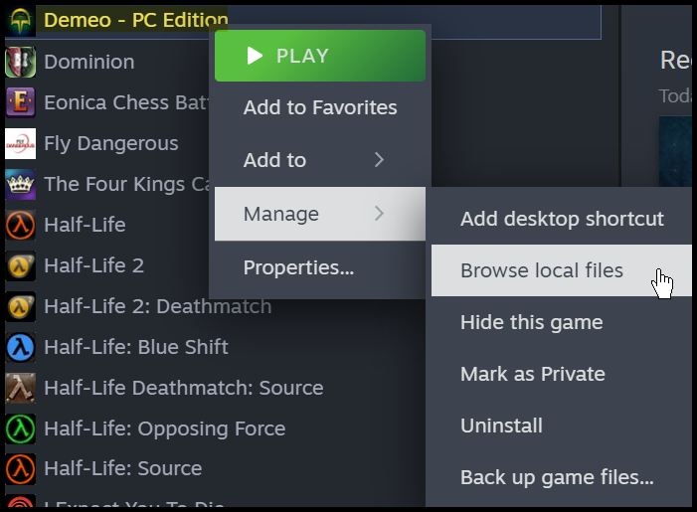

* A new window will appear where Demeo is installed.
* Download [HR-RTG.zip](https://github.com/Degederon/HouseRulesGuide/blob/main/HR-RTG.zip). This stands for HouseRules Ready to Go.
* Open the file HR-RTG.zip and copy all of these files and folders to your Demeo installation folder.

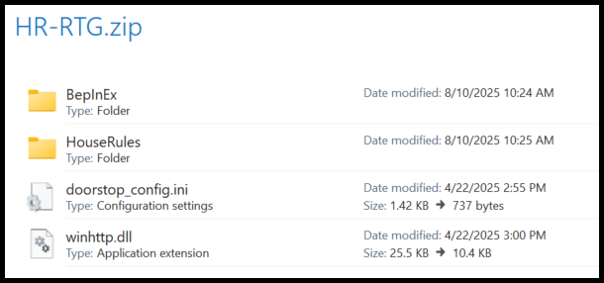

Here is what your folder will look like after all of the files and folders come together.

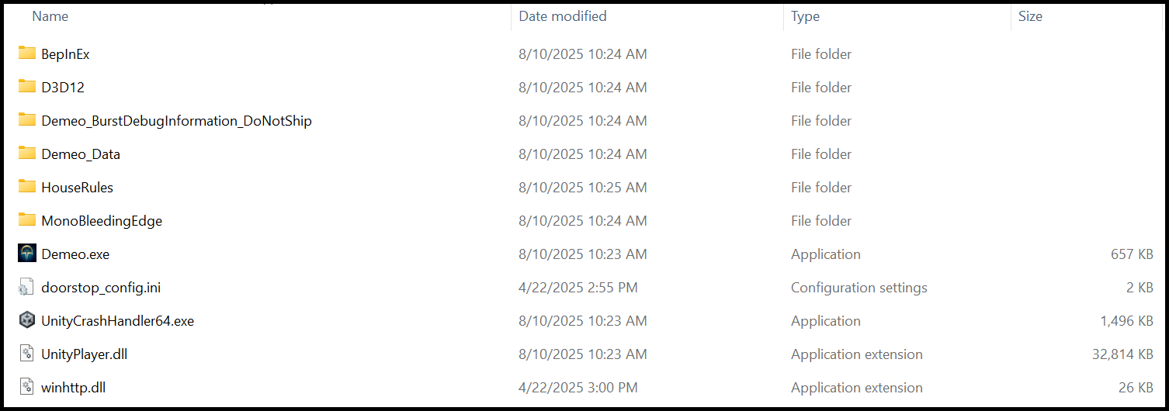

# Manual Installation - House Rules

Setting up is not hard if you know what you’re doing. Let’s get started.

1. Install the Steam application. This program requires Steam to operate properly.
2. Download and install Demeo software for the PC from Steam.
3. **Make sure the game is not running**.
4. Make sure you have all the [Requirements](https://github.com/LavaGang/MelonLoader?tab=readme-ov-file#requirements) installed before attempting to Install.
5. Download - BepInEx 5.x Mod Loader. [X86](https://github.com/BepInEx/BepInEx/releases/download/v5.4.23.3/BepInEx_win_x86_5.4.23.3.zip) or [X64](https://github.com/BepInEx/BepInEx/releases/download/v5.4.23.3/BepInEx_win_x64_5.4.23.3.zip).
6. Download - HouseRules.BepInEx.zip file [here](https://github.com/orendain/DemeoMods/releases/download/v2.0.0-houserules/HouseRules.BepInEx.zip).
7. Open the zip file for House Rules. In this example my steam installed Demeo for PC in C:\SteamLibrary\steamapps\common\Demeo - PC Edition. Extract the folders shown from the zip file to the Demo software folder. The contents of these folders will overwrite folders if they are named the same.

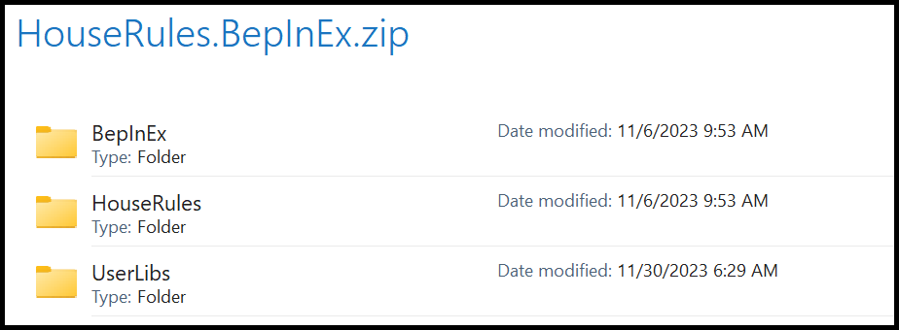

The folders you extracted should look like this after you paste them.

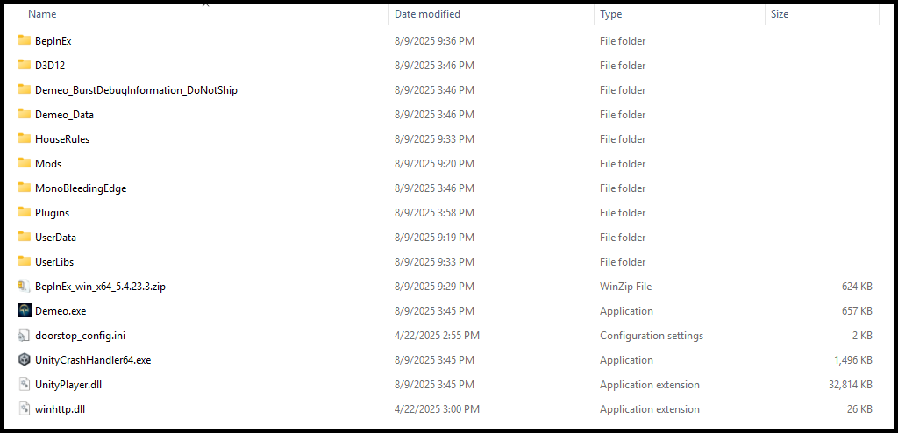

1. The file structure should look like this when you have finished. Make sure that the files highlighted below, from the zip file you downloaded in step 5, are present.

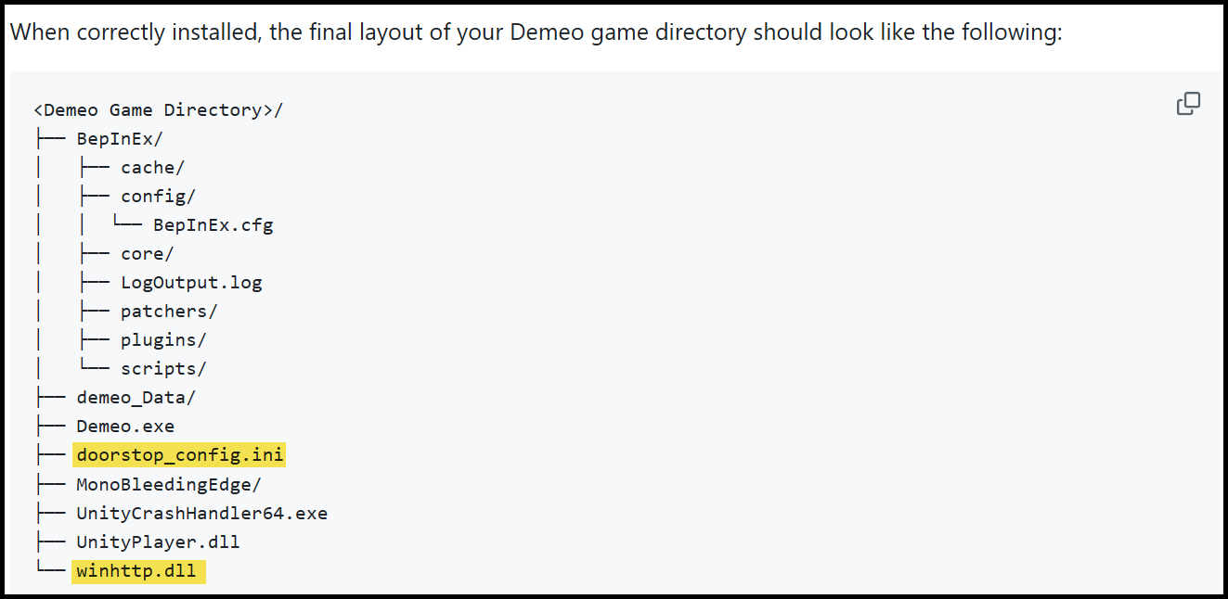

1. Go to <https://github.com/orendain/DemeoMods> for the latest mods or the list below as of August 9, 2025.

* [House Rules 2.0.0](https://github.com/orendain/DemeoMods/releases?q=houserules)
* [Room Finder 2.0.0](https://github.com/orendain/DemeoMods/releases?q=roomfinder)
* [Advanced Stats 1.1.0](https://github.com/orendain/DemeoMods/releases?q=advancedstats)
* [HighLighter 2.0.0](https://github.com/orendain/DemeoMods/releases?q=highlighter)
* [Room Code 1.3.0](https://github.com/orendain/DemeoMods/releases?q=roomcode)
* [Skip Intro 1.0.0](https://github.com/orendain/DemeoMods/releases?q=skipintro)
* [Free Camera 1.0.0](https://github.com/orendain/DemeoMods/releases?q=freecamera)

# Modifications - HouseRules

A simple approach to install modifications for House Rules Mods. Choose a mod and follow the instructions. Here is an example of what the plugins folder will look like when all mods are installed.

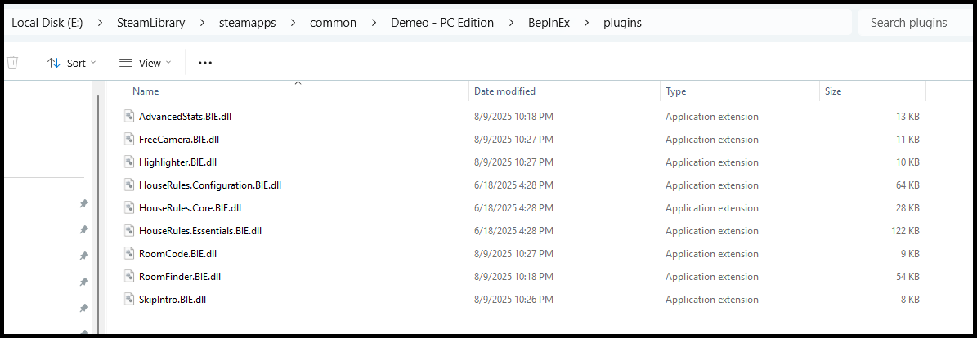

# Room Finder

This mod lists all public rooms, along with their properties, so you can pick which one to join.

* Download the Roomfinder mod file, [**click here**](https://github.com/orendain/DemeoMods/releases/download/v2.0.0-roomfinder/RoomFinder.BIE.dll), and place it into your BepInEx/plugins folder, located in Demeo's root game directory.

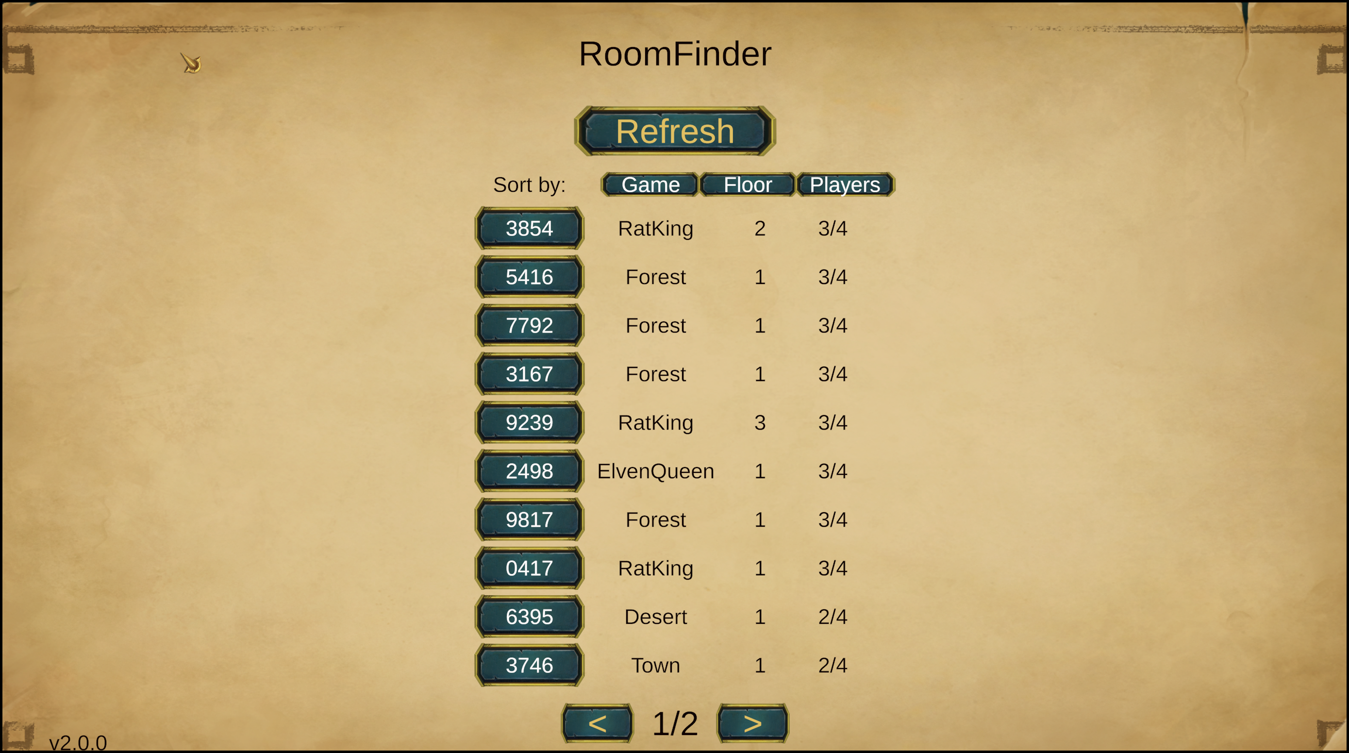

# Advanced Stats

Displays extra information about heroes when hovering over their pieces.

* Download the Advancedstats mod file, [**click here**](https://github.com/orendain/DemeoMods/releases/download/advancedstats-v1.1.0/AdvancedStats.BIE.dll), and place it into your BepInEx/plugins folder, located in Demeo's root game directory.

# Highlighter

Provides in-game highlighting/coloring. This includes highlighting all squares that would be in a character's line- of- sight when hovering the piece over a square.

* Download the Highlighter mod file, [**click here**](https://github.com/orendain/DemeoMods/releases/download/v2.0.0-highlighter/Highlighter.BIE.dll), and place it into your BepInEx/plugins folder, located in Demeo's root game directory.
* Important Note: The first time you start a game it work. If you start another game afterwards it causes issues with being able to land your pieces when you move. The Highlighter mod is currently broken. For this reason, this mod has been excluded until it is fixed.

# Room Code

Set your own room code, skipping Demeo's random room code generation.

* Download the Roomcode mod file, [**click here**](https://github.com/orendain/DemeoMods/releases/download/roomcode-v1.3.0/RoomCode.BIE.dll), and place it into your BepInEx/plugins folder, located in Demeo's root game directory.

Locate the file Installdir\SteamLibrary\steamapps\common\Demeo - PC Edition\BepInEx\config\ com.orendain.demeomods.roomcode.cfg. Here is an example of what it should look like. In this example it will try room 1234 first and if it should be taken it will try the second value and so on until a free room number is found.

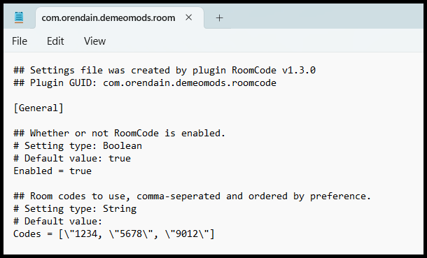

# SkipIntro

This mod skips the intro loading scene and takes you straight into the main menu.

* Download the SkipIntro mod file, [**click here**](https://github.com/orendain/DemeoMods/releases/download/v2.0.0-skipintro/SkipIntro.BIE.dll), and place it into your BepInEx/plugins folder, located in Demeo's root game directory.

# FreeCamera

This mod enables NonVR versions of Demeo to vertically tilt their cameras.

* Download the SkipIntro mod file, [**click here**](https://github.com/orendain/DemeoMods/releases/download/freecamera-v1.0.0/FreeCamera.BIE.dll), and place it into your BepInEx/plugins folder, located in Demeo's root game directory.

# Running Demeo - After mods installed

If you performed the instructions correctly, a screen like the following will be displayed.

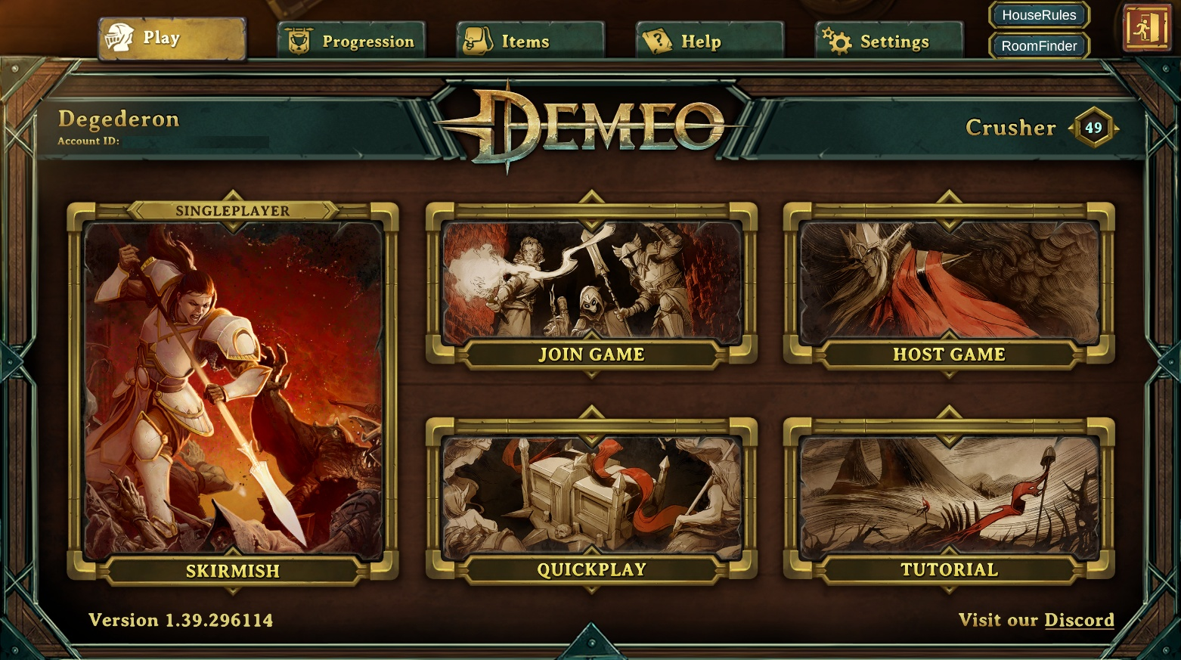

**A few notes: When you click on the HouseRules or RoomFinder buttons, the window that appears will remain on the screen until you click them again.**

# Using the House Rules Application

Now that you have clicked on the House Rules button, we take the conversation forward. There will be three screens to look over. Each feature selection has a subsection to read further on.

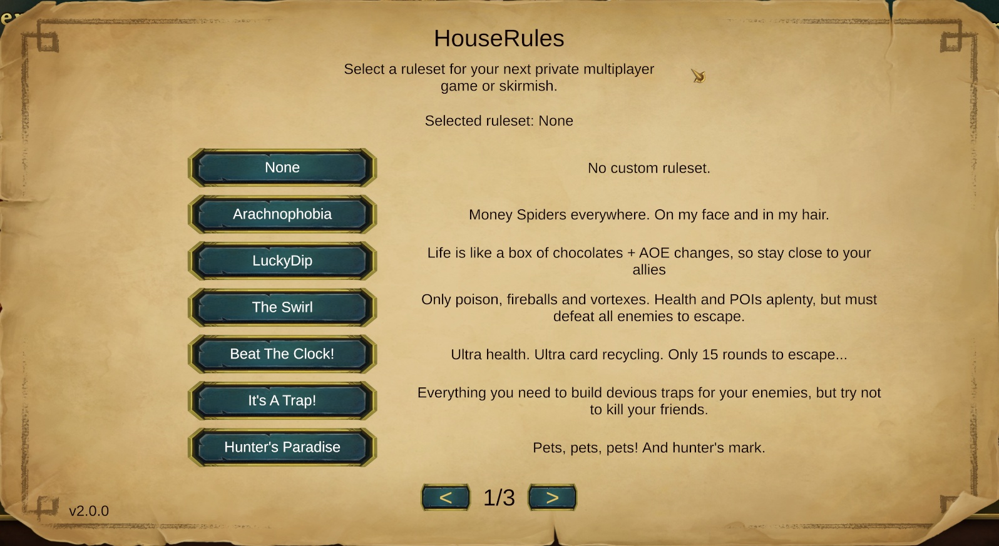

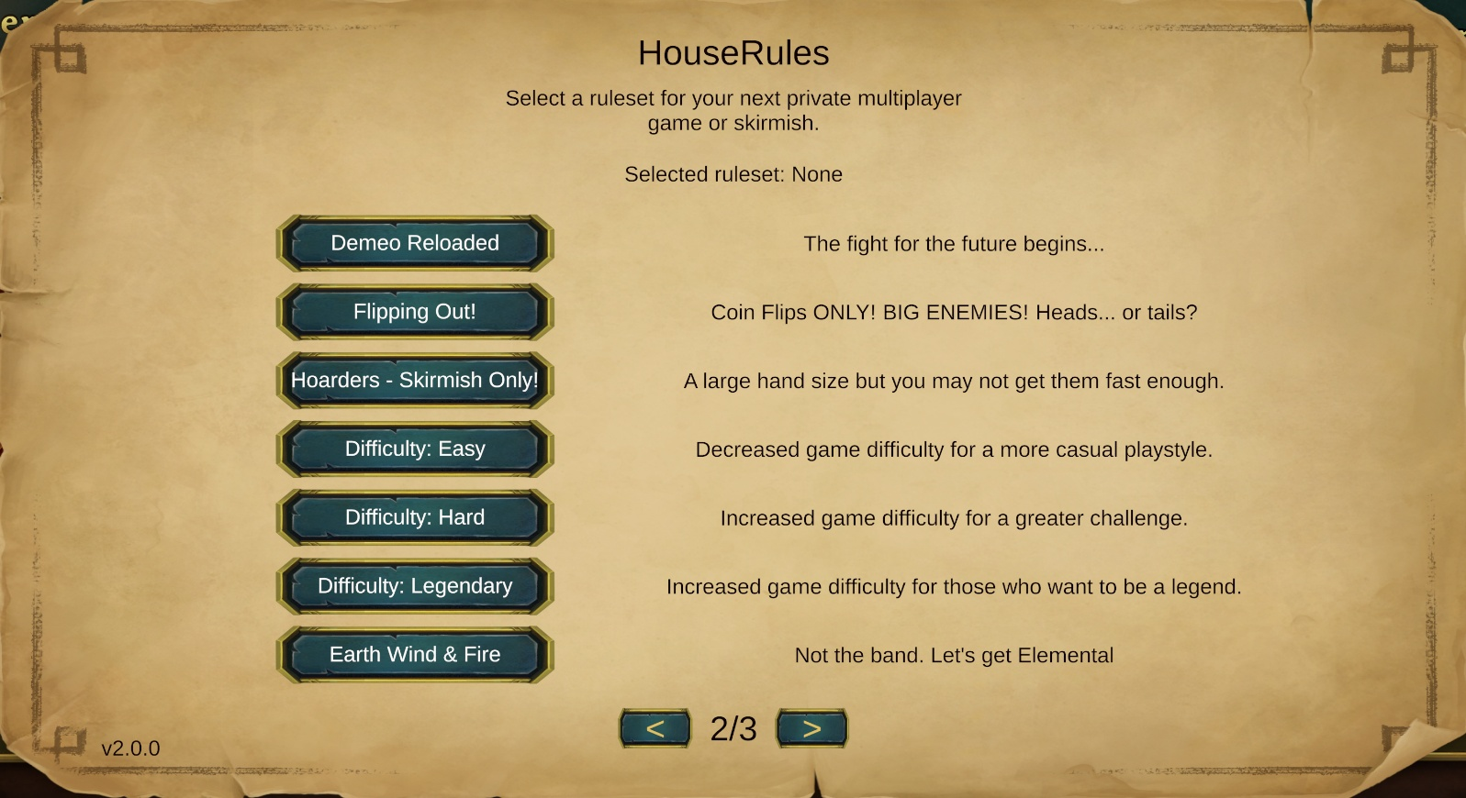

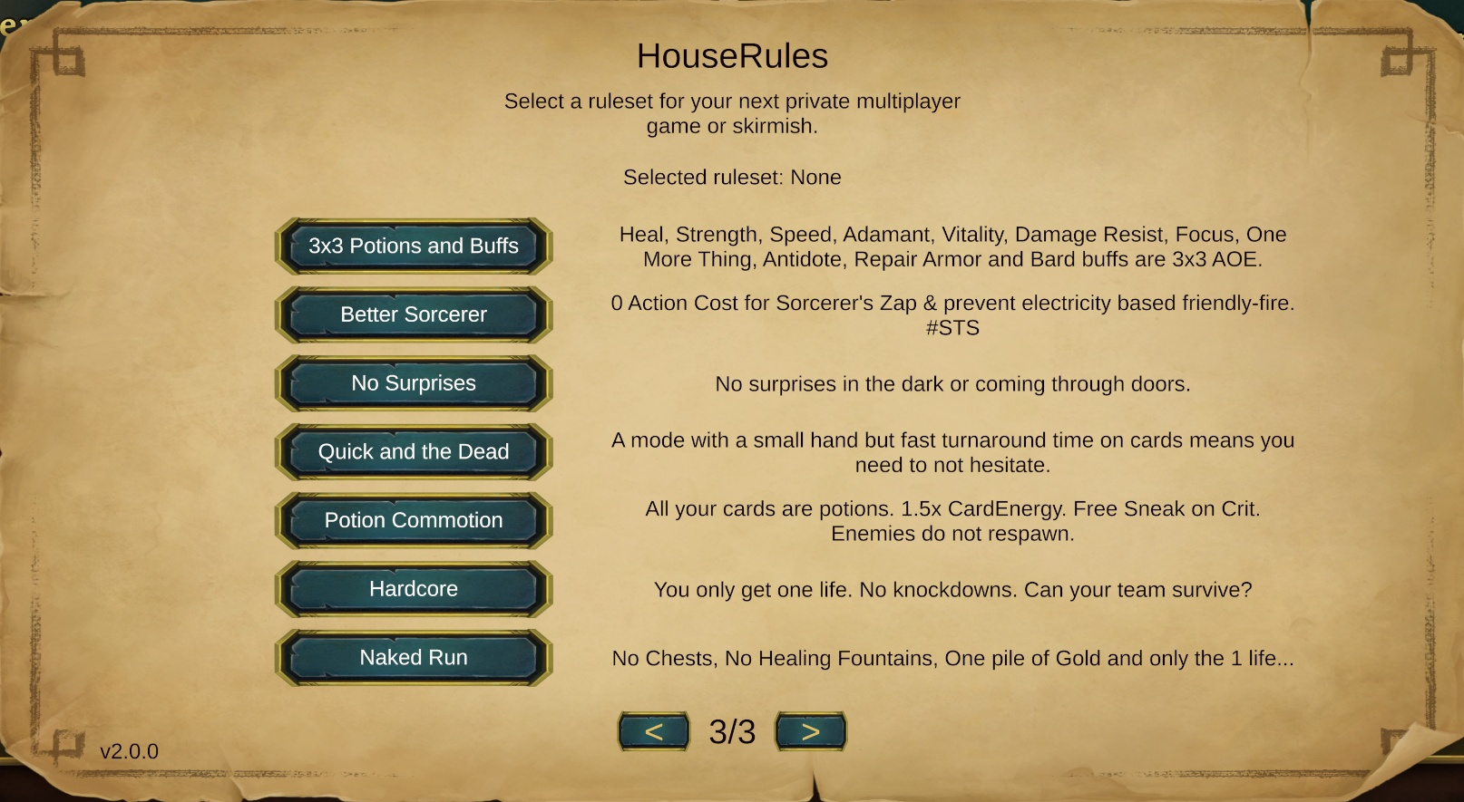

# Arachnophobia

If you don’t love spiders, then this isn’t the option to choose. Post your feedback on the forum about this gameplay choice. If it is chosen, your name will be given credit and posted in this guide for others to learn from.

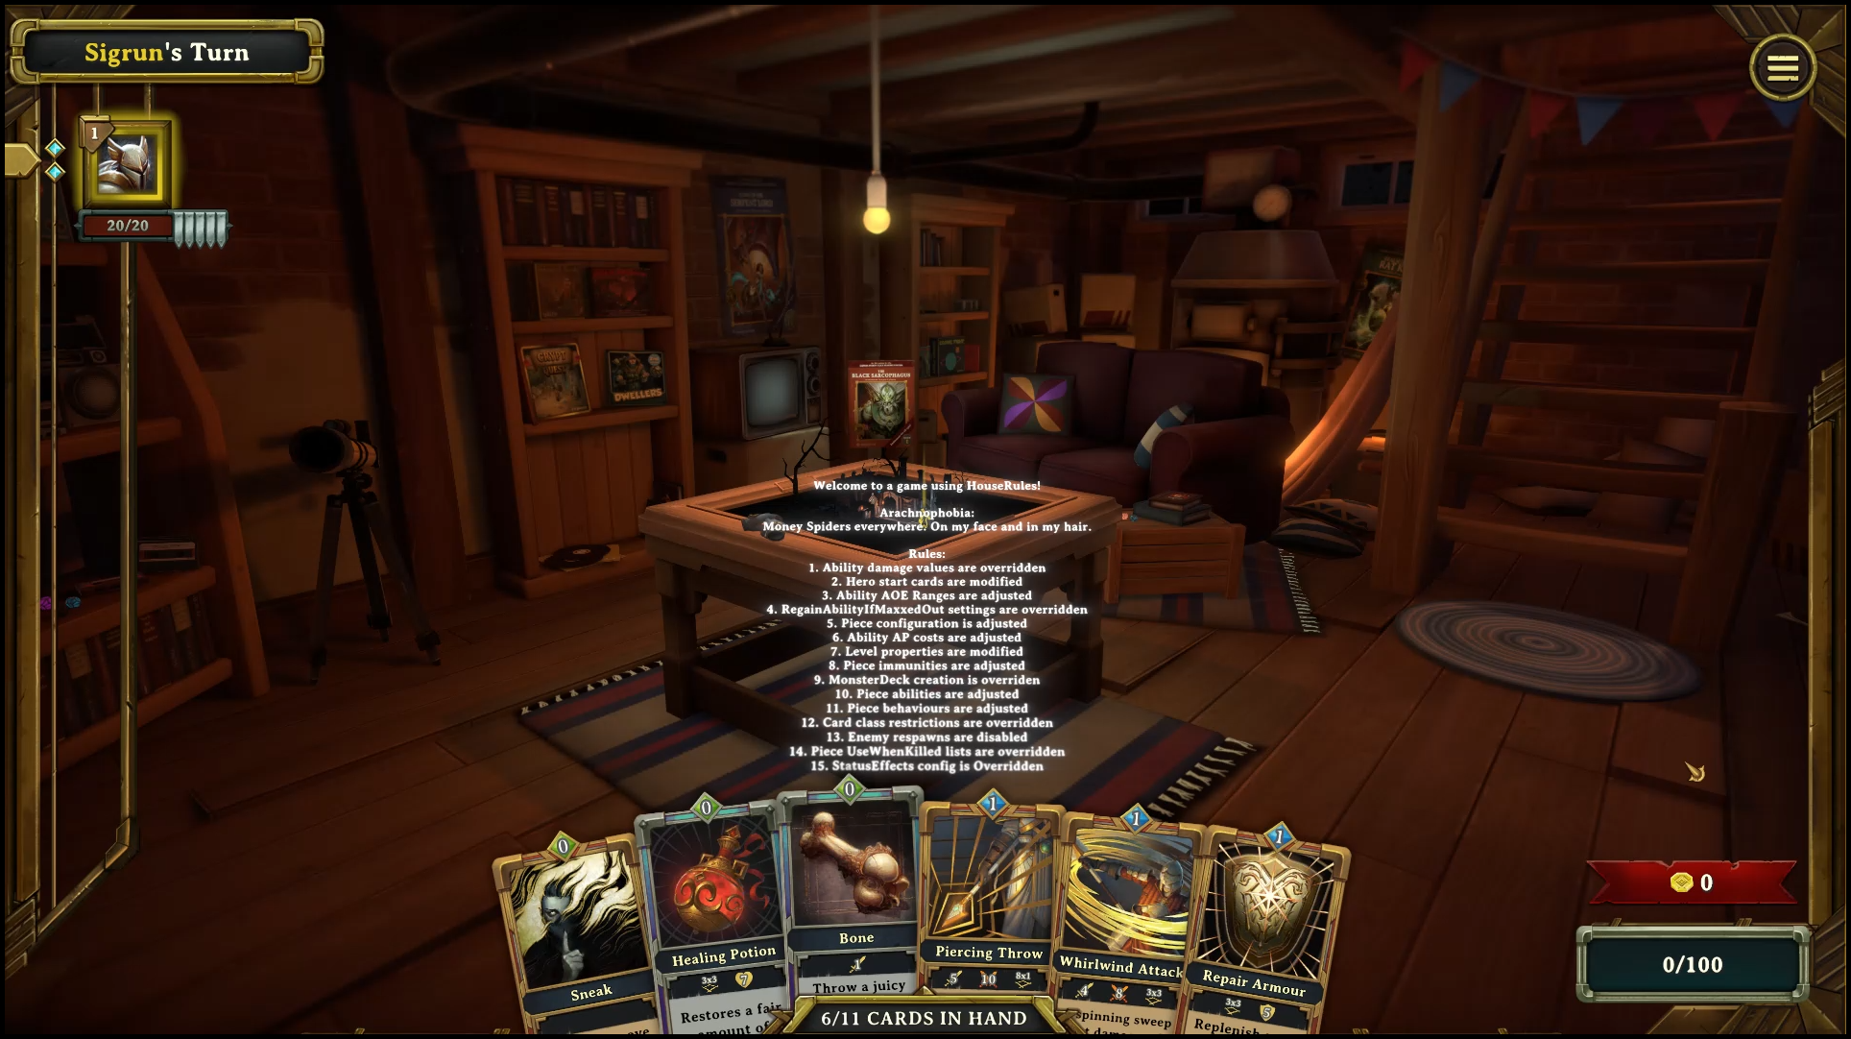

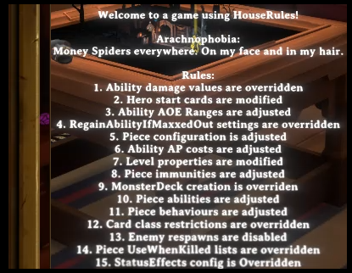

# LuckyDip

The explanation for this game play option is “Life is like a box of chocolates + AOE changes, so stay close to your allies.

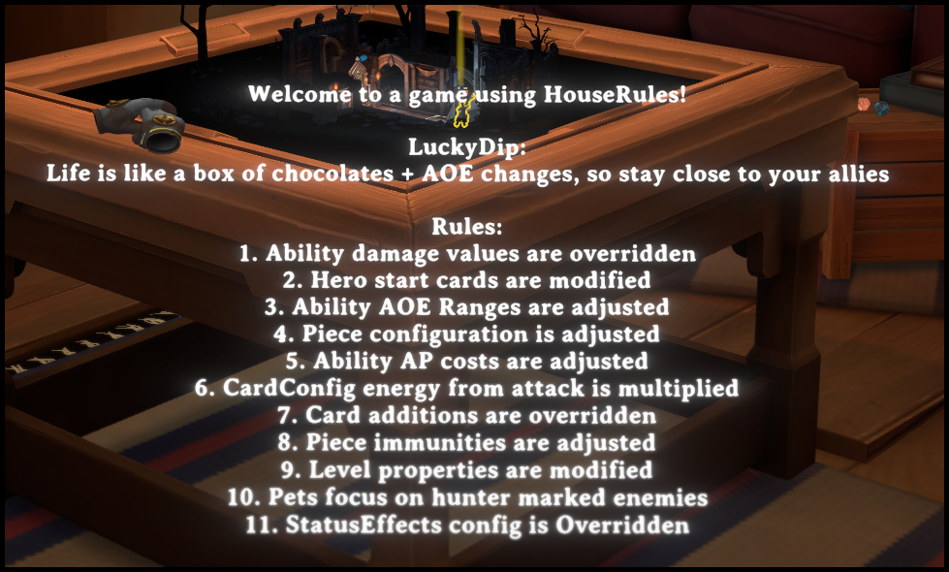

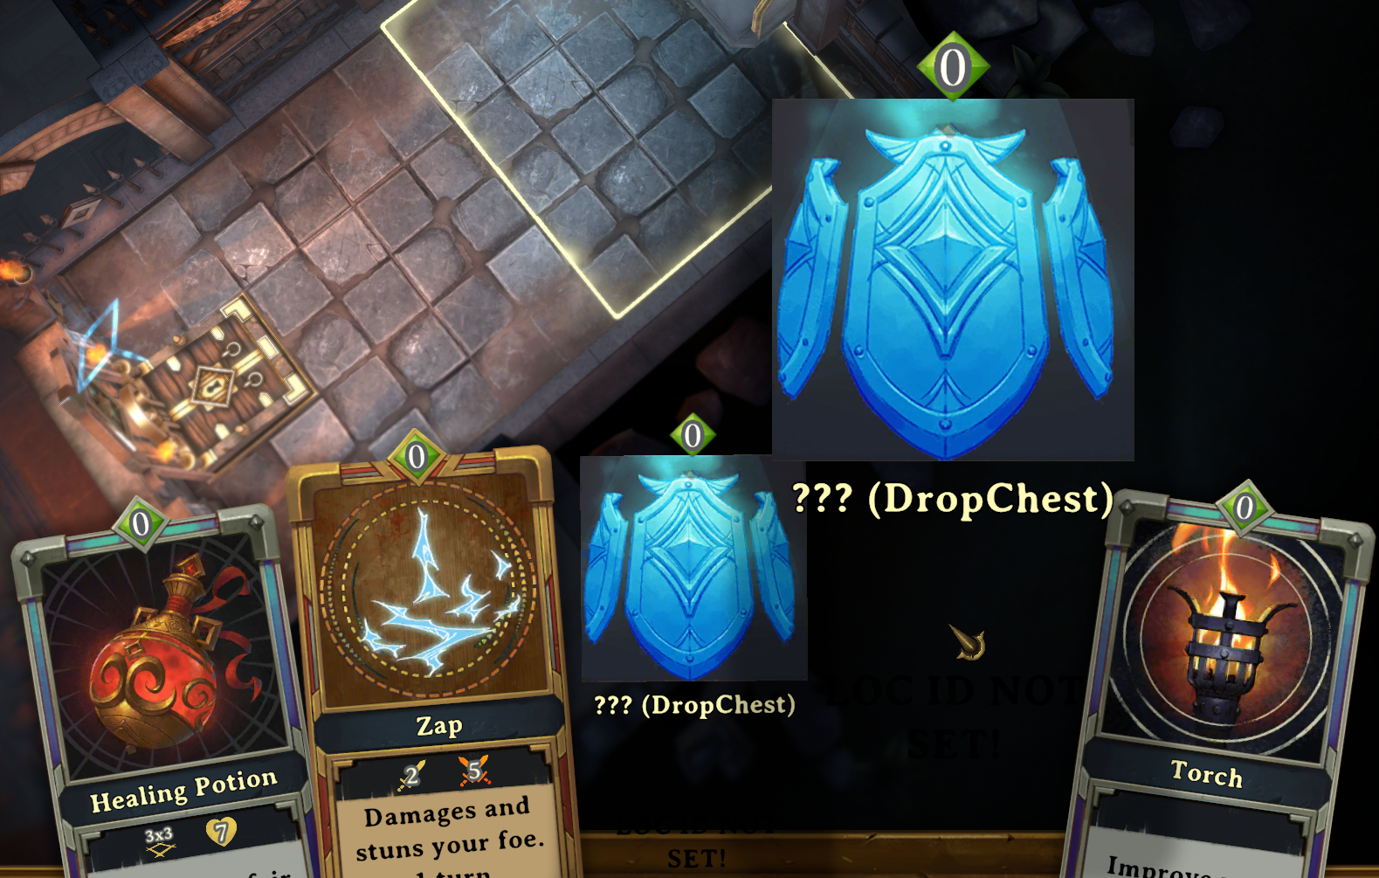

# The Swirl

Only poison, fireballs and vortexes are in use. Health and POIs are plentiful. You must defeat all of the enemies to escape this map.

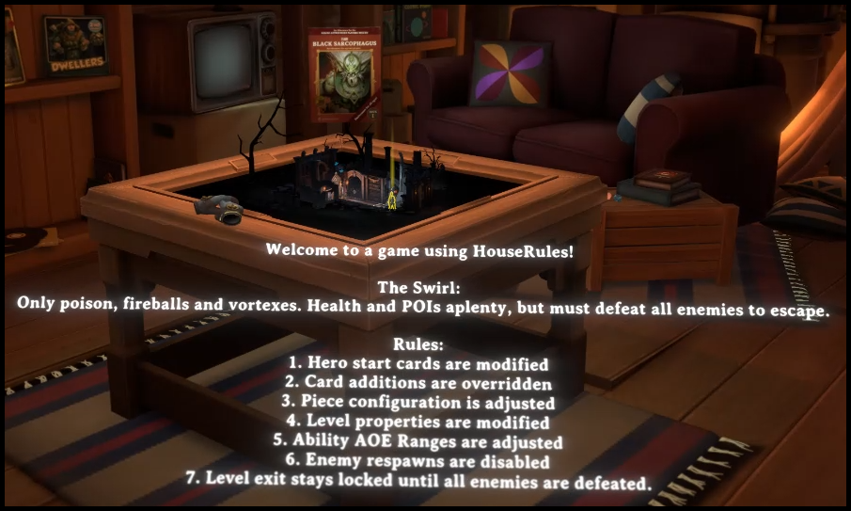

# Beat The Clock

You will be provided Ultra health and major recycling of cards. You have only 15 rounds to escape.

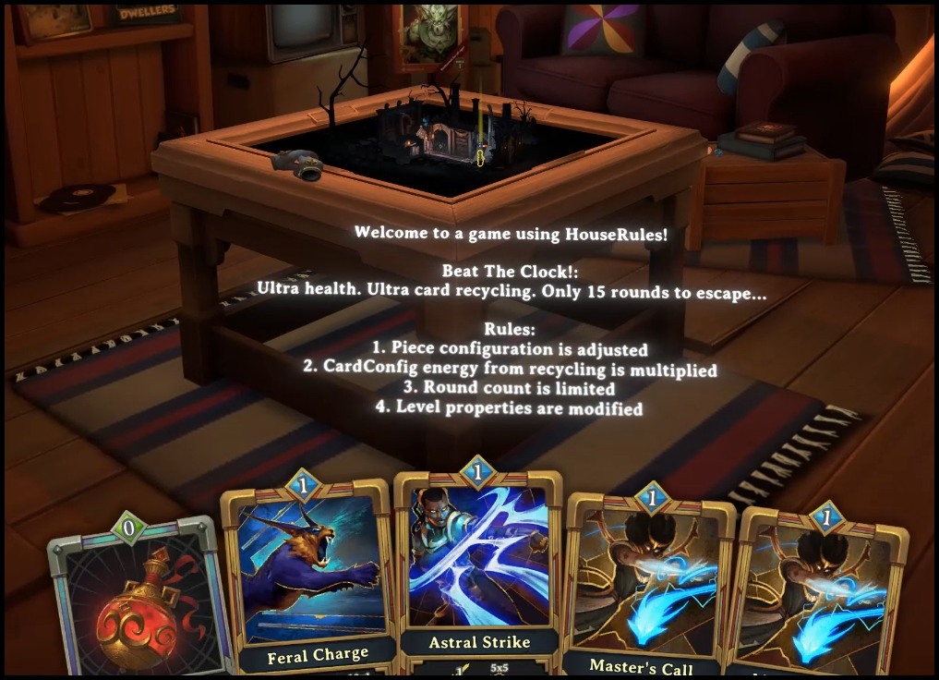

# It’s A Trap

Like traps, do you? In this game play you will have everything you build devious traps for your enemies. One note of caution, try not to kill your friends.

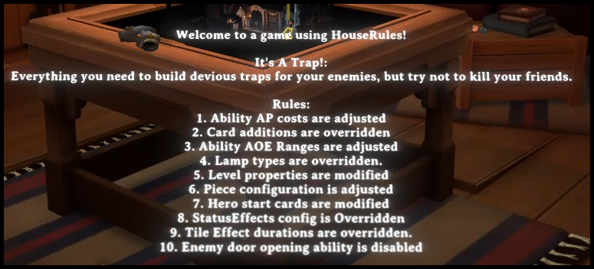

# Hunter’s Paradise

If you are like my beloved Katia the Hunter, you will love this. Pets, Pets and oh yes, more pets. Of course, there is a hunter’s mark!

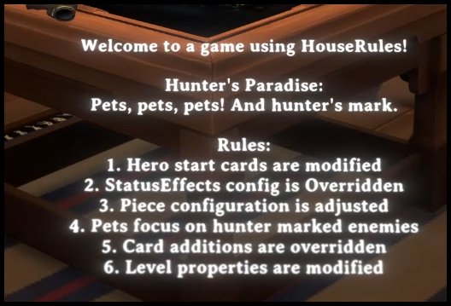

# Demeo Reloaded

The fight for the future begins…

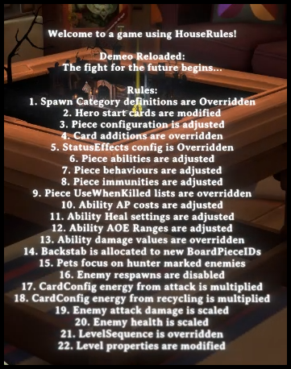

# Flipping Out!

Now it’s time to flip the coins and only the coins. Will you understand if I say Heads or Tails? BIG ENEMIES are ready to say hello.

1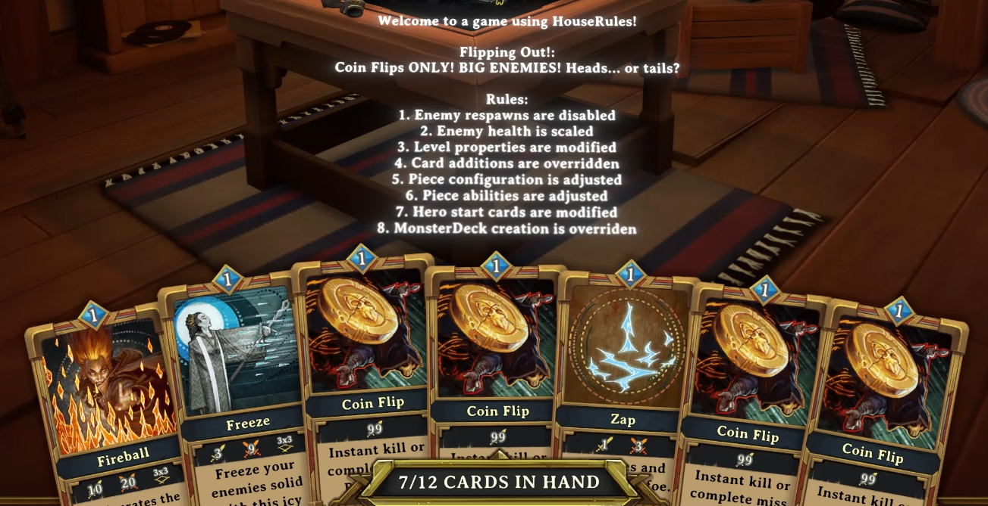 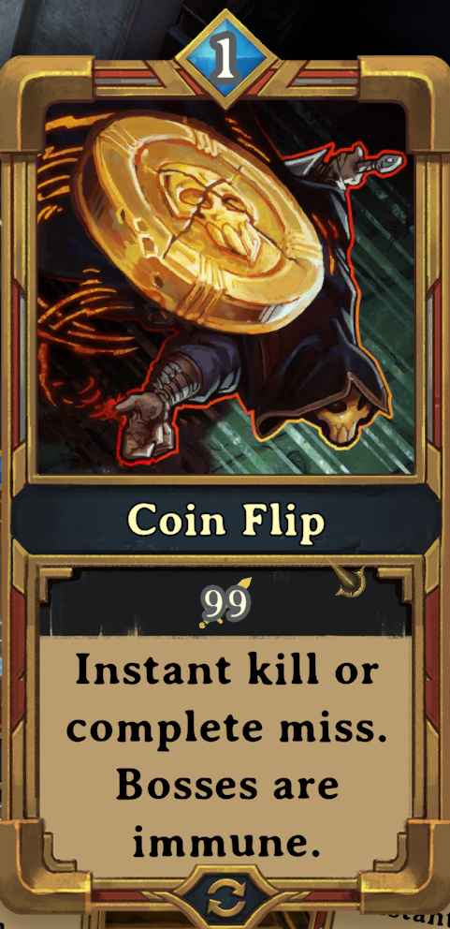

# Hoarders – Skirmish Only

A really big hand awaits you! Will they come fast enough is the question.

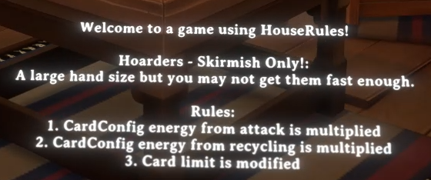

# Difficulty: Easy

A decreased game difficulty for the more casual play style.

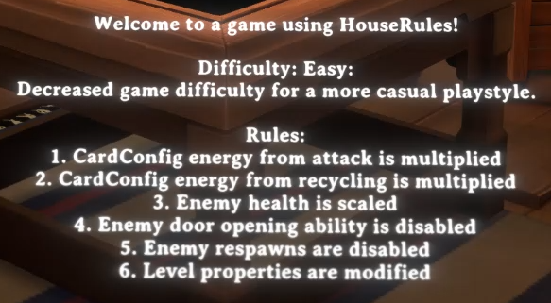

# Difficulty: Hard

An increased difficulty option makes for a greater challenge.

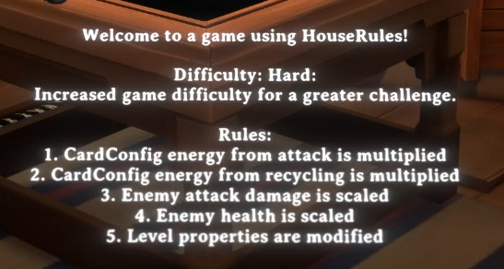

# Difficulty: Legendary

If the game weren’t difficult enough, now you get to terrorize yourself and beat them all! Become the legend!

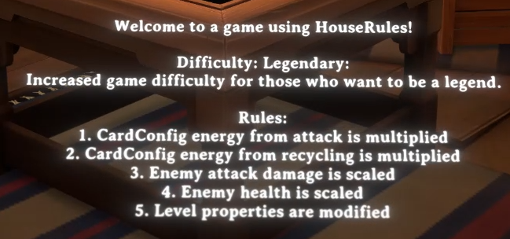

# Earth Wind & Fire

Not the band at all. Remember the lyrics to the song as she sings “Let’s get Physical”? This version is “Let’s get Elemental”.

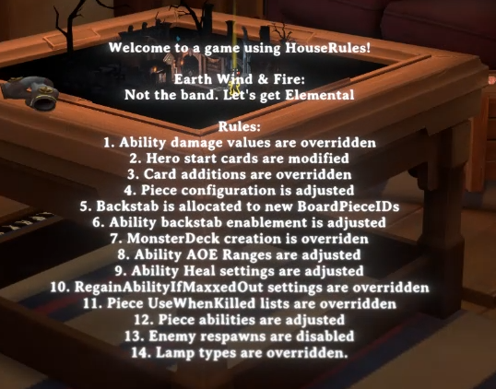

# 3x3 Potions and Buffs



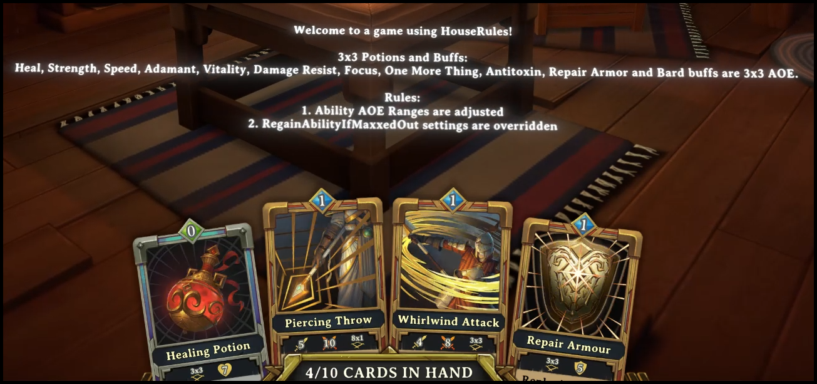

# Better Sorcerer



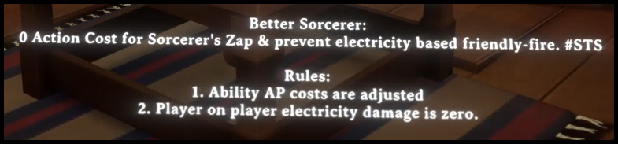

# No Surprises

Whether its in the dark or coming through those doors, there are no surprises.

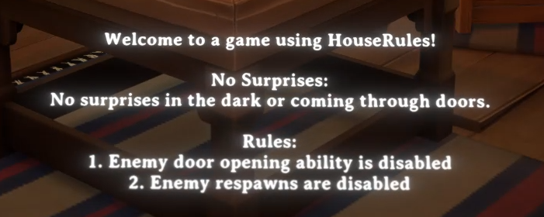

# Quick and the Dead

Here’s a mode that offers a small hand but very fast turnaround time on cards. Don’t hesitate!

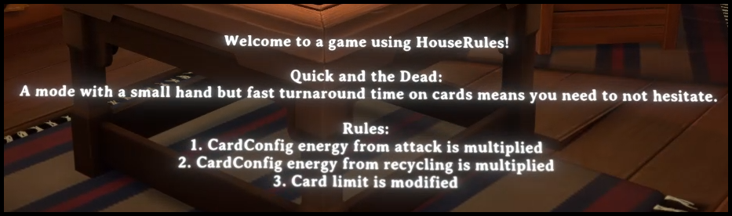

# Potion Commotion

OK potion lovers your wish has finally come true. All of your cards are potions. 1.5x CardEnergy. Free Sneak on Crit. Enemies do not respawn.

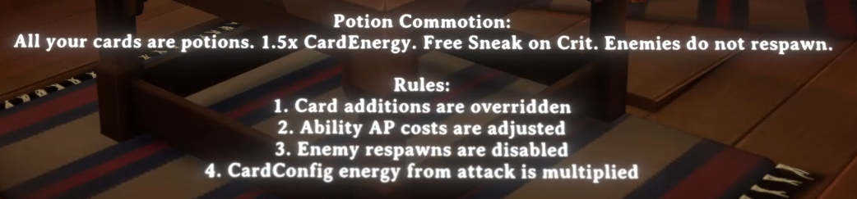

# Hardcore

You get one life, no knockdowns. Can your team make it out alive?

# Naked Run

No Chests, no Healing fountains, one pile of gold and one life. Good luck!

# Installing Custom Built Rulesets

All custom rules that you create will be installed into the UserData>HouseRules folder.

**Important**

Do NOT place your custom rulesets in the ExampleRulesets folder!

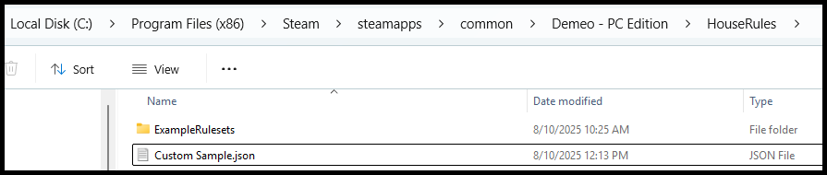

1. In this example I created a file called Custom Sample.json. When the file is opened you will find the name that will be displayed in the Demeo Rules menu.

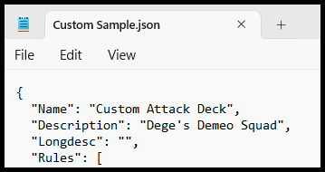

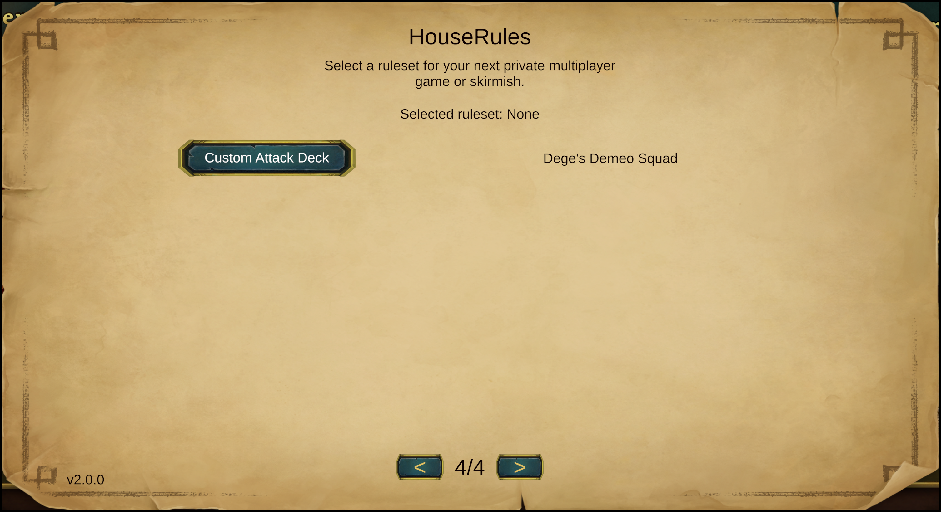

# Rules and Configurations

In this section we add to existing and known information provided by the author Orendain. Rule references come from [here](https://github.com/orendain/DemeoMods/blob/main/HouseRules.Essentials/README.md). There are many rules that have some examples and some we will try to add here with additional examples to make your custom ruleset journey more thought-provoking. In the following examples there will be comments added. Be mindful when creating your rules with examples that the comma following each rule with an added comment may not be needed. In other words if you don’t add a comment you will not need the comma.

Here is a list of the rules that are documented are highlighted and those that we will explore and expand on. There are currently 51 available rule types.

# AbilityActionCostAdjusted

This rule modifies the action point (AP) cost of specific abilities, allowing players to adjust the resource cost required to use them, thereby influencing strategic choices and gameplay pacing.

This rule is ideal for balancing ability usage, making powerful abilities more or less costly, or tailoring playstyles to emphasize certain actions. For example, reducing the AP cost of a healing ability can promote support roles, while increasing the cost of a high-damage ability can limit its spam potential.

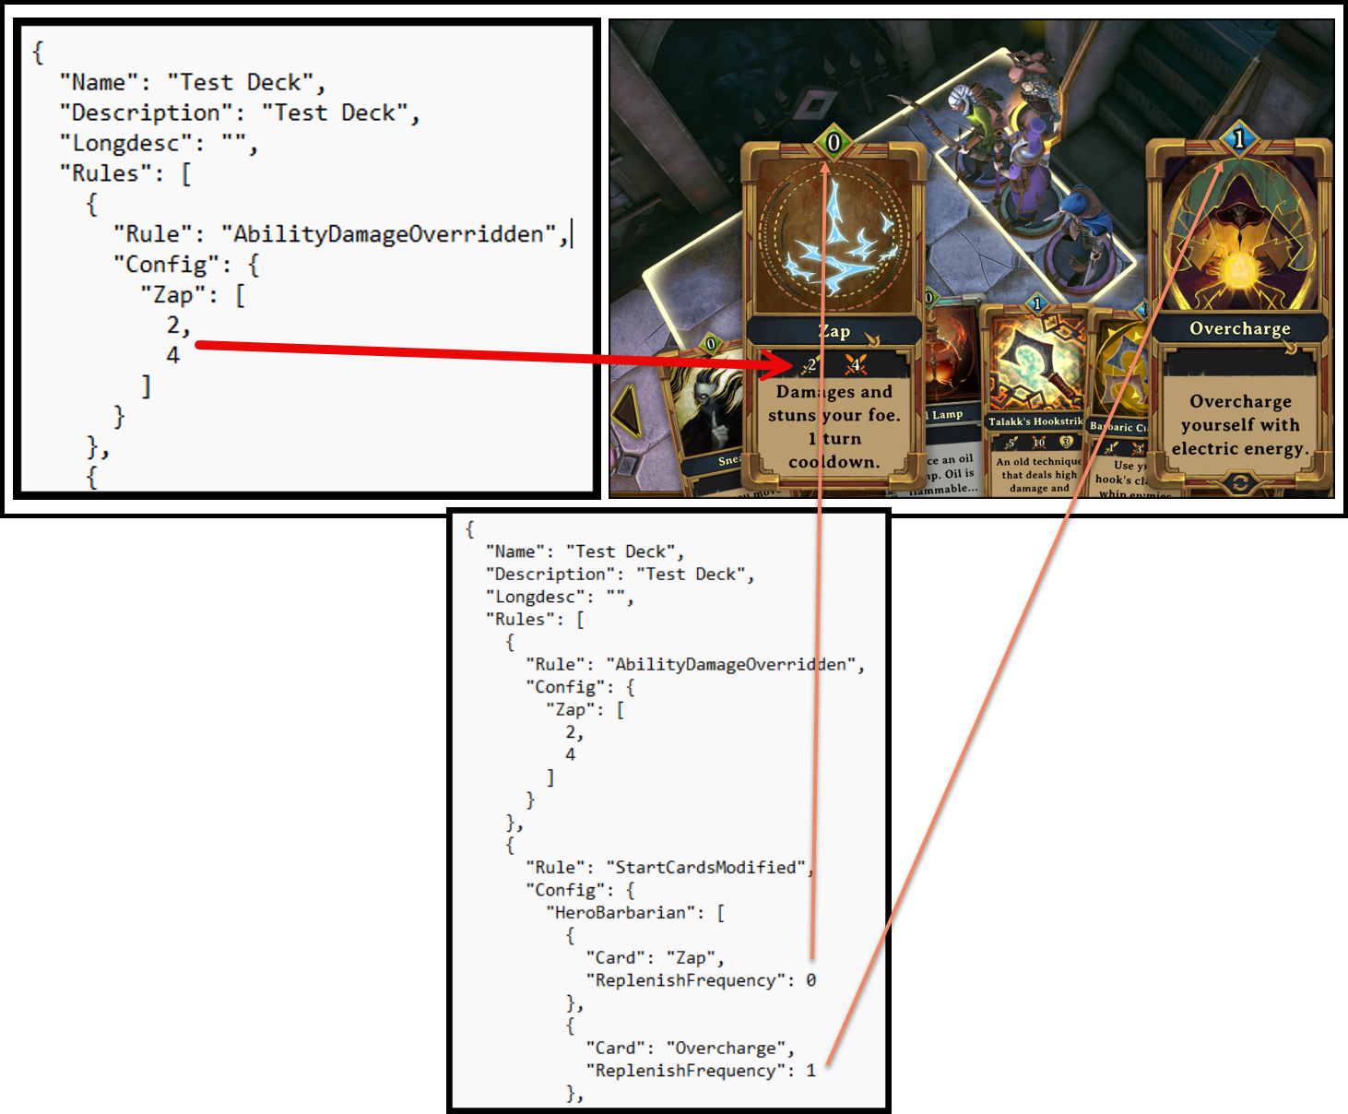

A casting cost, like the Overcharge shown, would count against your total turns allowed. If the card is a zero cost, like the Zap shown, it costs you nothing to use and does not count against you during a turn play. If it is a 1 and your total turns is 2, you just spent a casting cost of 1 and now have one turn left.

# AbilityAoeAdjusted

This rule does not operate with all abilities. The best example is if you specify a positive number, it will increase the range, or a negative number to decrease its range. For example, if you executed a fireball card by default it would look something like this:

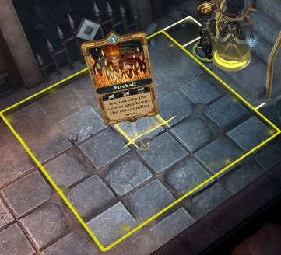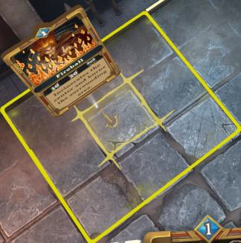The Fireball card would produce a field of 3x3 squares where damage will occur. Incrementing the number to 1 will create a 5x5 coverage field.

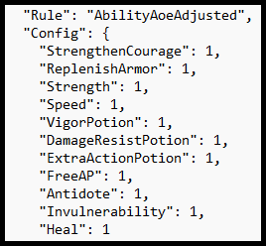

# AbilityBackstabAdjusted

This rule enables or disables the backstab bonus for specific abilities, determining whether they deal extra damage when used from behind an enemy. It is ideal for balancing or enhancing stealth-based strategies, allowing players to enable backstab bonuses for abilities that don’t typically have them or disable them to reduce the power of certain attacks.

**Purpose** - Enables or disables backstab bonuses for specified abilities. Allows designated abilities to deal extra damage when used from behind enemies.

**Scope** - Affects abilities that can deal damage (e.g., Zap, HunterArrow, Fireball). Applies only to specified AbilityKey values, not all abilities.

**Configuration** - Uses JSON object with AbilityKey strings as keys and boolean values (true/false). true enables backstab bonus; false disables it for the ability.

**Compatibility** - Works in multiplayer and Skirmish modes. Requires HouseRules v2.0.0, BepInEx 5.x, JSON in <GAME_DIR>/UserData/HouseRules/.

**Context -** The AbilityBackstabAdjusted rule customizes *Demeo* gameplay by allowing modders to enable backstab bonuses for specific abilities, extending the Assassin’s positional damage advantage to other abilities like Sorcerer’s Zap or Hunter’s HunterArrow. It’s ideal for campaigns emphasizing stealth and tactical positioning, enhancing strategic depth. The rule requires precise AbilityKey names (verified via HouseRules wiki or Demeo modding community) to avoid runtime errors. Configured in a JSON file (e.g., TestBackstabAbilities.json), parsed by BepInEx, it demands strict syntax to prevent parsing issues like Newtonsoft.Json.JsonReaderException. Testing is recommended to ensure balance, as enabling backstab for powerful abilities can significantly boost damage output.

**Configuration**

* + - * Zap - true (enables backstab bonus for Sorcerer’s Zap).
      * HunterArrow - true (enables backstab bonus for Hunter’s ranged attack).
      * Fireball - true (enables backstab bonus for Sorcerer’s Fireball).

**Effect** - Zap, HunterArrow, and Fireball deal extra damage when used from behind enemies in Skirmish or multiplayer modes.

**{**

**"Rule": "AbilityBackstabAdjusted",**

**"Config": {**

**"Zap": true, *// Enables backstab bonus for Sorcerer’s Zap***

**"HunterArrow": true, *// Enables backstab bonus for Hunter’s ranged attack***

**"Fireball": true *// Enables backstab bonus for Sorcerer’s Fireball***

**}**

**}**

# AbilityDamageOverridden

Thisrule overrides the base damage value of specific abilities, allowing players to adjust their power level to balance gameplay or enhance specific strategies. Used for fine-tuning the damage output of abilities, making weaker abilities more effective or toning down overpowered ones to suit custom rulesets.

**Purpose** - Overrides normal (targetDamage) and critical (critDamage) damage for abilities.

Customizes combat effectiveness for specific abilities.

**Scope** - Affects only damage-dealing abilities (e.g., Zap, Fireball).

Cannot make non-damaging abilities (e.g., Heal) deal damage.

**Compatibility** - Works in multiplayer and Skirmish modes.

Requires HouseRules v2.0.0, BepInEx 5.x, JSON in <GAME_DIR>/UserData/HouseRules/.

**Context** - Customizes ability damage to enhance *Demeo* combat, ideal for aggressive campaigns. Targets AbilityKey (e.g., Zap, Fireball) for targetDamage and critDamage.

Configured in JSON (e.g., PowerSurge.json), parsed by BepInEx, needs strict syntax.

Configuration

* Zap - [4, 8] (4 normal, 8 crit damage for Sorcerer’s attack).
* HunterArrow - [6, 12] (6 normal, 12 crit for Hunter’s ranged attack).
* Fireball - [8, 16] (8 normal, 16 crit for Sorcerer’s AoE).

**Effect** - Boosts Sorcerer and Hunter damage, paired with 25% more gold, locked enemy doors, 15% less enemy health for aggressive play. Implementation - Save in <GAME_DIR>/UserData/HouseRules/, test with BepInEx, verify AbilityKey names, check <GAME_DIR>/BepInEx/LogOutput.log.

**{**

**"Rule" - "AbilityDamageOverridden",**

**"Config" - {**

**"Zap" - [4, 8], // Sorcerer’s basic attack deals 4 normal, 8 crit damage**

**"HunterArrow" - [6, 12], // Hunter’s ranged attack deals 6 normal, 12 crit damage**

**"Fireball" - [8, 16] // Sorcerer’s AoE attack deals 8 normal, 16 crit damage**

**}**

**}**

# AbilityHealOverridden

This rule overrides the base healing amount of specific abilities, allowing players to adjust their restorative power to balance support roles or modify gameplay difficulty. For fine-tuning the healing output of abilities, enabling players to enhance support-focused characters or increase the challenge by reducing healing effectiveness.

**Purpose** - Overrides the healAmount for specified healing abilities. Customizes the amount of health restored by specific healing abilities.

**Scope** - Affects only abilities that heal (e.g., Heal, HealingLight). Cannot make non-healing abilities (e.g., Fireball) heal.

**Configuration** - Uses JSON object with AbilityKey strings as keys and positive integer values for healAmount. Specifies the new health restoration amount for each healing ability.

**Compatibility** - Works in multiplayer and Skirmish modes. Requires HouseRules v2.0.0, BepInEx 5.x, JSON in <GAME_DIR>/UserData/HouseRules/.

**Context -** The AbilityHealOverridden rule customizes *Demeo* gameplay by adjusting the health restored by specific healing abilities, enhancing support roles for classes like Guardian or Bard. It’s ideal for campaigns emphasizing survivability or cooperative play, allowing tailored healing strength. The rule requires precise AbilityKey names (verified via HouseRules wiki or Demeo modding community) to avoid runtime errors. Configured in a JSON file (e.g., TestHealBoost.json), parsed by BepInEx, it demands strict syntax to prevent parsing issues like Newtonsoft.Json.JsonReaderException. Testing is recommended to ensure balance, as excessive healing can reduce challenge.

**Configuration** -

* + - * Heal - 10 (sets Heal to restore 10 health).
      * HealingLight - 12 (sets HealingLight to restore 12 health).

**Effect** - Heal and HealingLight restore 10 and 12 health, respectively, in Skirmish or multiplayer modes, enhancing support capabilities.

**{**

**"Rule" - "AbilityHealOverridden",**

**"Config" - {**

**"Heal" - 10, *// Sets Heal ability to restore 10 health***

**"HealingLight" - 12 *// Sets HealingLight ability to restore 12 health***

**}**

# AbilityRandomPieceList

This rule modifies the pool of game pieces (e.g., enemies, allies, or objects) that an ability can randomly spawn or summon, allowing players to control the randomization outcomes for abilities with summoning mechanics. It is ideal for customizing summon-based abilities, enabling players to define specific pieces that can be spawned to align with desired playstyles, balance gameplay, or create thematic encounters.

**Purpose** - Overrides the randomPieceList for abilities that spawn random board pieces. Customizes which pieces (e.g., monsters, objects) are spawned by abilities like NaturesCall.

**Scope** - Affects abilities that spawn random pieces (e.g., BeastWhisperer, NaturesCall). Skirmish-only; does not work properly in multiplayer games.

**Configuration** - Uses JSON object with AbilityKey strings as keys and arrays of BoardPieceId strings as values. Specifies the list of pieces that can be spawned by the ability.

**Compatibility** - Limited to Skirmish mode; not reliable in multiplayer. Requires HouseRules v2.0.0, BepInEx 5.x, JSON in <GAME_DIR>/UserData/HouseRules/.

**Context -** The AbilityRandomPieceList rule enables modders to customize *Demeo* gameplay by altering the random pieces spawned by specific abilities, such as NaturesCall spawning creatures like GoblinRanger or Slime. It’s ideal for Skirmish campaigns where players want to control summoned allies or enemies for thematic or strategic purposes. The rule requires precise AbilityKey and BoardPieceId names (verified via HouseRules wiki or Demeo modding community) to avoid runtime errors. Configured in a JSON file (e.g., BeastMaster.json), parsed by BepInEx, it demands strict syntax to prevent parsing issues like Newtonsoft.Json.JsonReaderException. Note the Skirmish-only limitation, which may cause inconsistent behavior in multiplayer sessions.

**Configuration**

* NaturesCall - ["GoblinRanger", "Slime", "Wolf"] (spawns GoblinRanger, Slime, or Wolf).
* BeastWhisperer - ["Wolf", "Bear"] (spawns Wolf or Bear).

**{**

**"Rule" - "AbilityRandomPieceList",**

**"Config" - {**

**"NaturesCall" - ["GoblinRanger", "Slime"],**

**"BeastWhisperer" - ["Wolf", "Bear"]**

**}**

# BackstabConfigOverridden

This rule overrides the backstab damage multiplier for specific abilities, allowing players to customize the bonus damage dealt when attacking an enemy from behind. Ideal for fine-tuning the effectiveness of backstab mechanics, enabling players to enhance or reduce the power of abilities in stealth scenarios to balance gameplay or emphasize tactical positioning. It provides more granular control than the AbilityBackstabAdjusted rule, which only enables or disables backstabs, by allowing specific damage multiplier adjustments.

**Purpose** - Replaces the default Assassin-only backstab ability with a configurable list of player classes. Allows specified pieces to gain bonus damage when attacking from behind enemies.

**Scope** - Affects player character pieces (e.g., HeroRogue, HeroGuardian).

Extends backstab capability beyond the default HeroRogue (Assassin).

**Configuration** - Uses JSON array of BoardPieceId strings.

Specifies which pieces (e.g., HeroGuardian, HeroSorcerer) can backstab.

**Compatibility** - Works in multiplayer and Skirmish modes.

Requires HouseRules v2.0.0, BepInEx 5.x, JSON in <GAME_DIR>/UserData/HouseRules/.

**Context -** Customizes *Demeo* gameplay by extending backstab bonuses—typically exclusive to the Assassin (HeroRogue)—to other player classes, such as Guardian or Sorcerer. Ideal for campaigns emphasizing stealth and positional tactics, it enhances strategic flexibility by allowing diverse classes to deal increased damage from behind. Requires precise BoardPieceId names (verified via HouseRules wiki or Demeo modding community) to avoid runtime errors. Configured in a JSON file (e.g., TestBackstab.json), parsed by BepInEx, it demands strict syntax to prevent parsing issues like Newtonsoft.Json.JsonReaderException.

**Configuration**

* ["HeroGuardian", "HeroHunter", "HeroSorcerer"] (allows Guardian, Hunter, and Sorcerer to gain backstab bonuses).

**Effect** - Enables HeroGuardian, HeroHunter, and HeroSorcerer to deal extra damage when backstabbing in Skirmish or multiplayer modes.

**{**

**"Rule" - "BackstabConfigOverridden",**

**"Config" - [**

**"HeroGuardian", *// Allows Guardian to gain backstab bonuses***

**"HeroHunter", *// Allows Hunter to gain backstab bonuses***

**"HeroSorcerer" *// Allows Sorcerer to gain backstab bonuses***

**}**

# CardAdditionOverridden

This rule specifically overrides the default cards added to a player’s deck under certain conditions, such as at the start of a game, when leveling up, or during specific in-game events (e.g., completing objectives or triggering special effects). This rule provides granular control over deck composition, allowing players to tailor which cards are automatically added to a character’s deck to enhance playstyles, balance class roles, or create unique gameplay scenarios.

**Purpose** - Overrides the default lists of cards players receive from chests and card energy (mana). Customizes the card pool for specific player classes to alter gameplay strategies.

**Scope** - Affects player character pieces (e.g., HeroSorcerer, HeroGuardian). Replaces default card allocation; cannot be used with CardChestAdditionOverridden or CardEnergyAdditionOverridden.

**Configuration** - Uses JSON object with BoardPieceId strings as keys and arrays of AbilityKey strings as values. Specifies the cards available to each class from chests and mana.

**Compatibility** - Works in multiplayer and Skirmish modes. Requires HouseRules v2.0.0, BepInEx 5.x, JSON in <GAME_DIR>/UserData/HouseRules/.

**Context -** The CardAdditionOverridden rule customizes *Demeo* gameplay by redefining the card pools that player classes draw from when gaining cards via chests or card energy (mana). It’s ideal for campaigns tailoring class-specific strategies, such as enhancing Sorcerer’s offensive spells or Guardian’s defensive abilities. The rule requires precise BoardPieceId and AbilityKey names (verified via HouseRules wiki or Demeo modding community) to avoid runtime errors. Configured in a JSON file (e.g., TestCards.json), parsed by BepInEx, it demands strict syntax to prevent parsing issues like Newtonsoft.Json.JsonReaderException. Note the restriction against combining with CardChestAdditionOverridden or CardEnergyAdditionOverridden to avoid conflicts.

**Configuration**

* HeroSorcerer - ["Fireball", "Zap", "Freeze"] (Sorcerer receives Fireball, Zap, or Freeze).
* HeroGuardian - ["Heal", "Whirlwind"] (Guardian receives Heal or Whirlwind).

**Effect** - Replaces default card pools for Sorcerer and Guardian, enabling Sorcerer to draw offensive spells and Guardian to draw healing and melee cards from chests and mana in Skirmish or multiplayer modes.

**{**

**"Rule" - "CardAdditionOverridden",**

**"Config" - {**

**"HeroSorcerer" - ["Fireball", "Zap", "Freeze"], *// Sorcerer draws Fireball, Zap, or Freeze from chests and mana***

**"HeroGuardian" - ["Heal", "Whirlwind"] *// Guardian draws Heal or Whirlwind from chests and mana***

**}**

# CardChestAdditionOverridden

This rule specifically overrides the default cards added to a player’s deck under certain conditions, such as at the start of a game, when leveling up, or during specific in-game events (e.g., completing objectives or triggering special effects). It provides granular control over deck composition, allowing players to tailor which cards are automatically added to a character’s deck to enhance playstyles, balance class roles, or create unique gameplay scenarios. It is also for customizing the loot system to align with desired playstyles, balance resource availability, or create thematic gameplay experiences. By controlling which cards appear in chests, players can emphasize certain strategies, enhance class synergy, or adjust the game’s difficulty.

**Purpose** - Overrides the default lists of cards players receive from opening chests. Customizes the card pool for specific player classes when drawing from chests.

**Scope** - Affects player character pieces (e.g., HeroSorcerer, HeroHunter) when interacting with chests. Applies only to chest rewards; cannot be used with CardAdditionOverridden.

**Configuration** - Uses JSON object with BoardPieceId strings as keys and arrays of AbilityKey strings as values. Specifies the cards available to each class from chests.

**Context -** The CardChestAdditionOverridden rule customizes *Demeo* gameplay by redefining the card pools that player classes draw from when opening chests, allowing tailored class-specific strategies, such as enhancing Sorcerer’s spell options or Hunter’s utility cards. It’s ideal for campaigns focusing on chest-based rewards, distinct from mana-based card draws. The rule requires precise BoardPieceId and AbilityKey names (verified via HouseRules wiki or Demeo modding community) to avoid runtime errors. Configured in a JSON file (e.g., TestChestCards.json), parsed by BepInEx, it demands strict syntax to prevent parsing issues like Newtonsoft.Json.JsonReaderException. Note the restriction against combining with CardAdditionOverridden to avoid conflicts.

**Configuration**

* HeroSorcerer - ["Fireball", "Freeze", "Shock"] (Sorcerer receives Fireball, Freeze, or Shock from chests).
* HeroHunter - ["Arrow", "Trap"] (Hunter receives Arrow or Trap from chests).

**Effect** - Replaces default chest card pools for Sorcerer and Hunter, enabling Sorcerer to draw offensive and control spells and Hunter to draw ranged and utility cards from chests in Skirmish or multiplayer modes.

**{**

**"Rule" - "CardChestAdditionOverridden",**

**"Config" - {**

**"HeroSorcerer" - ["Fireball", "Freeze", "Shock"], // Sorcerer draws Fireball, Freeze, or Shock from chests**

**"HeroHunter" - ["Arrow", "Trap"] // Hunter draws Arrow or Trap from chests**

**}**

# CardEnergyFromAttackMultiplied

This rule adjusts the amount of energy (action points or equivalent resources) gained when using specific attack cards, allowing players to modify the energy economy to influence combat pacing and strategic options.

**Purpose** - Adjusts the amount of card energy (mana) gained when a player attacks. Multiplies the default card energy gained from attacks by a specified factor.

**Scope** - Affects all player character pieces that gain card energy from attacking enemies. Applies globally to attack-based energy gain, not specific to individual abilities or classes.

**Configuration** - Uses a single decimal value in JSON. Specifies the multiplier for card energy gained from attacks (e.g., 1.5 for 50% more energy).

**Compatibility** - Works in multiplayer and Skirmish modes. Requires HouseRules v2.0.0, BepInEx 5.x, JSON in <GAME_DIR>/UserData/HouseRules/.

**Context -** The CardEnergyFromAttackMultiplied rule customizes *Demeo* gameplay by modifying the amount of card energy (mana) players gain when attacking enemies, enabling faster card usage for abilities. It’s ideal for campaigns emphasizing frequent ability use, such as rapid spell-casting or item deployment. The rule applies a global multiplier to energy gained from attacks, requiring no specific BoardPieceId or AbilityKey, making it simple but impactful. Configured in a JSON file (e.g., TestEnergyBoost.json), parsed by BepInEx, it demands strict syntax to prevent parsing issues like Newtonsoft.Json.JsonReaderException. The rule is straightforward but should be tested to ensure balance, as excessive energy gain can overpower gameplay.

**Configuration**

* 1.5 (increases card energy gained from attacks by 50%).

**Effect** - Players gain 50% more card energy when attacking enemies, allowing faster access to abilities in Skirmish or multiplayer modes.

**{**

**"Rule" - "CardEnergyFromAttackMultiplied",**

**"Config" - 1.5 *// Increases card energy gained from attacks by 50%***

**}**

# CardClassRestrictionOverridden

This rule overrides the class restrictions on specific cards, allowing cards that are normally restricted to one class (e.g., Hunter, Sorcerer) to be used by other classes or removing their ability to be used by their default class. Rule is ideal for breaking traditional class boundaries, enabling cross-class synergies, or creating unique playstyles by allowing cards to be shared across or restricted from specific classes.

**Purpose** - Overrides default class-specific restrictions on cards, allowing specified classes to use restricted cards. Enables cards to be used by classes beyond their default restrictions (e.g., Sorcerer using Guardian cards).

**Scope** - Affects cards with class-specific restrictions, applying to player character pieces (e.g., HeroSorcerer, HeroGuardian).

Modifies which classes can use specific AbilityKey cards.

**Configuration** - Uses JSON object with AbilityKey strings as keys and arrays of BoardPieceId strings as values. Specifies which classes can use each restricted card.

**Compatibility** - Works in multiplayer and Skirmish modes.

Requires HouseRules v2.0.0, BepInEx 5.x, JSON in <GAME_DIR>/UserData/HouseRules/.

**Context -** The CardClassRestrictionOverridden rule customizes *Demeo* gameplay by allowing modders to remove or alter class-specific restrictions on cards, enabling flexible strategies like letting Sorcerers use healing cards or Hunters use melee abilities. It’s ideal for campaigns aiming for versatile class roles or cross-class synergy. The rule requires precise AbilityKey and BoardPieceId names (verified via HouseRules wiki or Demeo modding community) to avoid runtime errors. Configured in a JSON file (e.g., TestCardFreedom.json), parsed by BepInEx, it demands strict syntax to prevent parsing issues like Newtonsoft.Json.JsonReaderException. Care should be taken to ensure balance, as unrestricted card access can significantly alter gameplay dynamics.

**Configuration** - Heal - ["HeroSorcerer", "HeroHunter"] (allows Sorcerer and Hunter to use Heal).

* Whirlwind - ["HeroSorcerer", "HeroBard"] (allows Sorcerer and Bard to use Whirlwind).

**Effect** - Enables Sorcerer and Hunter to use the Heal card (typically Guardian-restricted) and Sorcerer and Bard to use the Whirlwind card (typically Guardian or Barbarian-restricted) in Skirmish or multiplayer modes.

**{**

**"Rule" - "CardClassRestrictionOverridden",**

**"Config":**

**"Heal" - ["HeroSorcerer", "HeroHunter"], // Allows Sorcerer and Hunter to use Heal card**

**"Whirlwind" - ["HeroSorcerer", "HeroBard"] // Allows Sorcerer and Bard to use Whirlwind card**

**}**

# EnemyDoorOpeningDisabled

This rule prevents enemies from opening doors in the game, altering their behavior to restrict movement and influence strategic positioning. Used for adjusting the tactical dynamics of encounters, making it easier for players to control enemy movement or create safer zones within levels.

**Purpose** - Prevents enemies from opening doors during gameplay. Disables enemies’ ability to open doors, giving players control over encounter pacing.

**Scope** - Affects all enemy pieces that would normally open doors in *Demeo*.

Applies globally to enemy behavior, not specific to individual enemies or levels.

**Configuration** - Uses a single boolean value in JSON (true or false). true disables enemy door-opening; false allows default behavior.

**Compatibility** - Works in multiplayer and Skirmish modes.

Requires HouseRules v2.0.0, BepInEx 5.x, JSON in <GAME_DIR>/UserData/HouseRules/.

**Context -** The EnemyDoorOpeningDisabled rule customizes *Demeo* gameplay by preventing enemies from opening doors, allowing players to control when and where encounters occur. It’s ideal for campaigns emphasizing tactical positioning or stealth, as it stops enemies from initiating ambushes through doors. The rule is simple, requiring only a boolean value, making it robust and easy to implement. Configured in a JSON file (e.g., TestDoorsLocked.json), parsed by BepInEx, it demands strict syntax to prevent parsing issues like Newtonsoft.Json.JsonReaderException. Testing is recommended to ensure balance, as this rule can significantly reduce enemy aggression.

**Configuration** - true (prevents enemies from opening doors).

**Effect** - Enemies cannot open doors, allowing players to dictate encounter timing in Skirmish or multiplayer modes.

**{**

**"Rule" - "EnemyDoorOpeningDisabled",**

**"Config" - true *// Prevents enemies from opening doors***

**}**

# EnemyRespawnDisabled

This rule prevents enemies from respawning in a level after being defeated, altering the game’s pacing and difficulty by eliminating recurring enemy waves. Used to reduce the intensity of encounters, allowing players to clear areas permanently and focus on exploration or resource management. Note that this rule affects all enemies globally unless further specified, and its impact should be tested to ensure it aligns with the desired gameplay experience, as some levels may rely on respawns for challenge.

**Purpose** - Prevents enemies from respawning after being defeated. Disables the default respawn mechanic, ensuring defeated enemies stay dead.

**Scope** - Affects all enemy pieces that would normally respawn in *Demeo*.

Applies globally to enemy respawn mechanics, not specific to individual enemies or levels.

**Configuration** - Uses a single boolean value in JSON (true or false). true disables enemy respawns; false allows default respawn behavior.

**Compatibility** - Works in multiplayer and Skirmish modes.

Requires HouseRules v2.0.0, BepInEx 5.x, JSON in <GAME_DIR>/UserData/HouseRules/.

**Context -** The EnemyRespawnDisabled rule customizes *Demeo* gameplay by preventing enemies from respawning after being defeated, reducing the frequency of encounters and allowing players to clear areas permanently. It’s ideal for campaigns emphasizing exploration or easier progression, as it lowers the overall enemy presence. The rule is simple, requiring only a boolean value, making it robust and easy to implement. Configured in a JSON file (e.g., TestNoRespawn.json), parsed by BepInEx, it demands strict syntax to prevent parsing issues like Newtonsoft.Json.JsonReaderException. Testing is recommended to ensure balance, as disabling respawns can significantly reduce difficulty.

**Configuration**

* true (prevents enemies from respawning after defeat).

**Effect** - Defeated enemies do not respawn, allowing players to clear areas permanently in Skirmish or multiplayer modes.

**{**

**"Rule" - "EnemyRespawnDisabled",**

**"Config" - true // Prevents enemies from respawning**

**}**

# FreeAbilityOnCrit

This rule allows specific abilities to have their action point (AP) cost waived when they score a critical hit, enhancing the reward for critical successes and encouraging aggressive or high-risk playstyles. Ideal for boosting the excitement of critical hits, making certain abilities more rewarding when they land critically, and promoting strategic use of high-crit-chance abilities. Note that only abilities that can score critical hits are eligible, and compatibility should be tested to ensure the rule functions as intended.

**Purpose** - Makes specified abilities free to use (0 AP cost) after landing a critical hit. Allows players to use designated abilities without action point cost following a crit.

**Scope** - Affects abilities that can deal critical hits (e.g., Zap, HunterArrow).

Applies only to specified AbilityKey values when a critical hit occurs.

**Configuration** - Uses JSON array of AbilityKey strings. Specifies which abilities become free after a critical hit.

**Compatibility** - Works in multiplayer and Skirmish modes.

Requires HouseRules v2.0.0, BepInEx 5.x, JSON in <GAME_DIR>/UserData/HouseRules/.

**Context -** The FreeAbilityOnCrit rule customizes Demeo gameplay by allowing specified abilities to be used at no action point (AP) cost after a player lands a critical hit, encouraging aggressive, crit-focused strategies. It’s ideal for campaigns emphasizing high-risk, high-reward combat, enhancing classes like Sorcerer or Hunter with frequent ability usage. The rule requires precise AbilityKey names (verified via HouseRules wiki or Demeo modding community) to avoid runtime errors. Configured in a JSON file (e.g., TestCritFree.json), parsed by BepInEx, it demands strict syntax to prevent parsing issues like Newtonsoft.Json.JsonReaderException. Testing is recommended to ensure balance, as free abilities can significantly boost player power.

**Configuration**

* ["Zap", "HunterArrow"] (makes Zap and HunterArrow free to use after a critical hit).

**Effect** - After landing a critical hit, players can use Zap (Sorcerer’s basic attack) or HunterArrow (Hunter’s ranged attack) without AP cost in Skirmish or multiplayer modes.

**{**

**"Rule" - "FreeAbilityOnCrit",**

**"Config" - {**

**"Zap", // Makes Sorcerer’s Zap free (0 AP) after a critical hit**

**"HunterArrow" // Makes Hunter’s HunterArrow free (0 AP) after a critical hit**

**}**

# GoldPickedUpMultiplied

This rule adjusts the amount of gold collected from sources like chests, enemy drops, or level rewards by applying a multiplier, allowing players to modify the in-game economy to influence resource availability and progression. For tweaking the rate at which players accumulate gold, enabling adjustments to purchasing power for items, upgrades, or other gold-based mechanics.

**Purpose** - Prevents enemies from opening doors during gameplay. Disables enemies’ ability to open doors, giving players control over encounter pacing.

**Scope** - Affects all enemy pieces that would normally open doors in *Demeo*.

Applies globally to enemy behavior, not specific to individual enemies or levels.

**Configuration** - Uses a single boolean value in JSON (true or false). true disables enemy door-opening; false allows default behavior.

**Compatibility** - Works in multiplayer and Skirmish modes.

Requires HouseRules v2.0.0, BepInEx 5.x, JSON in <GAME_DIR>/UserData/HouseRules/.

**Context -** The EnemyDoorOpeningDisabled rule customizes *Demeo* gameplay by preventing enemies from opening doors, allowing players to control when and where encounters occur. It’s ideal for campaigns emphasizing tactical positioning or stealth, as it stops enemies from initiating ambushes through doors. The rule is simple, requiring only a boolean value, making it robust and easy to implement. Configured in a JSON file (e.g., TestDoorsLocked.json), parsed by BepInEx, it demands strict syntax to prevent parsing issues like Newtonsoft.Json.JsonReaderException. Testing is recommended to ensure balance, as this rule can significantly reduce enemy aggression.

**Configuration**

* true (prevents enemies from opening doors).

**Effect** - Enemies cannot open doors, allowing players to dictate encounter timing in Skirmish or multiplayer modes.

**{**

**"Rule" - "GoldPickedUpMultiplied",**

**"Config" - 1.25 // Increases gold pickups by 25%**

**}**

# LevelExitLockedUntilAllEnemiesDefeated

This rule locks the level exit until all enemies in the level are defeated, preventing players from progressing to the next area or completing the level until the entire level is cleared of enemies. This rule is ideal for increasing the challenge and combat focus of a level, ensuring players must fully engage with all enemies before advancing. Note that this rule applies globally to all levels unless specified otherwise, and its impact should be tested to ensure it aligns with the desired gameplay experience, as it may significantly increase difficulty in levels with large enemy populations.

**Purpose** - Locks level exits until all enemies on the level are defeated. Prevents players from progressing to the next level until all enemies are cleared.

**Scope** - Affects all level exits in *Demeo*.

Applies globally to level progression mechanics, not specific to individual levels or enemies.

**Configuration** - Uses a single boolean value in JSON (true or false). true locks exits until all enemies are defeated; false allows default exit behavior.

**Compatibility** - Works in multiplayer and Skirmish modes.

Requires HouseRules v2.0.0, BepInEx 5.x, JSON in <GAME_DIR>/UserData/HouseRules/.

**Context -** The LevelExitLockedUntilAllEnemiesDefeated rule customizes *Demeo* gameplay by requiring players to defeat all enemies on a level before accessing the exit, promoting thorough combat and exploration. It’s ideal for campaigns emphasizing challenge or completionist playstyles, ensuring no enemies are bypassed. The rule is simple, requiring only a boolean value, making it robust and easy to implement. Configured in a JSON file (e.g., TestLevelLock.json), parsed by BepInEx, it demands strict syntax to prevent parsing issues like Newtonsoft.Json.JsonReaderException. Testing is recommended to ensure balance, as locking exits can increase difficulty significantly.

**Configuration**

* true (locks level exits until all enemies are defeated).

**Effect** - Players must defeat all enemies on a level before the exit unlocks in Skirmish or multiplayer modes.

**{**

**"Rule" - "LevelExitLockedUntilAllEnemiesDefeated",**

**"Config" - true *// Locks level exits until all enemies are defeated***

**}**

# LevelPropertiesModified

This rule allows players to override specific properties of a level, such as enemy spawn rates, chest spawn frequency, or environmental effects, to customize the gameplay experience on a per-level basis. For adjusting the difficulty, pacing, or atmosphere of individual levels in *Demeo*. It enables players to create challenging encounters, modify resource availability, or craft thematic scenarios by altering level-specific attributes.

**Purpose** - Adjusts properties like enemy count, chest count, or other level-specific settings for each level. Customizes level difficulty or resource availability by altering predefined attributes.

**Scope** - Affects specific levels in *Demeo* (e.g., Level_RealmOfTheRatKing).

Applies to properties like EnemyCount, ChestCount, or other level-specific settings.

**Configuration** - Uses JSON object with level identifiers as keys and nested objects specifying modified properties (e.g., EnemyCount, ChestCount) as values.

Requires valid level IDs and property names with integer values.

**Compatibility** - Works in multiplayer and Skirmish modes.

Requires HouseRules v2.0.0, BepInEx 5.x, JSON in <GAME_DIR>/UserData/HouseRules/.

**Context -** The LevelPropertiesModified rule customizes *Demeo* gameplay by altering level-specific attributes, such as the number of enemies or chests, to tailor difficulty or resource distribution. It’s ideal for campaigns aiming to adjust challenge levels or reward frequency, such as reducing enemies for easier progression or increasing chests for more loot. The rule requires precise level identifiers and property names (verified via HouseRules wiki or Demeo modding community) to avoid runtime errors. Configured in a JSON file (e.g., TestLevelProps.json), parsed by BepInEx, it demands strict syntax to prevent parsing issues like Newtonsoft.Json.JsonReaderException. Testing is crucial due to the rule’s complexity and potential for level-specific errors.

**Configuration** -

* Level_RealmOfTheRatKing - { "EnemyCount" - 8, "ChestCount" - 4 } (sets 8 enemies and 4 chests for Realm of the Rat King).

**Effect** - Modifies the Realm of the Rat King level to have 8 enemies and 4 chests, adjusting difficulty and rewards in Skirmish or multiplayer modes.

**{**

**"Rule" - "LevelPropertiesModified",**

**"Config" - {**

**"Level_RealmOfTheRatKing" - {**

**"EnemyCount" - 8, *// Sets 8 enemies in Realm of the Rat King***

**"ChestCount" - 4 *// Sets 4 chests in Realm of the Rat King***

**}**

# LevelSequenceOverridden

This rule overrides the default sequence of levels in a campaign, allowing players to define a custom order or selection of levels to play through, altering the progression and narrative flow of the game. Ideal for creating custom campaigns, adjusting difficulty progression, or tailoring the gameplay experience to focus on specific levels or themes.

**Purpose** - Replaces the default progression order of levels in a Demeo campaign. Customizes the order in which levels are played, altering campaign flow.

**Scope** - Affects the entire level progression for a campaign.

Applies to level identifiers (e.g., Level_RealmOfTheRatKing, Level_ElvenQueen).

**Configuratio**n - Uses JSON array of level identifier strings. Specifies the exact sequence of levels to be played in order.

**Compatibility** - Works in multiplayer and Skirmish modes.

Requires HouseRules v2.0.0, BepInEx 5.x, JSON in <GAME_DIR>/UserData/HouseRules/.

**Context** - The LevelSequenceOverridden rule customizes Demeo gameplay by redefining the order of levels in a campaign, allowing modders to create unique progression paths, such as prioritizing harder or thematic levels. It’s ideal for campaigns aiming to reshape narrative or difficulty curves. The rule requires precise level identifiers (verified via HouseRules wiki or Demeo modding community) to avoid runtime errors, as invalid IDs can cause crashes or parsing issues. Configured in a JSON file (e.g., TestLevelSequence.json), parsed by BepInEx, it demands strict syntax to prevent errors like the Newtonsoft.Json.JsonReaderException (e.g., from missing commas, as seen previously). Testing is critical due to the rule’s potential to disrupt campaign flow if misconfigured.

**Configuration**

* ["Level_RealmOfTheRatKing", "Level_ElvenQueen"] (sets campaign to play Realm of the Rat King followed by Elven Queen).

**Effect** - Replaces default level progression with a custom sequence starting with Realm of the Rat King, then Elven Queen in Skirmish or multiplayer modes.

**{**

**"Rule": "LevelSequenceOverridden",**

**"Config": [**

**"Level_RealmOfTheRatKing", *// First level in the sequence***

**"Level_ElvenQueen" *// Second level in the sequence***

**]**

**}**

# PartyyDamageOverridden

The rule overrides the base electricity damage dealt by party members’ abilities, allowing players to adjust the potency of electricity-based attacks across the entire party to balance gameplay or emphasize specific damage types. And is used for fine-tuning the effectiveness of electricity-based abilities (e.g., lightning or shock effects), enabling players to enhance or reduce their impact to suit custom rulesets.

**Purpose** - Overrides the default damage dealt by the player party’s abilities. Sets a uniform damage value for all damage-dealing abilities used by players.

**Scope** - Affects all damage-dealing abilities (e.g., Zap, HunterArrow, Whirlwind) used by player character pieces. Applies globally to the party’s damage output, not specific to individual abilities or classes.

**Configuration** - Uses a single integer value in JSON. Specifies the new damage value for all player damage-dealing abilities (e.g., 6 sets damage to 6).

**Compatibility** - Works in multiplayer and Skirmish modes. Requires HouseRules v2.0.0, BepInEx 5.x, JSON in <GAME_DIR>/UserData/HouseRules/.

**Context -** The PartyDamageOverridden rule customizes *Demeo* gameplay by setting a uniform damage value for all damage-dealing abilities used by the player party, streamlining combat output across classes like Sorcerer, Hunter, or Guardian. It’s ideal for campaigns aiming for consistent damage or simplified balance, such as boosting overall party strength. The rule is straightforward, requiring only an integer value, making it robust but impactful. Configured in a JSON file (e.g., TestPartyDamage.json), parsed by BepInEx, it demands strict syntax to prevent parsing issues like Newtonsoft.Json.JsonReaderException. Testing is crucial to ensure balance, as a high damage value can make combat overly easy.

**Configuration**

* + 6 (sets damage for all player damage-dealing abilities to 6).

**Effect** - All player damage-dealing abilities (e.g., Zap, HunterArrow, Whirlwind) deal 6 damage in Skirmish or multiplayer modes.

**{**

**"Rule" - "PartyDamageOverridden",**

**"Config" - 6 // Sets damage for all player damage-dealing abilities to 6**

**}**

# PetsFocusHunterMark

A HeroHunter may always want their pet to focus on enemies that are marked. To assure that use this rule.

{ "Rule": "PetsFocusHunterMark", "Config": true }

# PieceDownedCountAdjusted

When a hero is ‘downed”, that number can be a maximum of 3 or reduced by this rule. This rule can only be used with an updated [HouseRules_Essentials.dll](https://discord.com/channels/841011788195823626/943995355161325578/1122421702085853256) from the Demeo Discord forum. The released version of this dll does not allow for this rule.

{ "Rule": "PieceDownedCountAdjusted", "Config": {

"HeroBard": "0",

"HeroHunter": "1",

"HeroSorcerer": "2",

"HeroGuardian": "3",

"HeroRogue": "2",

"HeroBarbarian": "2" }

}

The end result of the above configuration is that when the Bard, configured for zero, was killed he was out of the game. The Hunter, configured as 1, was killed and had one more opportunity to be stepped on or healed. The sorcerer had 2 and the Guardian had 3. After they exceed count, death occurs.

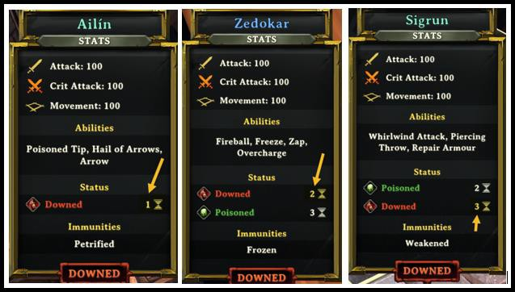

# PieceConfigAdjusted

This is where you would list specifics for a given character piece.

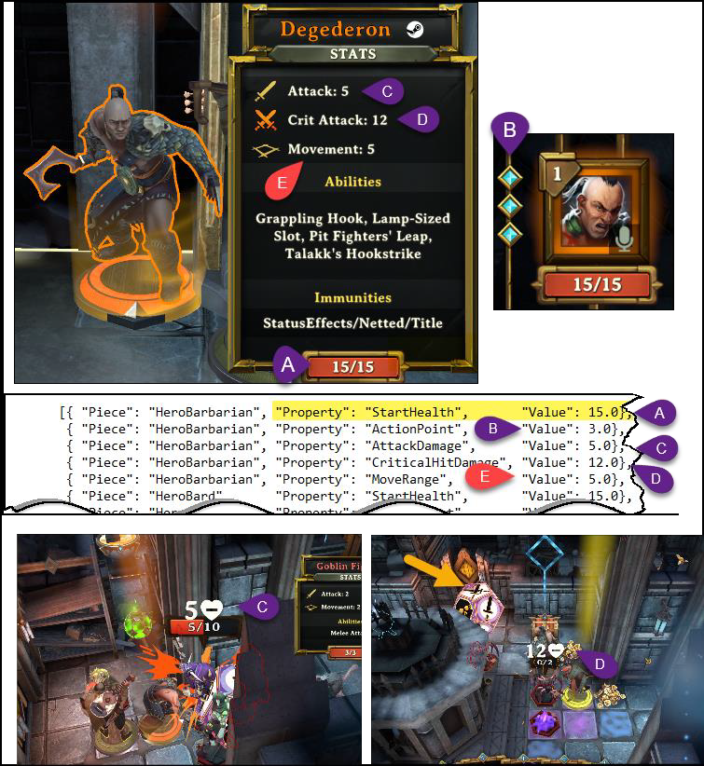

* + - The **starting health** of a character is shown as 15 or a number you configured.
    - The **Action Point** is how many turns the character will have. The default is 2. Having three turns allows the player more time to incorporate a turn strategy.
    - The Attack Damage is the minimal amount of damage (Die shows one sword) that will be dealt to an enemy during a hand-to-hand combat attack.
    - The **Critical Hit Damage** is the maximum amount of damage (Die shows two crossed swords) that will be dealt to an enemy during a hand-to-hand combat attack.
    - The **Move Range** is how many squares the character can move on each character movement.

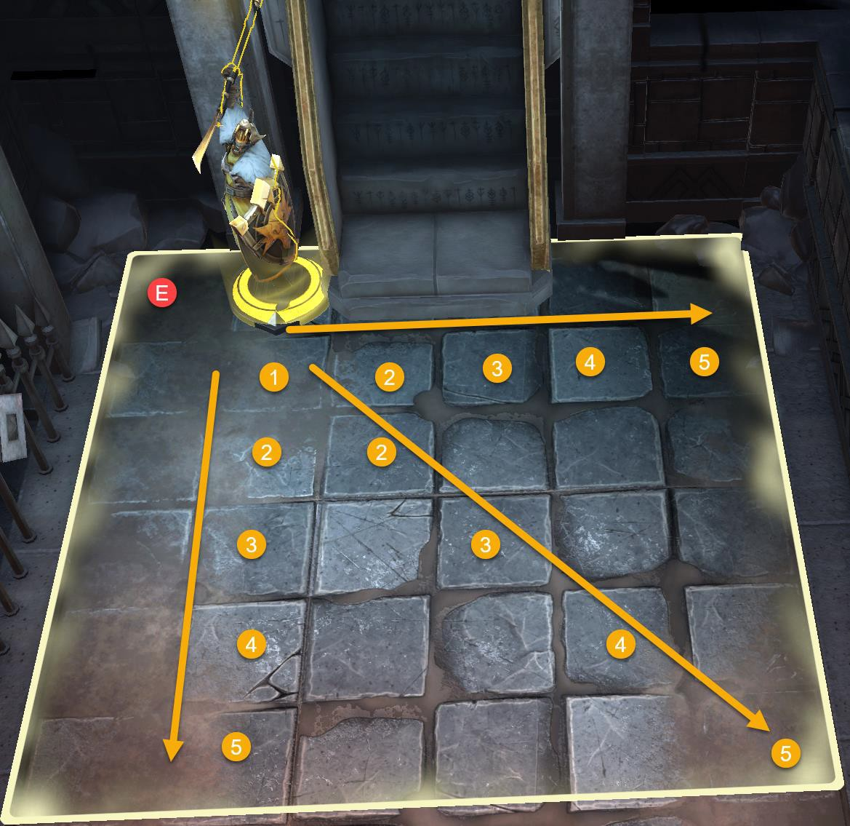

Here are some assorted other game pieces you might find interesting.

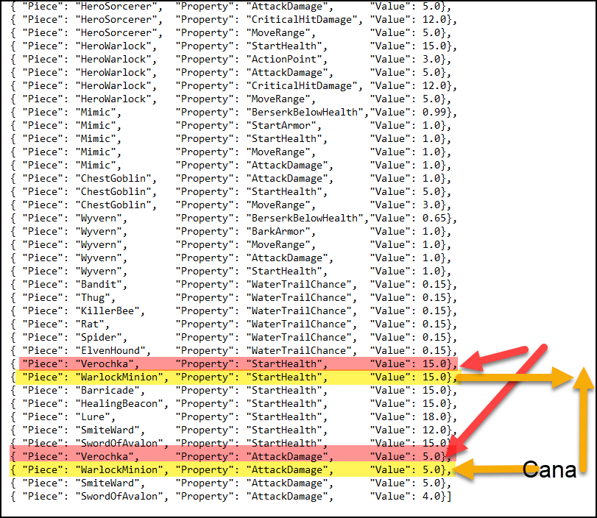

{ "Rule": "PieceConfigAdjusted",

"Config":

[{ "Piece": "HeroBarbarian", "Property": "StartHealth",

{ "Piece": "HeroBarbarian", "Property": "ActionPoint",

"Value": 15.0},

"Value": 3.0},

{ "Piece": "HeroBarbarian", "Property": "AttackDamage", "Value": 5.0},

{ "Piece": "HeroBarbarian", "Property": "CriticalHitDamage", "Value": 12.0},

{ "Piece": "HeroBarbarian", "Property": "MoveRange", "Value": 5.0},

{ "Piece": "HeroBard", "Property": "StartHealth",

{ "Piece": "HeroGuardian", "Property": "StartHealth",

{ "Piece": "HeroHunter", "Property": "StartHealth",

{ "Piece": "HeroRogue", "Property": "StartHealth",

{ "Piece": "HeroSorcerer", "Property": "StartHealth",

{ "Piece": "HeroWarlock", "Property": "StartHealth",

"Value": 15.0},

"Value": 15.0},

"Value": 15.0},

"Value": 15.0},

"Value": 15.0},

"Value": 15.0}, }

Examples above show how to declare different characters.

# Ability Keys

A new update to this grid has been provided. An ability could be a card in a player’s hand. For example, the card Adamant Potion is actually called Invulnerability. Not all cards have pretty pictures or graphics, but they do have some interesting things to offer. If the card isn’t listed it is because we didn’t assess all of them or it was redundant to another card that is noted and referenced.

|  |  |  |  |  |
| --- | --- | --- | --- | --- |
| **Ability Name** | **Real Card Name** | **Card Description** | **Card Displays** | **Comment** |
| AbsorbCorruption | Absorb Wake Corruption | Spend 1 turn absorbing corruption – aborts upon damage | No |  |
| AbsorbMySoul | AbsorbMySoul |  | No |  |
| AcidSpit | Acid Spit | Spits a large glob of acidic slime | No |  |
| AltarHeal | Use Heal | Restores a fair amount of health. | No |  |
| Antidote | Antitoxin | Poison will not affect you…for a while | Yes | Online Reference is reversed |
| ArbalestierArrow | Use HunterArrow | A ranged attack. 1 turn cooldown. | No |  |
| ArbalestierBarrage | Barrage | Unleashes a hail of arrows (3) | Yes |  |
| ArbalestierPoisonedTip | ArbalestierPoisonedTip | Releases a cloud of noxious poison fumes. | No |  |
| Bandage | Use Heal | Restores a fair amount of health. | No |  |
| Banish | Banish | Teleport an enemy out of sight | Yes |  |
| Barrage | Use ArbalestierBarrage | Unleashes a hail of arrows (3) | No |  |
| BeaconOfHealing | Healing Ward | Heals 1 random nearby player every turn | Yes |  |
| BeaconOfSmite | The Behemoth | Belches Fires and thunder at nearby enemies. AOE damage. | Yes |  |
| BlindingLight | Blinding Light | Blinding Light | No |  |
| Blink | Blink | Get in close and personal to deal massive damage | Yes |  |
| BlockAbilities | Hymn of Obstruction | Stop an enemy from using its special abilities | Yes |  |
| Bone | Bone | Throw a juicy bone at your enemies to hurt and taunt them. | Yes |  |
| BossBerserkOnDeath | Boss Berserk On Death |  | No |  |
| BossShockwave | The Grand Rupture |  | No |  |
| CallCompanion | Call Companion | Call a powerful friend from the wild to fight by your side (Verochka) | Yes |  |
| Charge | Charge | Rush forward and knock all enemies out of your path | Yes |  |
| ChargeBarbarian | Use Charge |  |  |  |
| ChargeMove | Charge Move | Rush forward and knock all enemies out of your path | No |  |
| CoinFlip | Use PanicFlip | Instant kill or complete miss. Bosses are immune. | No |  |
| Confuse | ScrollOfCharm |  | Yes |  |
| Corrupt | Corrupt |  | No |  |
| CorruptedDeathExplode | CorruptedDeathExplode |  | No |  |
| CorruptionBomb | CorruptionBomb |  | No |  |
| CorruptOneTurn | Corrupt One Turn |  | No |  |
| CursedDagger | Cursed Dagger | Wounds and weakens your target | Yes |  |
| DamageResistPotion | Alag’s Fighting Spirit | Absorb Alag's spirit and permanently resist 1 HP of damage. | Yes |  |
| DeathBeam | Rift Beam | A beam of energy, several tiles long. | Yes | Works, Artword or description issue |
| DeathDropJavelin | Drop Stolen Loot | When killed, stolen loot is dropped. | No |  |
| **Ability Name** | **Real Card Name** | **Card Description** | **Card Displays** | **Comment** |
| DeathDropJeweledScarab | DeathDropJeweledScarab |  | No |  |
| DeathDropMagicPotion | DeathDropMagicPotion |  | No |  |
| DeathDropVortexDust | DeathDropVortexDust |  | No |  |
| DeathDropWaterBottle | DeathDropWaterBottle |  | No |  |
| DeathDropWoodBone | DeathDropWoodBone |  | No |  |
| DeathFlurry | Regal Burst | A massive attack consisting of smaller strikes. | Yes | Works, Artword or description issue |
| Deflect | Astral Barrier | Will defle6ct incoming spells and projectiles, bouncing back. | Yes |  |
| Detox | Detox | Detox | Yes | Works, Artword or description issue |
| DigRatsNest | Dig Rat’s Nest | Digs a rat’s nest that will continuously spawn rats | Yes |  |
| DiseasedBite | Poisonous Bite | A biting attack which poisons the target. | Yes | Works, Artword or description issue |
| DiseasedBiteKnockback | Diseased Bite Knockback |  | Yes | Works, Artword or description issue |
| DivineLight | Divine Light |  | No |  |
| DrainingKiss | Draining Kiss | Transfer health from an Enemy to an Ally. | No |  |
| DrainLife | Drain Life |  | Yes | Works, Artword or description issue |
| DropChest | Drop Chest | Drops a chest. | No |  |
| EarthShatter | Earth Shatter | Powerful ground pound causing rocks to fall. | No |  |
| Electricity | Thunderbolt | Inflicts damage and causes extra damage. | Yes | Works, Artword or description issue |
| ElvenKingMeleeWhip | King's Bash | A melee attack with knockback | Yes | Works, Artword or description issue |
| ElvenKingShockwaveChargeup | Use Overcharge |  | No |  |
| ElvenSummonerDeflect | Deflect Barrier | Spells and projectiles will bounce back. | No |  |
| EmergencyTeleport | Teleportation | Teleports you to any tile of your choice. | No |  |
| EnemyArrow | Use HunterArrow | A ranged attack. 1 turn cooldown. | No |  |
| EnemyArrowSnipe | Heavy Arrow | Powerful arrow that causes knockback. | No | Actual callout is EnemyArrowSnipe, not EnemyHunterArrowSnipe |
| EnemyBossHandCharge | Rush | Rushes forwards, ploughing the board and causing damage. | Yes | Works, Artword or description issue |
| EnemyBossHandGoToHealingState | EnemyBossHandGoToHealingState |  |  | Did not test |
| EnemyBossHandHeal | EnemyBossHandHeal |  |  | Did not test |
| EnemyBossHandHealSelf | EnemyBossHandHealSelf |  |  | Did not test |
| EnemyBossHandsIntro | EnemyBossHandsIntro |  |  | Did not test |
| EnemyBossHandSmash | EnemyBossHandSmash |  |  | Did not test |
| EnemyBossHandSpawnPiece | EnemyBossHandSpawnPiece |  |  | Did not test |
| EnemyDropStolenGoods | EnemyDropStolenGoods |  |  | Did not test |
| EnemyFireball | EnemyFireball | Shoots an explosive projectile | No |  |
| EnemyFlashbang | Use FlashBang | Blinds nearby enemies for 1 turn | No | Works, Artword or description issue |
| EnemyFrostball | EnemyFrostball |  |  | Did not test |
| EnemyHeal | EnemyHeal |  |  | Did not test |
| EnemyHealOne | EnemyHealOne |  |  | Did not test |
| EnemyHumanHeal | EnemyHumanHeal |  |  | Did not test |
| EnemyInvulnerability | Invulnerability | Makes the receiver invulnerable | Yes | Works, Artword or description issue |
| **Ability Name** | **Real Card Name** | **Card Description** | **Card Displays** | **Comment** |
| EnemyJavelin | EnemyJavelin |  |  | Did not test |
| EnemyKnockbackMelee | EnemyKnockbackMelee |  |  | Did not test |
| EnemyLowerBossHands | EnemyLowerBossHands |  |  | Did not test |
| EnemyMelee | EnemyMelee |  |  | Did not test |
| EnemyMeleeBleed | EnemyMeleeBleed |  |  | Did not test |
| EnemyPikeMeleeAttack | EnemyPikeMeleeAttack |  |  | Did not test |
| EnemyRaiseBossHands | EnemyRaiseBossHands |  |  | Did not test |
| EnemySpawnLeftBossHand | EnemySpawnLeftBossHand |  |  | Did not test |
| EnemySpawnRightBossHand | EnemySpawnRightBossHand |  |  | Did not test |
| EnemyStealCard | Steal Card | Steals cards upon attack. | No |  |
| EnemyStealGold | Steal Gold | Steals gold upon attack. | No |  |
| EnemyTelegraphBossHandCharge | EnemyTelegraphBossHandCharge |  |  | Did not test |
| EnemyTelegraphBossHandSmash | EnemyTelegraphBossHandSmash |  |  | Did not test |
| EnemyTownBossHeal | EnemyTownBossHeal |  |  | Did not test |
| EnemyTurretDamageProjectile | EnemyTurretDamageProjectile |  |  | Did not test |
| EnemyWoodBone | Wooden Bone | Makes Root Hounds loyal, or throw it in water to spawn one. | No |  |
| EnergyPotion | Energy Potion |  | No |  |
| Enrage | Enrage |  | No |  |
| ExplodingGasLamp | Launch Gas Lamp | Launch a gas lamp with your hook. Burst on impact. | Yes |  |
| ExplodingIceLamp | Launch Ice Lamp | Launch a ice lamp with your hook. Burst on impact. | Yes |  |
| ExplodingLampPlaceholder | A blank card used to store retrieved lamps |  | Yes |  |
| ExplodingOilLamp | Launch Oil Lamp | Launch an oil lamp with your hook. Busts on impact. | Yes |  |
| ExplodingVortexLamp | Launch Vortex Lamp | Launch an vortex lamp with your hook. Busts on impact. | Yes |  |
| ExplodingWaterLamp | Launch Water Lamp | Launch an water lamp with your hook. Busts on impact. | Yes |  |
| Explosion | Explosion |  | No |  |
| ExplosiveOrb | Explosive Orb | Note -Appears to lay a big square of damage | Yes | Works, Artword or description issue |
| Exterminate | Hail Of Arrows | Blanket an area with deadly projectiles. | Yes |  |
| ExtraActionPotion | Focus (Potion) | Gain 1 Extra point for 3 Turns | Yes |  |
| EyeOfAvalon | Detect Enemies | A beacon that temporarily reveals all enemies in its sight. | Yes |  |
| Fireball | Fireball | Incinerates the center and burns the surrounding area. | Yes |  |
| FlashBang | Flash Bomb | Blinds nearby enemies for 1 turn | Yes |  |
| FreeAP | OneMoreThing | Lets you perform one additional action. | Yes |  |
| Freeze | Freeze | Freeze your enemies solid with this icy spell. | yes |  |
| FretsOfFire | Frets Of Fire | Note - Large square damages enemy, not player | Yes | Works, Artword or description issue |
| GasLamp | Gas Lamp | Place a gas lamp. Gas is poisonous… | Yes |  |
| GoblinBruteCharge | GoblinBruteCharge |  | No |  |
| God | God |  |  |  |
| GodsFury | Heavens Fury | Cause the sky to come crashing down. | Yes |  |
| Grab | Pull | Pulls an enemy close | No | Works, Artword or description issue |
| **Ability Name** | **Real Card Name** | **Card Description** | **Card Displays** | **Comment** |
| Grapple | Grappling Hook | Pulls foes and objects towards you or travel by hook. | Yes |  |
| GrapplingPush | Barbaric Chainwhip | Use your hooks's chain to whip enemies away. | Yes |  |
| GrapplingSmash | Talakk’s Hookstrike | An old technique that deals high damage and drains health. | Yes |  |
| GrapplingTotem | The Leviathan | Mechanical device that pulls enemies close. | Yes |  |
| GrapplingTotemHook | Leviathan's Hooks | Will disperse hooks that pull enemies in. | Yes |  |
| GuidingLight | Guiding Light | Summon a bright orb that shows the way forward | Yes |  |
| Heal | Healing Potion | Restores a fair amount of health. | Yes |  |
| HealingLight | Healing Light |  | No |  |
| HealingPowder | Healing Powder |  | No |  |
| HolyWater | HolyWater |  | No |  |
| HunterArrow | Arrow | A ranged attack. 1 turn cooldown. | Yes |  |
| HymnOfBattle | Use Hymn of Obstruction |  | Yes |  |
| HymnOfHealing | Hymn Of Healing |  | No | Works, Artword or description issue |
| HymnOfIntimidation | Hymn Of Intimidation |  | No | Works, Artword or description issue |
| IceExplosion | IceExplosion | No description | Yes | Works, Artword or description issue |
| IceLamp | Ice Lamp | Place an ice lamp. Ice is freezing… | Yes |  |
| Implode | Consuming Vortex | Cause an enemy at half HP to implode. Bosses are immune. | Yes |  |
| Implosion | Vortex | Manifest a vortex which pulls enemies toward it. | Yes |  |
| ImplosionExplosionRain | Vortex Storm | Drops several vortexes from above, causing damage. | Yes | Works, Artword or description issue |
| InvisibilityPotion | Potion of Invisibility | Drink it, and become invisible for awhile. | Yes |  |
| Invulnerability | [AdamantPotion](https://demeo.fandom.com/wiki/Adamant_Potion) | Makes you invulnerable for three turns | Yes |  |
| Javelin | SigataurianJavelin | A mighty weapon used by Sigataurs…hard to come by. | Yes |  |
| LastCrusade | LastCrusade |  | No |  |
| LaySpiderEgg | Lay Egg | Lay a spider egg that hatches when destroyed. | Yes |  |
| Leap | Leap | Jumps to a tile - shock with knockback upon landing. | Yes |  |
| LeapHeavy | Pit Fighters' Leap | Leap to attack or overcome obstacles. | Yes |  |
| LeechMelee | LeechMelee | Steals health from the attacked unit. | Yes | Works, Artword or description issue |
| LetItRain | Downpour | Heals Rootling’s and turn Root Vines into Root Creepers | Yes | Works, Artword or description issue |
| LightningBolt | Lightning Bolt | Unleashes a magic bolt of lightning. | Yes |  |
| LongRangeSpearPoke | Spear Thrust | A long-ranged melee attack that knocks players back. | Yes | Works, Artword or description issue |
| LuckPotion | Luck Potion |  | Yes |  |
| MagicMissile | Master's Call | Fire a magical projectile and instruct Cana what to do. | Yes |  |
| MagicPotion | Magic Potion | Increases magical damage by +1 | Yes |  |
| MagicShield | Magic Shield | Reduce damage on any attack by half for 3 turns. | Yes |  |
| MagicWall | Magic Barrier | Manifest a blocking wall 3 tiles wide. | Yes |  |
| MarkOfAvalon | Hunters Mark | A marked enemy takes more damage and is always visible. | Yes |  |
| MarkOfVerga | Varga's Retribution | Drain foes to amass bonus damage for future attacks. | Yes |  |
| **Ability Name** | **Real Card Name** | **Card Description** | **Card Displays** | **Comment** |
| MarkTargetTile | Mark Target |  | No |  |
| MiniBarricade | Barricade | Place a barricade 1 tile wide | Yes |  |
| MinionCharge | Feral Charge | Command Cana to charge, attacking all in her path. | Yes |  |
| MinionMelee | MinionMelee |  |  |  |
| MinionRespawnInitiator | MinionRespawnInitiator |  |  |  |
| MissileSwarm | Astral Strike | A magical strike, firing a flurry of projectiles at foes. | Yes |  |
| MonsterBait | Lure | Place a decoy to attract curious enemies. | Yes |  |
| NaturesCall | Beast Whisperer | Summon lesser beasts to fight for you | Yes |  |
| Net | Net |  |  |  |
| NotesOfConfusion | Piercing Voice |  |  |  |
| OilLamp | Oil Lamp | Place an oil lamp. Oil is flammable… | Yes |  |
| Overcharge | Use Overload |  | No |  |
| Overload | Overcharge | Overcharge yourself with electric energy. | Yes |  |
| PanicFlip | Coin Flip | Instant kill or complete miss. Bosses are immune. | Yes |  |
| PanicPowderArrow | Panic Powder | Causes a single enemy to panic. | Yes |  |
| Petrify | Petrify | Turns you to stone. | Yes | Works, Artword or description issue |
| PiercingSpear | Piercing Throw | Damage all enemies in a straight line with this throw. | Yes |  |
| PlayerLeap | Pit Fighters' Leap | Leap to attack or overcome obstacles. | Yes |  |
| PlayerMelee | Player Melee |  | No | Works, Artword or description issue |
| PoisonedTip | Poisoned Tip | Shoot a high-damage arrow with a poisoning effect. | Yes |  |
| PoisonGas | Poison Gas |  | No | Works, Artword or description issue |
| PoisonGasGrenade | Poison Bomb | Releases a cloud of noxious poison fumes. | Yes | Online Reference is reversed |
| Portal | Portal of Zozh | Place an exit portal anywhere, then use the entrance portal. | Yes |  |
| ProximityMine | BoobyTrap | A trap that explodes on enemy contact. | Yes |  |
| PVPBarricade | PVPBarricade |  |  | Did not test |
| PVPBeastWhisperer | PVPBeastWhisperer |  |  | Did not test |
| PVPBlink | PVPBlink |  |  | Did not test |
| PVPConfuse | PVPScrollOfCharm |  |  | Did not test |
| PVPCursedDagger | PVPCursedDagger |  |  | Did not test |
| PVPDamageResistPotion | PVPDamageResistPotion |  |  | Did not test |
| PVPGasLamp | PVPGasLamp |  |  | Did not test |
| PVPHuntersMark | PVPHuntersMark |  |  | Did not test |
| PVPIceLamp | PVPIceLamp |  |  | Did not test |
| PVPOilLamp | PVPOilLamp |  |  | Did not test |
| PvPReplenishArmor | PvPReplenishArmor |  |  | Did not test |
| PVPStealth | PVPStealth |  |  | Did not test |
| PVPVortexLamp | PVPVortexLamp |  |  | Did not test |
| RaiseRoots | Root Raiser | Makes Root Vines rise from the ground. | Yes | Works, Artword or description issue |
| Rally | Rally |  |  | Works, Artword or description issue |
| **Ability Name** | **Real Card Name** | **Card Description** | **Card Displays** | **Comment** |
| RalmasRevenge | Ralma's Revenge | Invoke Ralma… | Yes |  |
| RatFrenzy | Vermin Frenzy | Coordinate a rat attack, targeting one Champion. | Yes |  |
| RatKingRatBomb | Rat Bomb | Cluster of vermin that inflicts damage and spawns rats | Yes | Works, Artword or description issue |
| RatsNest | Dig Rat's Nest | Digs a rat's nest that will continuously spawn rats. | Yes |  |
| RatWhisperer | Beast Whisperer | Summon lesser beasts to fight for you | Yes |  |
| Regroup | Regroup | Make your teammates join you…wherever you are. | Yes |  |
| Rejuvenation | Rejuvenation | Full heals all party members. | Yes |  |
| ReleaseEnergy | ReleaseEnergy |  |  |  |
| RemoveCorruption | RemoveCorruption |  |  |  |
| RemoveScorpionFrenzy | RemoveScorpionFrenzy |  |  |  |
| ReplenishArmor | Repair Armour | Replenish some of your armour. 1 Turn cooldown. | Yes |  |
| ReplenishBarkArmor | Bark Armour | Protective armour that limits the damage |  | Works, Artword or description issue |
| RevealPath | Reveal Path | Reveals the key holder and dungeon exit | Yes |  |
| Revive | Revive |  |  | Did not test |
| RootWall | Root Wall |  |  | Did not test |
| ScabRat | Spawn Scab Rat | Make a friend! | Yes |  |
| ScarePowder | Panic Powder Arrow | Panic Powder Arrow | No |  |
| ScrollCharm | Use Confuse |  | No |  |
| ScrollElectricity | Scroll of Lightning | Blast your enemies with magical lightning. | Yes |  |
| ScrollTsunami | Scroll of Tsunami | Unleash a magical, destructive tsunami. | Yes |  |
| SecondWind | Second Wind |  | No |  |
| ShatteringVoice | Shattering Voice |  | No |  |
| Shockwave | Shockwave | Pounds the ground, creating a powerful shockwave. | Yes |  |
| Shuffle | Shuffle | Swap place with all players in line of sight. | Yes | Works, Artword or description issue |
| SnakeBossLongRange | SnakeBossLongRange |  |  | Did not test |
| SnakeBossMeteorRain | Rain of Ends | Rain of ends | Yes |  |
| SnakeBossOneshot | SnakeBossOneshot |  |  | Did not test |
| SnakeBossShortRange | SnakeBossShortRange |  |  | Did not test |
| SodiumHydroxide | Bottle Of Lye | This powerful solvent can cause poisonous chemical burns. | Yes |  |
| SongOfRecovery | Song Of Recovery | Make allies recover health over time. Cleanses all ailments. | Yes |  |
| SongOfResilience | Song Of Resilience | Summons magical armour that protect your allies. | Yes |  |
| SpawnBossMinions | Summon Cultists | Summons three devoted Allies | Yes |  |
| spawncorruptionnode | Planting Wake | Spreads corruption across the ground | Yes | Works, Artword or description issue |
| SpawnCultists | Summon Cultists | Summons three devoted Allies. (not the same as spawnbossminions) | Yes | Works, Artword or description issue |
| SpawnElvenSummonerDefenders | Summon Defense Rifts | Will spawn several Summoning Rifts as a defense. | Yes | Works, Artword or description issue |
| SpawnEnemyTurret | Spawn Turret | Places a fixed defense that fires at players every turn | Yes | Works, Artword or description issue |
| SpawnExplodingBarrel | SpawnExplodingBarrel | Make a friend! | Yes | Works, Artword or description issue |

|  |  |  |  |  |
| --- | --- | --- | --- | --- |
| **Ability Name** | **Real Card Name** | **Card Description** | **Card Displays** | **Comment** |
| SpawnGiantRat | Spawn Giant Rat | Make a friend! | Yes | Works, Artword or description issue |
| SpawnGiantSlime | Spawn Giant Slime | Make a friend! | Yes | Works, Artword or description issue |
| SpawnGoblinBrute | Spawn Goblin Brute | Make a friend! | Yes | Works, Artword or description issue |
| SpawnGoblinRanger | Spawn Goblin Ranger | Make a friend! | Yes | Works, Artword or description issue |
| SpawnGoldPile | SpawnGoldPile |  |  | Did not test |
| SpawnGreaterMonster | SummonGreaterMonster |  |  | Did not test |
| SpawnJeweledScarab | Jeweled Scarab | A Jewelled Scarab, highly coveted and valuable. | Yes | Works, Artword or description issue |
| SpawnLargeSpider | SpawnLargeSpider |  |  | Did not test |
| SpawnLesserMonster | SummonLesserMonster |  |  | Did not test |
| SpawnMarauder | Spawn Marauder | Make a friend! | Yes |  |
| SpawnMediumMonster | SummonMediumMonster |  |  | Did not test |
| SpawnMoreUnseenOnDeath | Summon Cultists | Summons three devoted allies | Yes | Works, Artword or description issue |
| SpawnMushrooms | Spawn Fungus Growth | Spore fungus spawning | Yes | Works, Artword or description issue |
| SpawnRandomLamp | Spawn Random Lamp |  | Yes | Works, Artword or description issue |
| SpawnRat | Spawn Rats | Spawns a number of rats | Yes | Works, Artword or description issue |
| SpawnScarabSandPile | Spawn Scarab SandPile |  | Yes | Works, Artword or description issue |
| SpawnSlime | Spawn Slime | Spawns a small slime | Yes |  |
| SpawnSnakeBossAgain | SpawnSnakeBossAgain |  |  |  |
| SpawnSnakeTailBossAgain | SpawnSnakeTailBossAgain |  |  |  |
| SpawnSpiderlings | Spawn Spiderlings | Will spawn spiderlings if destroyed | Yes | Works, Artword or description issue |
| SpawnSummoningRiftGreater | Summon Greater Rift | Will spawn a greater summoning rift | Yes | Works, Artword or description issue |
| SpawnSummoningRiftLesser | Summon Minor Rift | Will spawn a miner summoning rift | Yes |  |
| SpawnSummoningRiftMedium | SpawnSummoningMediumRift | Will spawn a summoning rift | Yes |  |
| SpawnTombstone | Spawn Tombstone | Note - Drops a tombstone | Yes |  |
| Speed | Swiftness Potion | Increases movement range by +1 | Yes |  |
| SpellPower | Power Potion | Note - Cast on Character | Yes |  |
| SpiderWebshot | Webshot | Shoots a spider web that will entangle the target | Yes | Works, Artword or description issue |
| SplittingArrow | SplittingArrow |  |  | Did not test |
| Stealth | Sneak | Lets you move about unseen. No replensh while stealthed. | Yes |  |
| Strength | Strength Potion | Increases physical damage by +1 | yes |  |
| StrengthenCourage | Courage Shanty | Strengthen the courage of an ally in 3 phases. | Yes |  |
| StrengthenMinion | Riftwalk | Summons enemies. | Yes | Works, Artword or description issue |
| SummonElemental | Summon Elemental | Summons a powerful elemental to fight for you. | Yes |  |
| SummoningRiftFusion | Rift Fusion | Fuse with another rift. | No |  |
| SummonMinion | Riftwalk | Summons enemies. | Yes | Works, Artword or description issue |
| SwordOfAvalon | Repeating Ballista | A repeating ballista which shoots 3 bolts every turn. | Yes |  |
| SyncEmerge | Synchronized Emerge | As a Scorpion emerges, others within range will follow. | Yes | Online reference missing |
| **Ability Name** | **Real Card Name** | **Card Description** | **Card Displays** | **Comment** |
| TauntingScream | Howl of the Ancients | A scream so strong it wekens your enemies. | Yes |  |
| Telekinesis | Telekinesis |  | No |  |
| TelekineticBurst | Telekinetic Push | A massive push, causing knockback and damage. | Yes |  |
| Teleport | Teleportation | Teleports you to any tile of your choice. | Yes | Online Reference is reversed |
| TeleportEnemy | Teleport Ally | Teleports an ally closer to the threat | Yes |  |
| TeleportLamp | Lamp Teleport | Pick up and drops lamps on the player using telekinesis | No |  |
| TeleportRotateSit | TeleportRotateSit | Note - Not sure what this does | Yes | Works, Artword or description issue |
| TeleportToBattle | TeleportToBattle | Hurricane Route | Yes |  |
| ThornPowder | Thorn Arrow | Ranged attack that causes thorns | Yes |  |
| TileBlock | TileBlock |  |  | Did not test |
| TileUnblock | TileUnblock |  |  | Did not test |
| TorchLight | Torch | Improve your vision or light up an area. | Yes |  |
| Tornado | Hurricane Anthem | Summon a chaotic hurricane that moves at random. | Yes |  |
| TornadoCharge | TornadoCharge |  |  |  |
| TownBossAddXWalls | TownBossAddXWalls |  |  |  |
| TownBossWallAbility | TownBossWallAbility |  |  |  |
| Tsunami | Tsunami |  |  |  |
| TurretDamageProjectile | TurretDamageProjectile |  |  |  |
| TurretHealProjectile | Healing Orb | An orb that can heal damage. | Yes | Works, Artword or description issue |
| TurretHighDamageProjectile | Cannonball | Shoots an explosive cannonball | Yes |  |
| VenomousSting | VenomousSting |  |  |  |
| VerminFrenzy | Vermin Frenzy | Coordinate a rat attack, targeting one Champion. | Yes |  |
| VialOfFireImmunity | Fire Resistance | Resist all fire damage…for a while | Yes |  |
| VialOfIceImmunity | Ice Resistance | Resist all ice damage…for a while | Yes |  |
| VigorPotion | Vitality Potion | Increase your max health by +3 | Yes |  |
| VortexDust | Vortex Dust | Manifest a minor vortex which pulls all enemies towards it. | Yes |  |
| VortexLamp | Vortex Lamp | Place a vortex lamp. Vortexes are strong… | Yes |  |
| WallDestroy | Wall Destroy |  | Yes | Works, Artword or description issue |
| WarCry | War Cry | Causes enemies to flee in panic. | Yes |  |
| WaterBottle | Water Flask | Drink to heal or throw it to drench a target or the ground | Yes |  |
| WaterDive | Puddle Teleport | Teleports from one wet tile to another | No |  |
| WaterExplosion | Water Explosion | No Description | No |  |
| WaterLamp | Water Lamp | Place a water lamp. Water is wet… | Yes |  |
| WaterSplashCorruption | Splash Recovery | Heals Root Hounds and might cause tiles to get wet! | No |  |
| Weaken | Weaken | A debuff that causes the victim to become weaker. | No |  |
| WeakeningShout | Weakening Shout | No Description - | No |  |
| WebBomb | Web Bomb | Explodes in a sticky mess and entangles multiple foes. | Yes |  |
| Whip | Root Whip | Players too close to mother Cy will be thrashed | No |  |

|  |  |  |  |  |
| --- | --- | --- | --- | --- |
| **Ability Name** | **Real Card Name** | **Card Description** | **Card Displays** | **Comment** |
| WhipSmall | Root Whip | Players too close to mother Cy will be thrashed | Yes | Works, Artword or description issue |
| WhirlWind | Whirlwind Attack | A spinning sweep that damages all adjacent enemies. | Yes |  |
| WizardBossFocusFire | Focus Fire | Synmchronized doppelganger attack | No |  |
| WizardBossShowHint | WizardBossShowHint |  | No |  |
| WizardBossShuffle | Doppelganger Shuffle | Shuffles doppelgangers around. | No |  |
| WizardBossSpawnDoppelgangers | Spawn Doppelgangers | Spawning Umbal doppelgangers | No |  |
| WizardBossSqueeze | Squeeze | A doppelganger squeeze attack, pinching a player | No |  |
| WizardBossZap | Salvo Corrupto | A magical attack stemming from Rackarn's corruption. | Yes |  |
| WoodBone | Wooden Bone | Makes Root Hounds loyal, or throw it in water to spawn one. | Yes |  |
| Zap | Zap | Damages and stuns your foe. 1 turn cooldown. | Yes |  |
|  | Vortex Storm |  |  |  |

# Behaviors

|  |  |  |
| --- | --- | --- |
| * AbilityBuildUp * AbsorbCorruptionBehaviour * AttackAndRetreat * AttackAndRetreatToOwner * AttackPlayer * AttackRandomTile * AvoidElvenKingAttacks * BurrowBehaviour * CastOnSelf * CastOnTeam * ChargeMove * ChargeToSafety * Charging * ConfusedTeleportEnemy * CorruptionBehaviour * Downed * EarthShatter * ElvenSummonerBehaviour * ExplosiveOrb * Flee * FleeAndHeal * FleeToFOW * FleeToFOWAndBurrow * FollowCloseToPlayerMeleeAttacker * FollowPlayerMeleeAttacker * FollowPlayerRangedAttacker * GuardPost * GuardTile * GuidingLightBehaviour * Heal * HealAOE * HealFromFOW * HostileTowardsEntangled | * Invalid * Javelin * KeepDistance * LeechMelee * MadElvenKingHandBehaviour * MotherCyBossBehaviour * Patrol * PikeAttack * RangedAttackHighPrio * RangedSpellCaster * ReptileArcherBehaviour * RootHoundMasterBehaviour * RootLordBehaviour * RootWall * SandPileBehaviour * SlimeFusion * SnakeBossBehaviour * SpawnBuildUp * SpawnPiece * StationaryAbilityBehaviour * StrengthenNodeBehaviour * SummoningRiftFusionBehaviour * SupportUnit * Swarm * TornadoCharge * TownBossBehaviour * TsunamiRangedAttackIfYouSeeThisAfterForestReleaseTellTomasToFixThisAndIfYouAreAModderIgnoreThis * Turret * UseBuildUpAbilityBehaviour * VerminFrenzy * VortexAbilityBehaviour | * WaterDiveRetreat * WizardBossBehaviour |

# Board Pieces

|  |  |  |
| --- | --- | --- |
| * AltarOfBlessing * Bandit * Barricade * BeggarTown * BigBoiMutant * BossTown * BotBoxHead * Brookmare * Cavetroll * CavetrollBoss * ChestGoblin * CultMemberElder * Door1x1Tile * Door1x2Tile * Door1x3Tile * DruidArcher * DruidHoundMaster * EarthElemental * ElvenArcher * ElvenCultist * ElvenHound * ElvenMarauder * ElvenMystic * ElvenPriest * ElvenQueen * ElvenSkirmisher * ElvenSpearman * ElvenSummoner * EmptySandPile * EndLevelChest * EnemyTurret * EyeOfAvalon | * FireElemental * ForestEndLevelChest * GasLamp * GeneralRonthian * GiantSlime * GiantSpider * GoblinChieftan * GoblinFighter * GoblinMadUn * GoblinRanger * GoldPile * GoldSandPile * Gorgon * GrapplingTotem * GuidingLight * HealingBeacon * HeroBarbarian * HeroBard * HeroBot * HeroGuardian * HeroHunter * HeroRogue * HeroSorcerer * HeroWarlock * IceElemental * IceLamp * JeweledScarab * KillerBee * KillerBeeHive * LargeCorruption * LevelEntrance * LevelEntranceDesert | * LevelEntranceForestPortal * LevelEntranceInvisible * LevelEntranceTown * LevelExit * LevelExitDesert * LevelExitForestPortal * LevelExitInvisible * LevelExitTown * LocustSwarmCloud * Lure * MadElvenKingHandLeft * MadElvenKingHandRight * MagicWall * MerchantDesert * Mimic * MotherCy * None * OilLamp * OnboardingRat * PoisonousRat * Portal * PotionStand * ProximityMine * Ralma * Rat * RatKing * RatNest * ReptileArcher * ReptileMutantWizard * RootBeast * RootCreeper * RootGolem |

|  |  |  |
| --- | --- | --- |
| * RootHound * RootLord * RootMage * RootVine * SandScorpion * ScabRat * ScarabSandPile * ScorpionSandPile * Seeker * SellswordArbalestier * SellswordArbalestierActive * SellswordMelee * SellswordMeleeActive * ServantOfAlfaragh * Sigataur * SilentSentinel * Slimeling * SmallCorruption * SmiteWard * SnakeBoss * SnakeTailBoss * Spider * SpiderEgg * SporeFungus * SubHeroRatOverseer * SummoningRiftBig * SummoningRiftMedium * SummoningRiftSmall * SwordOfAvalon | * TheUnheard * TheUnseen * TheUnspoken * Thug * Tombstone * Torch * Tornado * TownBreakableWall * TownEndLevelChestInvisible * TreasureChest * TreasureChestGold * Verochka * VillagerFemaleTown * VillagerMaleTown * VortexLamp * WarlockMinion (Cana) * WaterBottleChest * WaterSplash -> (EnemySplashWater) * WaterLamp * WizardBoss * Wyvern |  |

# Effect State Types

|  |  |  |
| --- | --- | --- |
| * AIDirectorAmbientEnemy * AbilityBlocked * AbilityBuildUp * ActionPreventedInfinite * Aggroed * Antidote * BattleSong * Berserk * BerserkHandsActivated * Bleeding1 * Bleeding2 * Bleeding3 * Blinded * BossHandChargeState * BossHandHealState * BossHandIdleState * BossHandOnGroundState * BossHandSmashState * BossHandSpawnableTarget * BossHandsDeathCooldown * CanaHunting * CanaStay * ChargeUp * Charging * Confused * ConfusedPermanentVisualOnly * CorruptedRage * Corruption * Courageous * DefeatNearbyEnemiesExit * DefeatNearbyEnemy * Deflect * DeflectionBarrier * Discharge * Diseased * Disoriented | * Downed * ElvenHand1RespawnCooldown * ElvenHand2RespawnCooldown * ElvenHand3RespawnCooldown * ElvenHand4RespawnCooldown * ElvenSummonerCycleCounter * ElvenSummonerEscapeTimer * Enraged * ExposeEnergy * ExtraAction * ExtraEnergy * Fearless * FireImmunity * Flying * ForestEndLevelChestHalfOpened * Frenzy * FrenzyTarget * Deflect * DeflectionBarrier * Discharge * Diseased * Disoriented * Downed * ElvenHand1RespawnCooldown * ElvenHand2RespawnCooldown * ElvenHand3RespawnCooldown * ElvenHand4RespawnCooldown * ElvenSummonerCycleCounter * ElvenSummonerEscapeTimer * Enraged * ExposeEnergy * ExtraAction * ExtraEnergy * Fearless * FireImmunity * Flying | * ForestEndLevelChestHalfOpened * Frenzy * FrenzyTarget * Frozen * God * GrappledByTotem * HandsActivated * HasExplodingLamp * Heal * HealingPowder * HealingSong * Heroic * IceImmunity * Invisibility * Invisible * Invulnerable1 * Invulnerable3 * It * Key * KeyEndChest * KingShockwaveCharge * Locked * Luck * MagicShield * MagicShield1 * MarkOfAvalon * MarkOfVerga * MinionLevel1 * MinionLevel2 * MinionLevel3 * MinionLevelBoost * MinionSummoned * Netted * Overcharge * PVPConfused * PVPHuntersMark |

|  |  |  |
| --- | --- | --- |
| * PVPStealthed * Panic * Petrified * PlayerBerserk * PlayerPanic * Portal * Rally * Recovery * Resilience * RespawnCounter * RessurectAfterTurns * Revealed * ScorpionFrenzyTarget * SelfDestruct * SpawnBuildUp * SpawnedFromSummoningRift * SpellPower * Stealthed * StolenCard * StolenGold * StrengthInNumbers * StunSelf * Stunned * SuddenDeath * SummoningRiftSpawn * SummoningSickness * Tangled * TangledEnemy * Thorns * Torch * TorchPlayer | * TownBossEngaging * TownBossHP20 * TownBossHP40 * TownBossHP50 * TownBossHP60 * TownBossHP80 * TownBossThrone * UnitLeader * UnitSpawnCounter * Untargetable * UsedHookThisTurn * Venom * Weaken1Turn * Weaken2Turns * Wet * WizardDoppelganger |  |

# Piece Types

|  |  |  |
| --- | --- | --- |
| * Beggar * Boss * Bot * Brittle * Canine * Corruption * Creature * DesertCreature * Downable * EndLevelChest * ExplodingLamp * Flying * ForestCreature * GiantSlime * Goblin * GrabbableInteractable * HasMinionPowder * IgnoreWhenCharmed * Immovable * ImmuneToMarkOfVarga * Interactable * LevelEntrance * LevelExit * LevelMerchant * Lure * MadElvenKingHand * MagicWall * MiniBarricade * NPC * NonAttackable * NonGrabbable * NonTeleportable | * Pickup * Player * Portal * PreserveBetweenLevels * Prop * ProximityMine * Rat * RatNest * RefillPotionsOnLevelTransition * Reptile * Rootling * Sellsword * ShowHealthbar * ShowNameplate * SmallSlime * SummoningRift * Thief * TooHeavyToGrapple * UNUSED_REMOVE_ME * Undefined * UpdateFogOfWar * UseLevelSequenceVisionRange * ValidCorruptionTarget * Villager |  |

# Cards (Pictures of player cards)

|  |  |  |  |  |
| --- | --- | --- | --- | --- |
| P1330C1T15#yIS1 | P1331C2T15#yIS1 |  | P1333C4T15#yIS1 | P1334C5T15#yIS1 |
| P1336C6T15#yIS1 |  |  | P1339C9T15#yIS1 | P1340C10T15#yIS1 |
| P1342C11T15#yIS1 |  | P1344C13T15#yIS1 | P1345C14T15#yIS1 | P1346C15T15#yIS1 |

|  |  |  |  |  |
| --- | --- | --- | --- | --- |
| P1348C16T15#yIS1 |  |  |  |  |
|  |  |  |  |  |
|  | P1361C27T15#yIS1 | P1362C28T15#yIS1 | P1363C29T15#yIS1 | P1364C30T15#yIS1 |

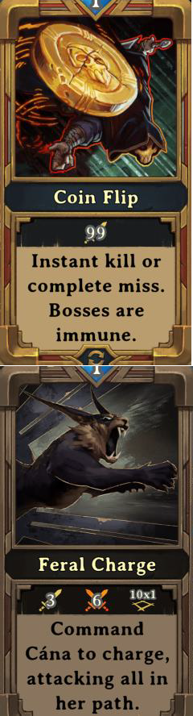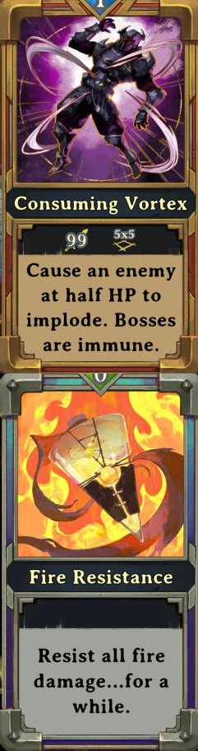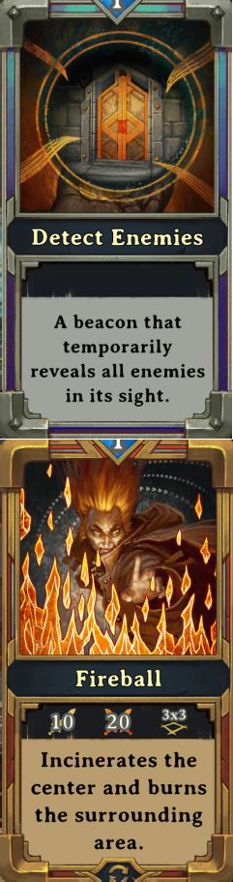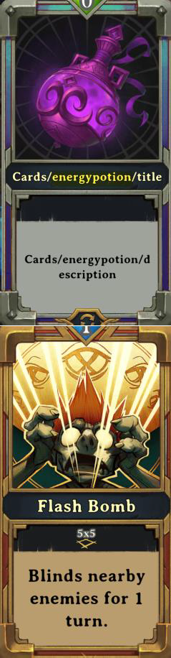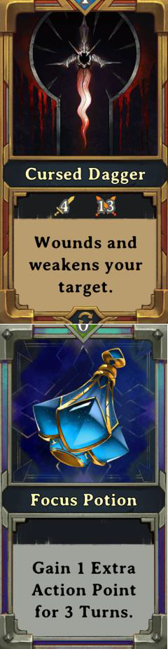

|  |  |  |  |  |
| --- | --- | --- | --- | --- |
| P1366C31T15#yIS1 | P1367C32T15#yIS1 |  | P1369C34T15#yIS1 | P1370C35T15#yIS1 |
| P1372C36T15#yIS1 | P1373C37T15#yIS1 |  | P1375C39T15#yIS1 | P1376C40T15#yIS1 |
| P1378C41T15#yIS1 | P1379C42T15#yIS1 | P1380C43T15#yIS1 | P1381C44T15#yIS1 | P1382C45T15#yIS1 |

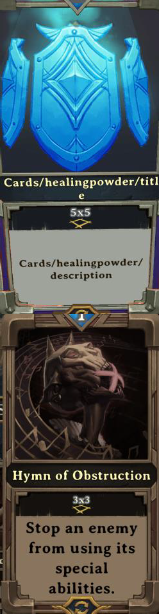

|  |  |  |  |  |
| --- | --- | --- | --- | --- |
| P1384C46T15#yIS1 | P1385C47T15#yIS1 |  | P1387C49T15#yIS1 | P1388C50T15#yIS1 |
|  | P1391C52T15#yIS1 |  | P1393C54T15#yIS1 | P1394C55T15#yIS1 |
|  | P1397C57T15#yIS1 | P1398C58T15#yIS1 | P1399C59T15#yIS1 | P1400C60T15#yIS1 |

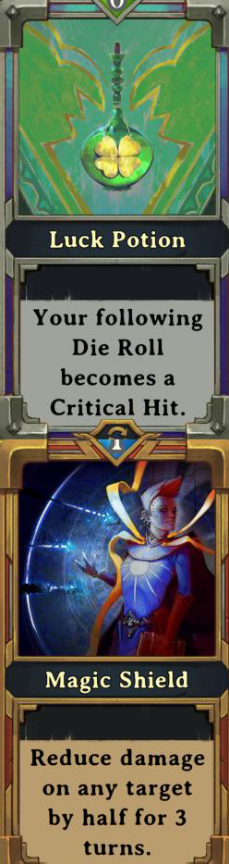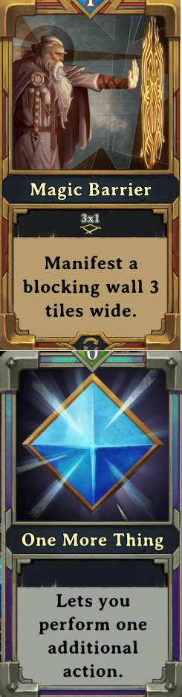

|  |  |  |  |  |
| --- | --- | --- | --- | --- |
| P1402C61T15#yIS1 |  | P1404C63T15#yIS1 | P1405C64T15#yIS1 | P1406C65T15#yIS1 |
| P1408C66T15#yIS1 |  | P1410C68T15#yIS1 | P1411C69T15#yIS1 | P1412C70T15#yIS1 |
| P1414C71T15#yIS1 | P1415C72T15#yIS1 | P1416C73T15#yIS1 | P1417C74T15#yIS1 | P1418C75T15#yIS1 |

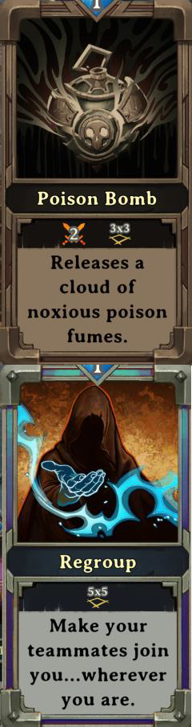

|  |  |  |  |  |
| --- | --- | --- | --- | --- |
| P1420C76T15#yIS1 | P1421C77T15#yIS1 | P1422C78T15#yIS1 |  |  |
| P1426C81T15#yIS1 | P1427C82T15#yIS1 | P1428C83T15#yIS1 |  |  |
| P1432C86T15#yIS1 | P1433C87T15#yIS1 | P1434C88T15#yIS1 | P1435C89T15#yIS1 | P1436C90T15#yIS1 |

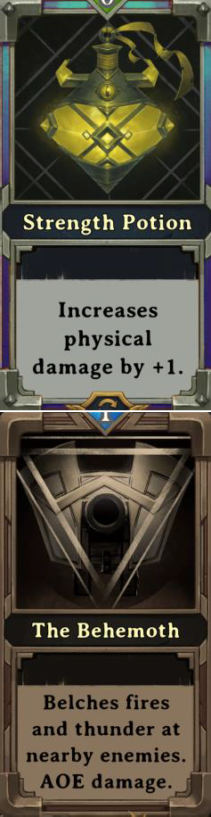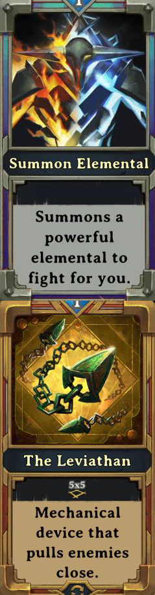

|  |  |  |  |  |
| --- | --- | --- | --- | --- |
|  | P1439C92T15#yIS1 | P1440C93T15#yIS1 | P1441C94T15#yIS1 | P1442C95T15#yIS1 |
|  | P1445C97T15#yIS1 | P1446C98T15#yIS1 | P1447C99T15#yIS1 |  |

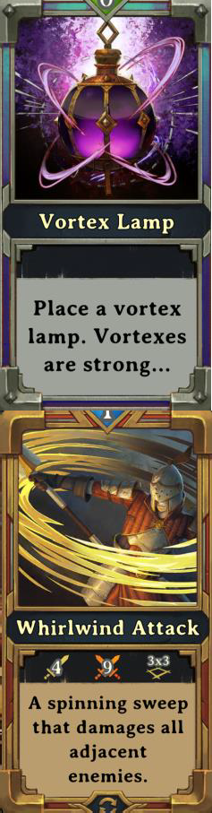

# Character Selection

There are seven character you can select from.

# Guardian (Sigrun)

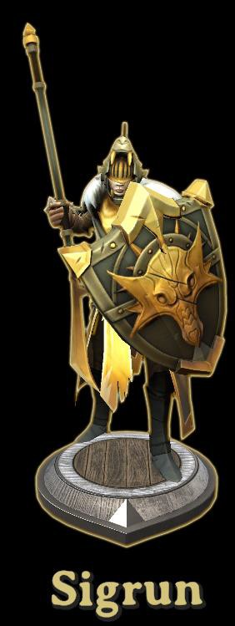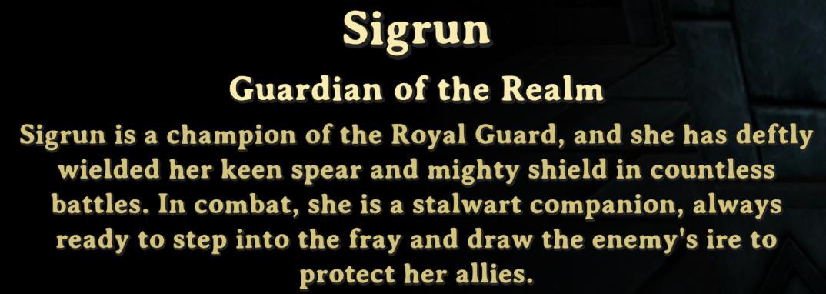

# Sorcerer (Zedokar)

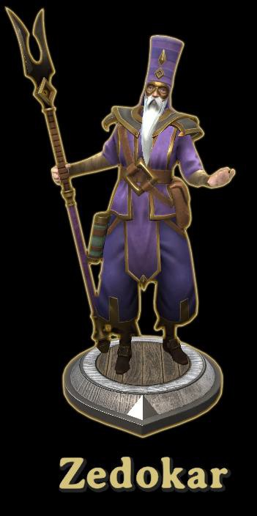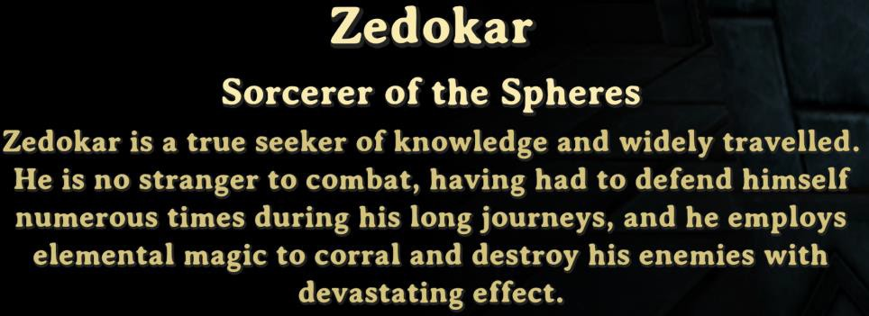

# Hunter (Ailin)

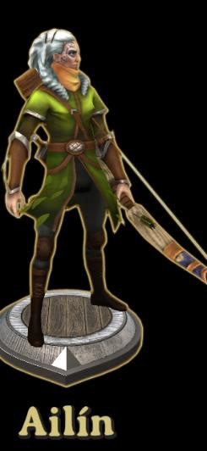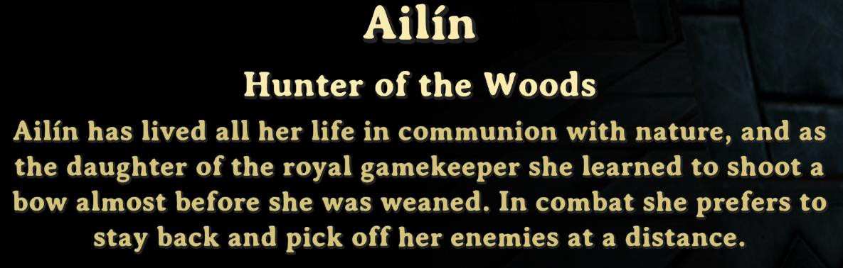

# Assassin(Kai)

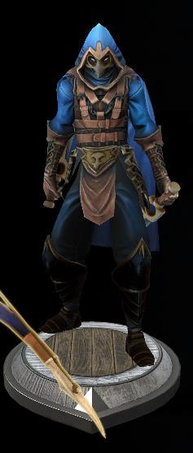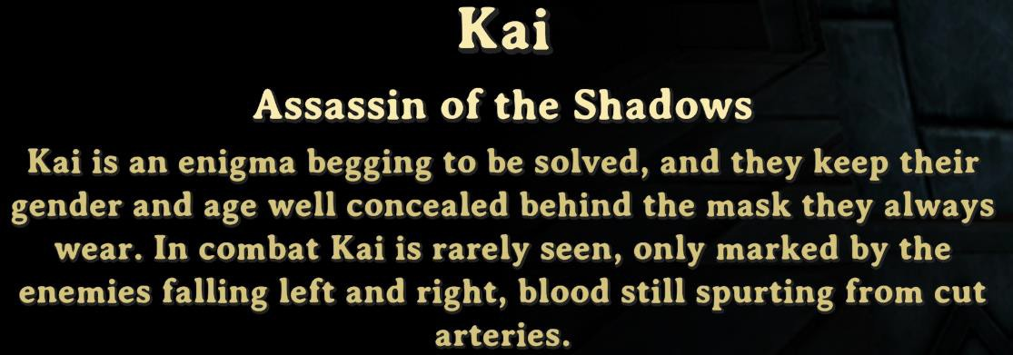

# Bard (Molthas)

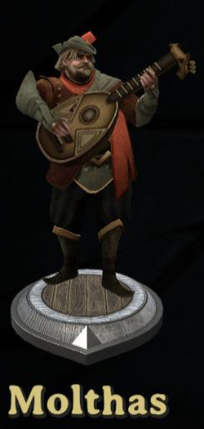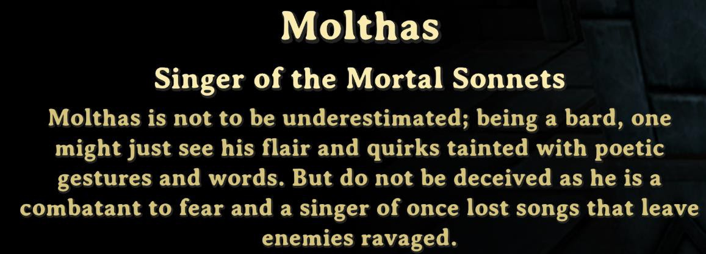

# Warlock (Oana)

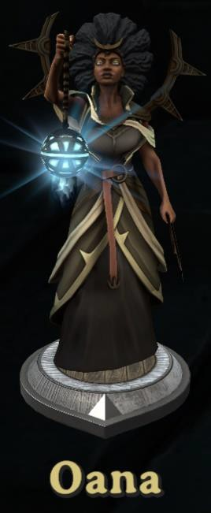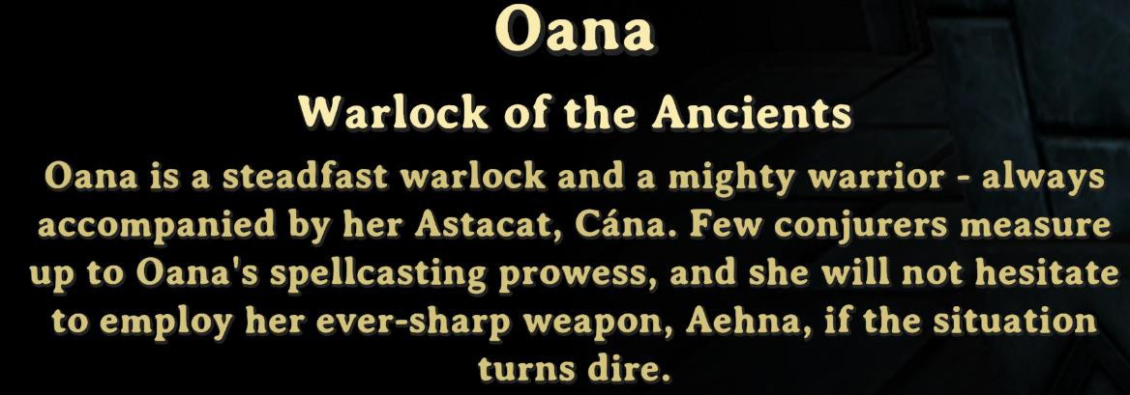

# Warlock (Oana)

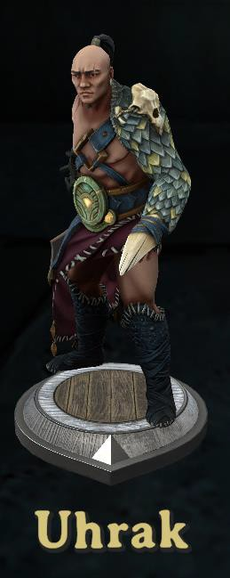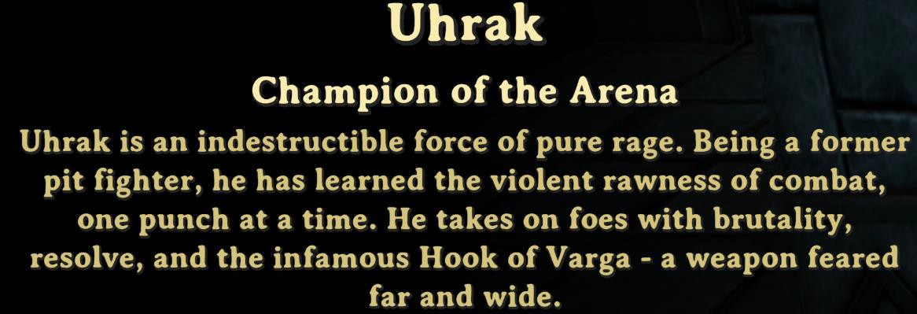

# User\ Feedback Tips and Tricks

The following feedback was observed on some user forums. None of these have been verified and for that

reason it is one player’s opinion. It might provide you some interesting insight as to the mechanics for items or how to make your playing experience more valuable and enjoyable!

1. Have you played and noticed that the screen will zoom in and out on various items? Go to game Settings and adjust Camera Auto Focus.
2. Fire does extra damage on poison tiles (good combos possible with gas lamp + fireball, poison bomb+fire lamp, proximity mine+ gas lamp) CAREFUL, poison spreads and having your character stand on a poison tile when the fire hits…. Is no fun
3. If your character DOESNT move and the poison spreads underneath, it won’t poison you (tile must be clean

when your 1st move into it)

1. Electricity does extra damage to wet target (including your character so be careful with sorcerer’s lighting

attack)

1. Frozen target skips a turn and receive extra damage (I love throwing Ice lamps with Barbarian)
2. Elemental enemies explode when they die, make sure you kill them from range
3. If your character is 2 tiles or less away from a lamp, an enemy archer will hit the lamp to damage you
4. Enemies that are entangled by the Web bombs, will make spiders attack these enemies in priority
5. Never open a door at the end of a turn
6. Barbarian’s hook can grab enemies, lamps, party members, downed party members, ballista’s, healing well,

(barbarian is my favorite class)

1. Mini bosses, big spiders, and final bosses enrage at 50% HP so plan your turn accordingly cause enraged monsters can wreak havoc on your party
2. You can drag cards you don’t like to the far right in the blue mana pool… gives you mana points. 100 mana points give each character a class specific card
3. When playing solo in skirmish, try different classes, it will help you a lot to understand what is going on, or what can be done when playing with others based on each class’ strength and weaknesses
4. Potions are your friend, they cost no action, can be given to other players. And as mentioned, they last till the end. It’s max +3 for one attribute. (Having 3 potions + bard buff makes your characters pretty strong)
5. On your archer\hunter if you have pet cards (call companion or the other one I forget) make sure you use the card before changing floor. Pets will follow to next floor, and it frees card space.
6. When having melee attack, try to position your characters in a way you won’t hit them if you roll a miss (learned that the hard way in a game I got really unlucky on my dice rolls)
7. Give swiftness potion to the bard,
8. charm enemies get healed when you hit a fountain
9. If a Charm Spider drops eggs, check the eggs they should be charmed too… if that’s the case, hit the egg…those spiders will be charmed
10. Charming an enemy and hitting it once to make it go berserk can help. Make sure you kill it before the end of the charm.
11. Friendly elemental also explodes when they die…. Or after a few turns. Keep an eye on the countdown.
12. Blocking door is helpful (barricades, sorcerer wall, stealth assassin) and can save you from a lot of damage.
13. I would add that you can block a small opening by dropping a lamp in the doorway.
14. When you’re surrounded by enemies, placing a barricade, cannon, ballista, healing ward or friendly between you and the heaviest hitter will cause that enemy to attack that instead of you.
15. If you’re standing against a wall, the fire or ice elemental will hit you instead of freeze/burn you.
16. The best way to kill the elven summoner is to attack and then move more than 5 spaces away. It will cause

him to stay put, and he won’t throw any new rifts out.

1. Certain enemies will always go for the guardian, so he should be placed in between the enemy and the hero he’s guarding. Also, if the guardian uses the whirlwind attack card to kill multiple enemies, the lesser enemies that didn’t die will panic and run away. The guardian can also use the charge card to escape a bad situation.
2. The wizard can stun an enemy that’s about to attack by zapping them with a bolt of lightning.
3. If you use a panic card on an enemy, to keep them from attacking, make sure you attack them while they’re

still panicked.

1. If you want to use a regroup card, ask your teammates if they agree it should be used.
2. The beggar takes 7 cards and trades you a different card.
   1. Bone = Detect Enemies
   2. Oil Lamp = Luck Potion
   3. Repeating Ballista = Reveal Path
   4. Strength Potion = Alag’s Fighting Spirit
   5. Teleportation = Jeweled Scarab
   6. Water Flask = Swiftness Potion
   7. Rejuvenation = Ralma’s Reckoning (must have card)
3. If gold is next to a monster, you can attack the monster from the pile to pick up while attacking. Take the moment to carefully do it, it's very annoying to mess up and miss an attack like this. But picking up cash and attacking at the same time is baller
4. Upgrade potions (speed, damage, etc.) last the whole dungeon. Drink on floor 1, still active on floor 3. Should be noted though, while you can give them to some pets (like Cana, the warlocks cat) they are much less permanent when you do. If Cana dies, the potion wears off. Give potions to people, not pets.
5. **Dege Tip** – Lower right-hand corner is the Mana Pool. Drag unwanted cards into the man pool. When you exceed 100, everybody will get another card. Make sure to announce to your friends if they have room!
6. **Dege Tip** - Look at the base of the enemy miniature piece on the board. There is a little arrow that shows which way the character is facing.

# Troubleshooting

Here we try to show you as many errors as we receive and can confirm what the root cause is.

# Tshooting - The select ruleset is not for multiplayer games

This error will occur when an item that you have declared in the code is not going to function for multiplayer. In the example shown below, if you try to declare the CardLimitModified, it will not work in multiplayer. The

reason it didn’t complain by the MelonLoader is that it is legal for single player, but not multiplayer. It is also an acceptable feature, so you will only see this error when you try to enter multiplayer and it will then be revealed that the ruleset has been deactivated.

"Rule" - "CardLimitModified", "Config" - 10



# Tshooting - Failed to import

This is pretty common when you forget to properly declare statements. In the case below you will notice within the first few lines that an error was encountered at line 750. Goto line 750 or the line number reported in your error and look for a grammatical or syntax error. The last statement in a long rule block will not have a comma.

In the case of this error - "Target" - 1

}

}, ← Notice that the , in place

{"Rule" - "CardLimitModified", "Config" - 10} ← Notice the missing ,

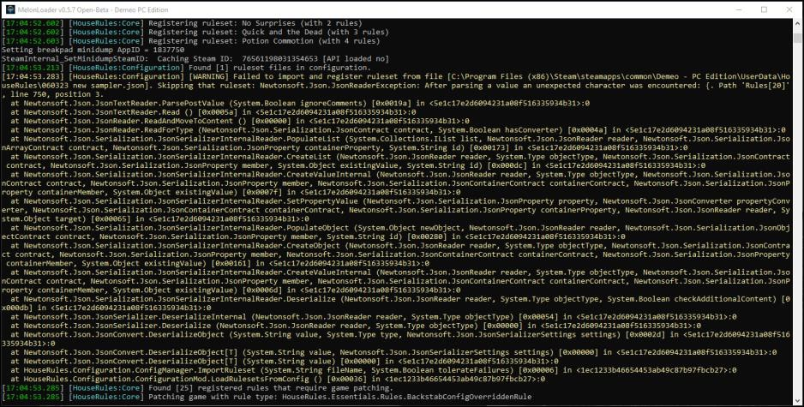

**Update** received on 062223 from a player “Frak”. The email noted that there is a .Json validator that could be used to test out your .Json before trying to load it into Demeo. So smart and I wish I had thought of it, but **Frak** did! Here is what you do.

* + 1. Go to [https -//jsonformatter.curiousconcept.com/](https://jsonformatter.curiousconcept.com/)
    2. You will be presented with a screen like this.

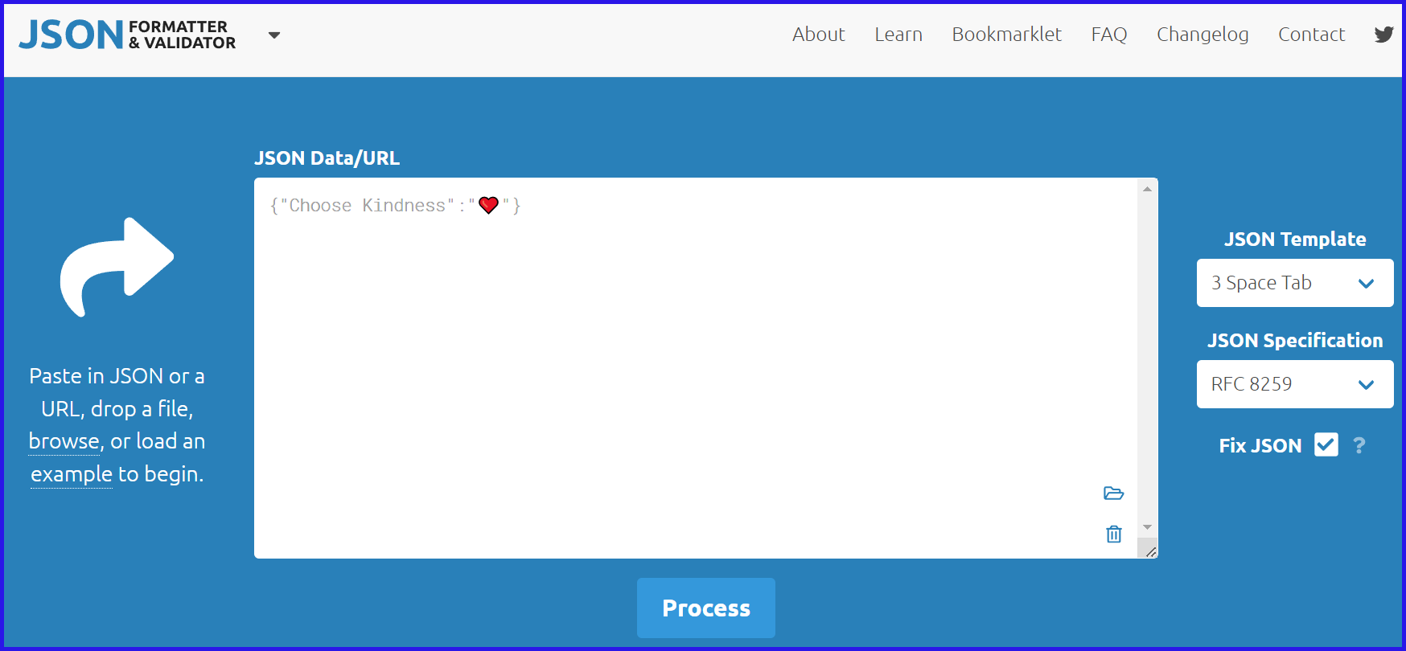

* + 1. Drag your .json sample into the window above.
    2. Click Process button to see your results. A red or green indicator will reveal the results of your Json file.

Authors Note – I have a Json file I have been meaning to troubleshoot. This utility allows you to identify the mistake and can REPAIR IT. What a time saver.

Click [here](https://www.youtube.com/watch?v=TnZx0QQl79Y) to see a demonstration from Dege on YouTube.

# Tshooting - Disconnected

There have been reports scattered over the last year of users getting disconnected. Not clear what the root cause is. If you know from experience, send your feedback to [demeo@epomd.com.](mailto:demeo@epomd.com)

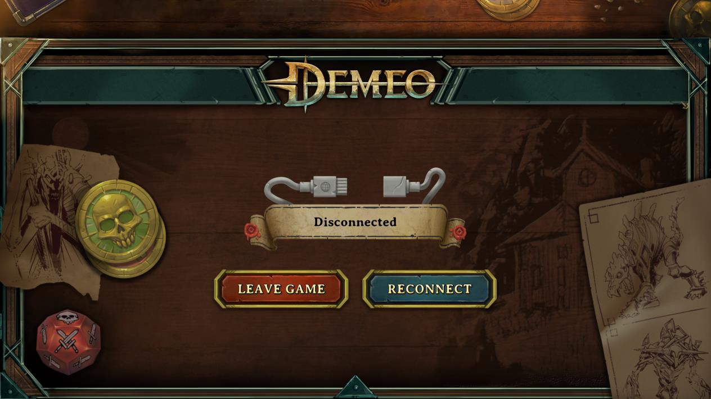

# MAP LEVELS

There are five maps with a variety of floors. You can select from Black Sarcophagus, Rat King, Roots of Evil, Serpent Lord or the Reign of Madness map. We captured each floor for you. You can program the floor that interests your team. Put this rule in place and configure it.

"Rule" - "LevelSequenceOverridden", "Config" - [ "ElvenFloor01", "SewersFloor07", "ForestFloor09", "ForestShopFloor", "ElvenFloor08" ]

**LevelSequenceOverridden** - The Level Sequence of dungeon floors is overridden.

* List of levels must be exactly five items long. The game will crash at the end if the list is any longer.
* Shop levels can be replaced with game levels.
* It is possible to use levels from any book (Elven, Sewers, Forest) together in a single list
* Level soundtracks may not match the played level or adventure (e.g. The shop "Ah Customers, Welcome" will always play on 2nd and 4th levels)
* Level names are ElvenFloor01-17, SewersFloor01-12, ForestFloor01-03, ForestFloor05-09, ShopFloor02, and shop floors.

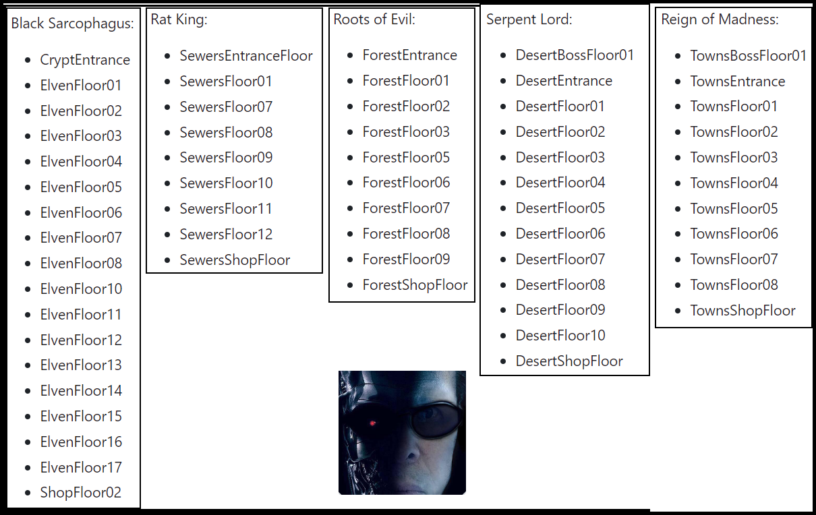

# BLACK SARCOPHAGUS – ENTRANCE

There are 17 floors offered for the Black Sarcophagus. There are two really important things to know about maps. Every time you start a map, the entrance and exit are randomized. The base map is exactly as it is shown with those two exceptions. The tiles have been lit up, allowing you to see as much detail to the map as possible.

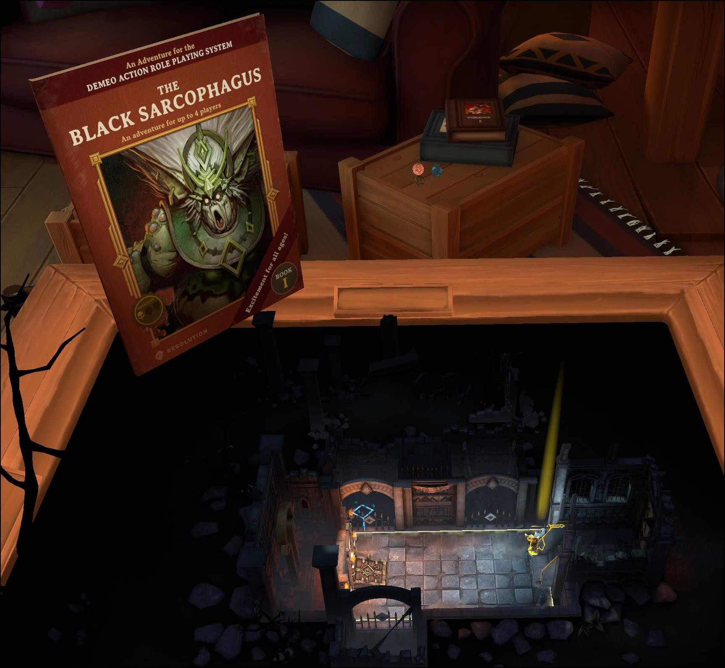

# BLACK SARCOPHAGUS - ELVEN MAP FLOOR 1

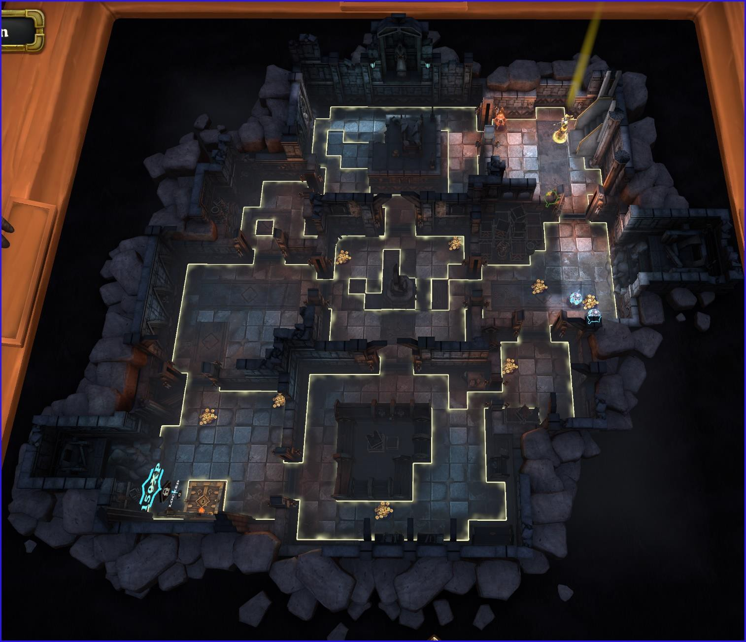

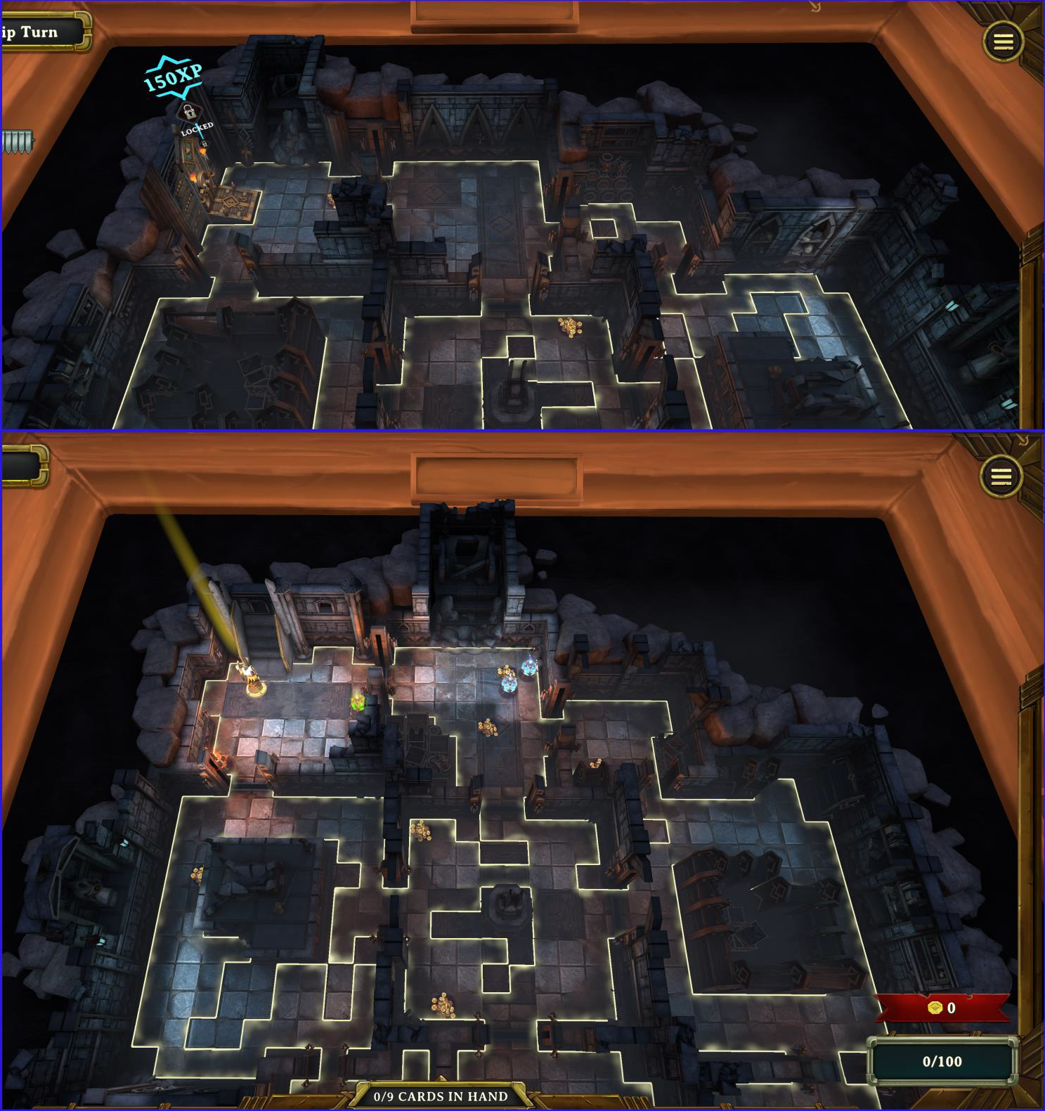

[Follow Dege in a video tour of BLACK SARCOPHAGUS Floor 1 (Narrated 4 -45)](https://www.youtube.com/watch?v=h96vs4KOKyY) [Video overview of BLACK SARCOPHAGUS Floor 1 (No narration)](https://www.youtube.com/watch?v=gAWbYcEOLqo)

# P1942#yIS1BLACK SARCOPHAGUS - ELVEN MAP FLOOR 2

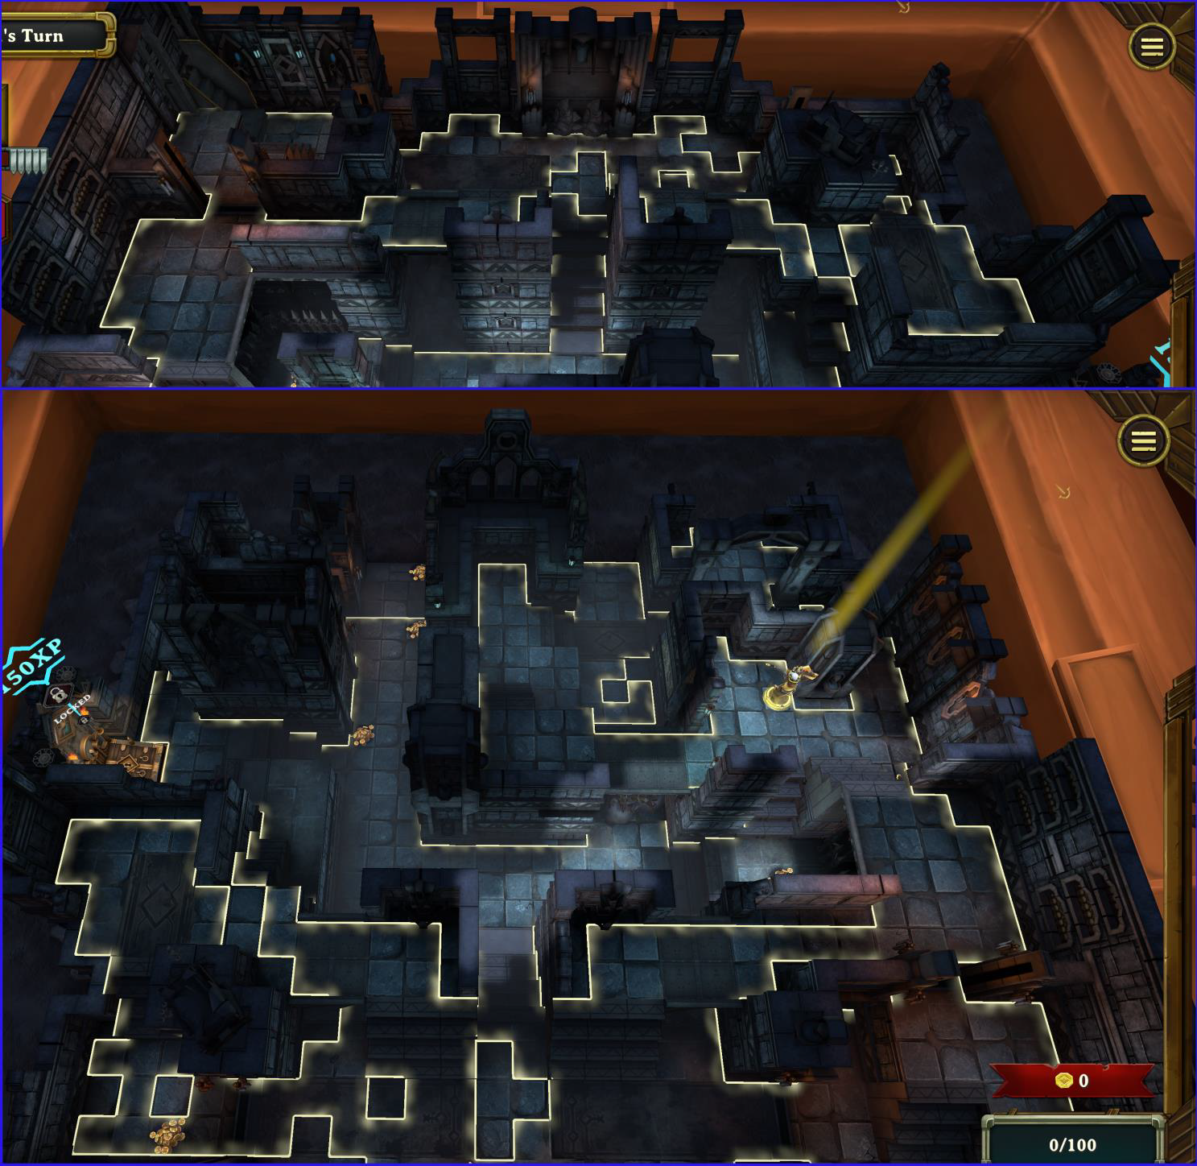

[Follow Dege in a video tour of BLACK SARCOPHAGUS Floor 2 (Narrated 3 -47)](https://www.youtube.com/watch?v=eAyY0WCk9bo) [Video overview of BLACK SARCOPHAGUS Floor 2 (No narration)](https://www.youtube.com/watch?v=eAyY0WCk9bo)

# P1946#yIS1BLACK SARCOPHAGUS - ELVEN MAP FLOOR 3

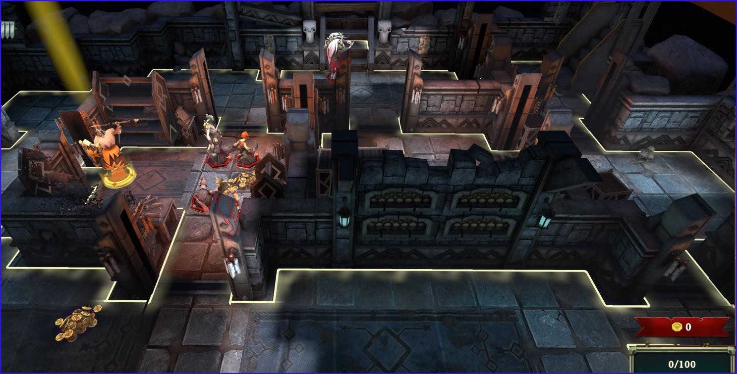

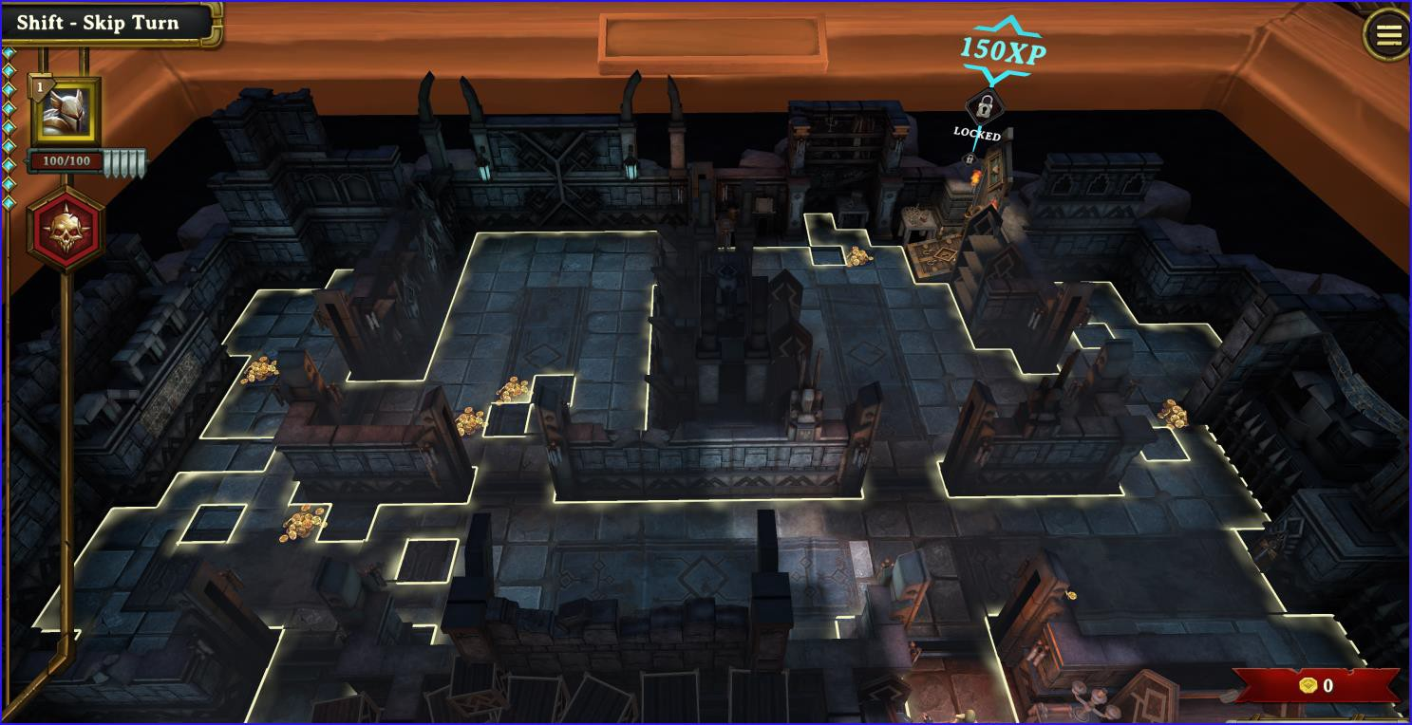

[Follow Dege in a video tour of BLACK SARCOPHAGUS Floor 3 (Narrated 2 -58)](https://www.youtube.com/watch?v=6uAiRoNx_wo) [Follow Dege in a video tour of BLACK SARCOPHAGUS Floor 3 (No Narration)](https://www.youtube.com/watch?v=lQzfnimP4I4)

# P1951#yIS1BLACK SARCOPHAGUS - ELVEN MAP FLOOR 4

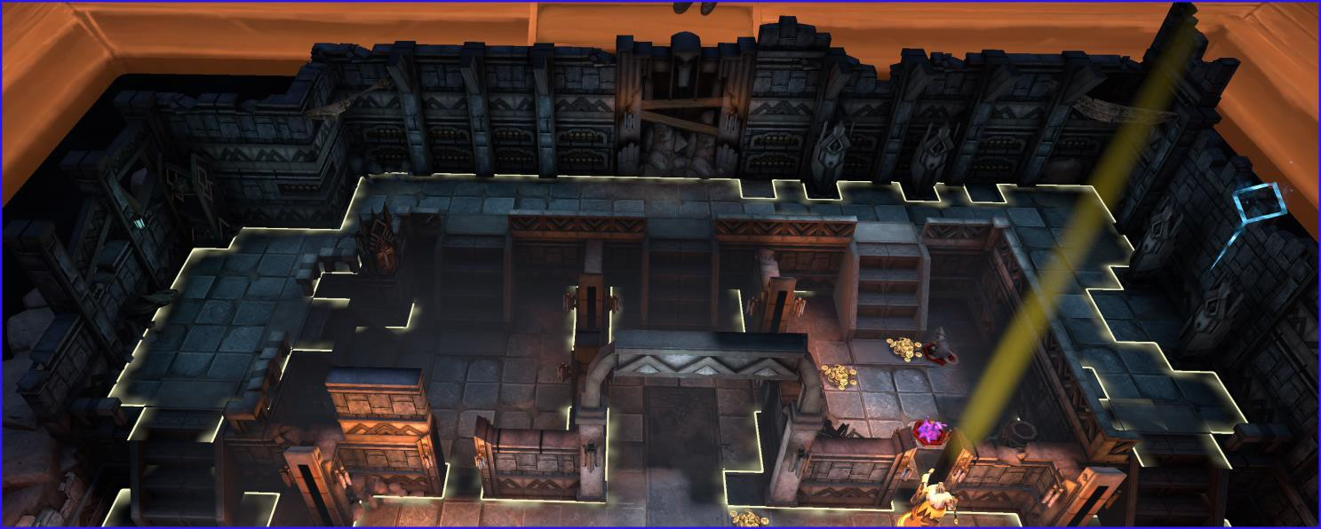

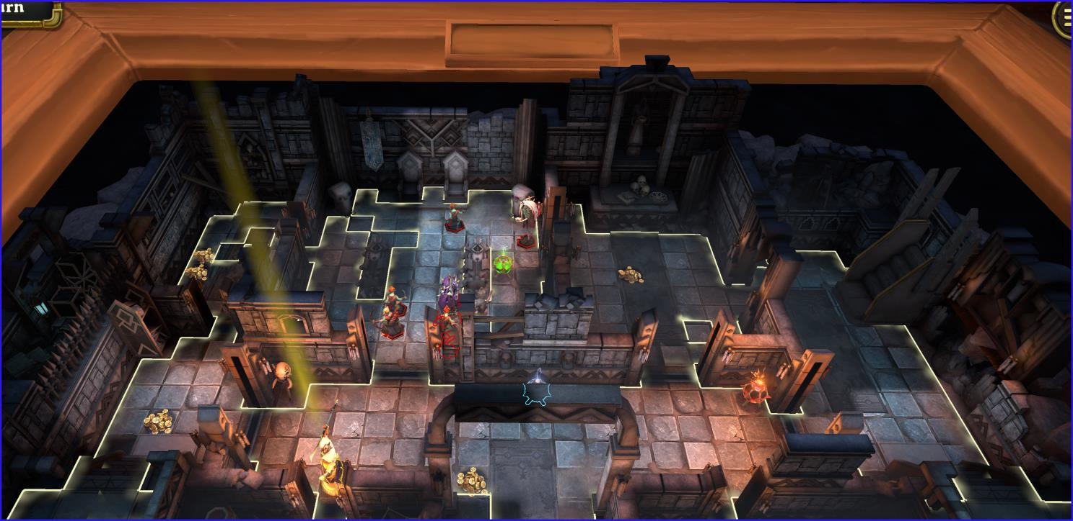

[Follow Dege in a video tour of BLACK SARCOPHAGUS Floor 4 (Narrated 4 -27)](https://www.youtube.com/watch?v=6xSRbL_dPxw) [Take a video tour of BLACK SARCOPHAGUS Floor 4 (No Narration)](https://www.youtube.com/watch?v=l7l4dqSxYrc)

# P1956#yIS1BLACK SARCOPHAGUS - ELVEN MAP FLOOR 5

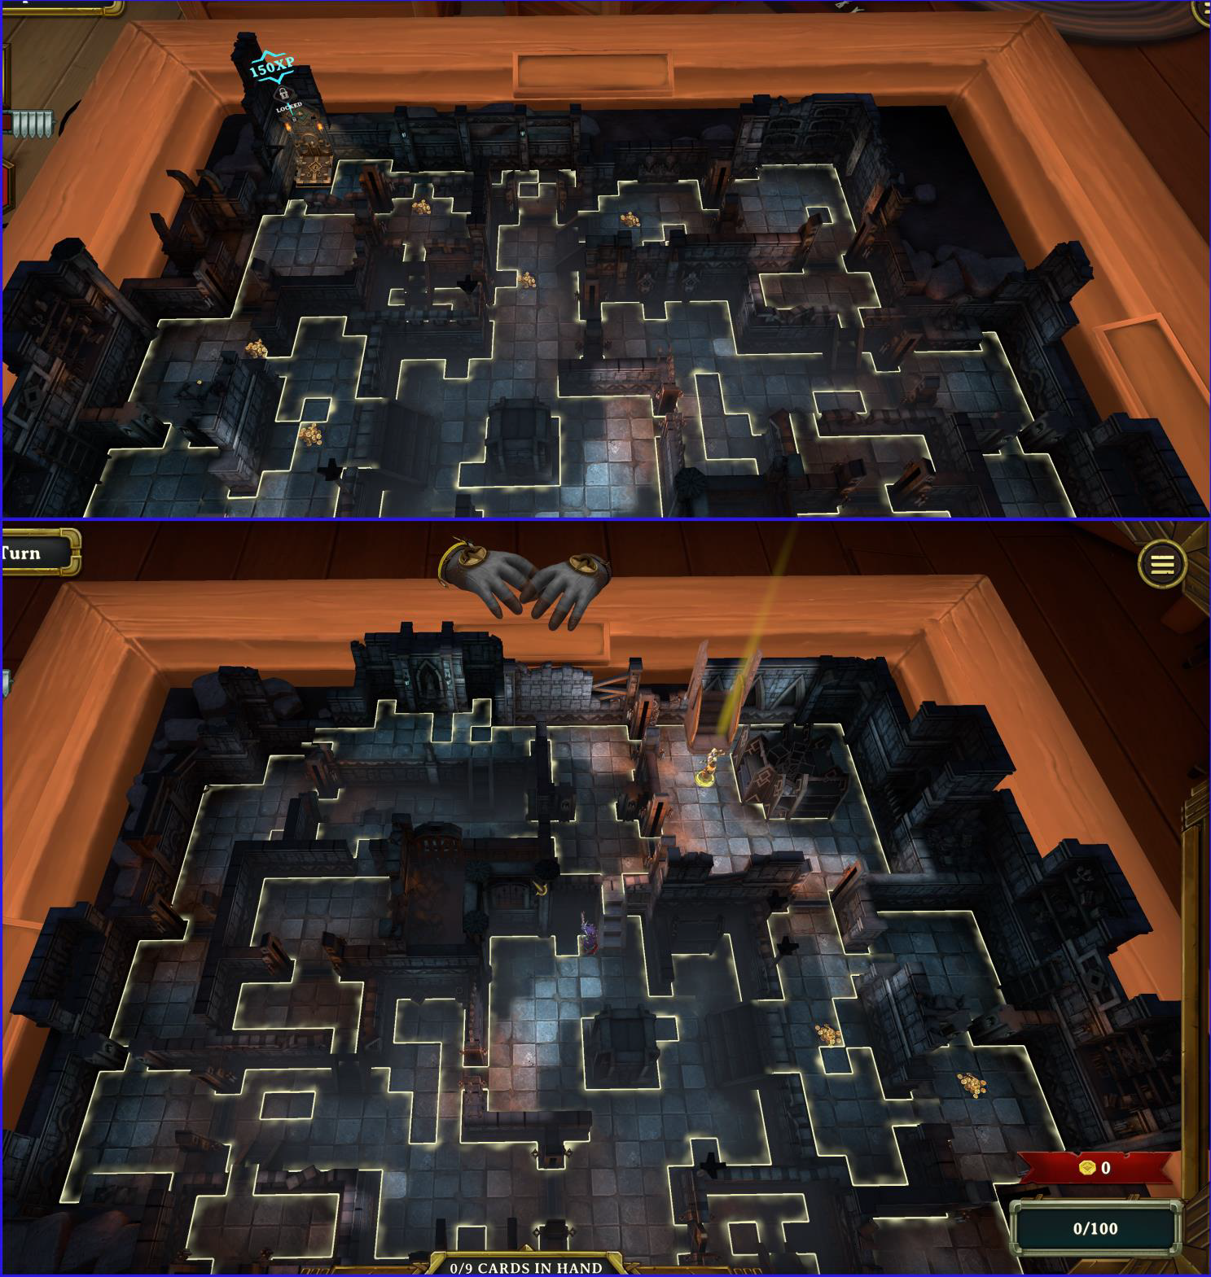

[Follow Dege in a video tour of BLACK SARCOPHAGUS Floor 5 (Narrated 2 -59)](https://www.youtube.com/watch?v=5y_BazGvtqo) [Take a video tour of BLACK SARCOPHAGUS Floor 5 (No Narration)](https://www.youtube.com/watch?v=7FGSYJ3WHi8)

# P1960#yIS1BLACK SARCOPHAGUS - ELVEN MAP FLOOR 6

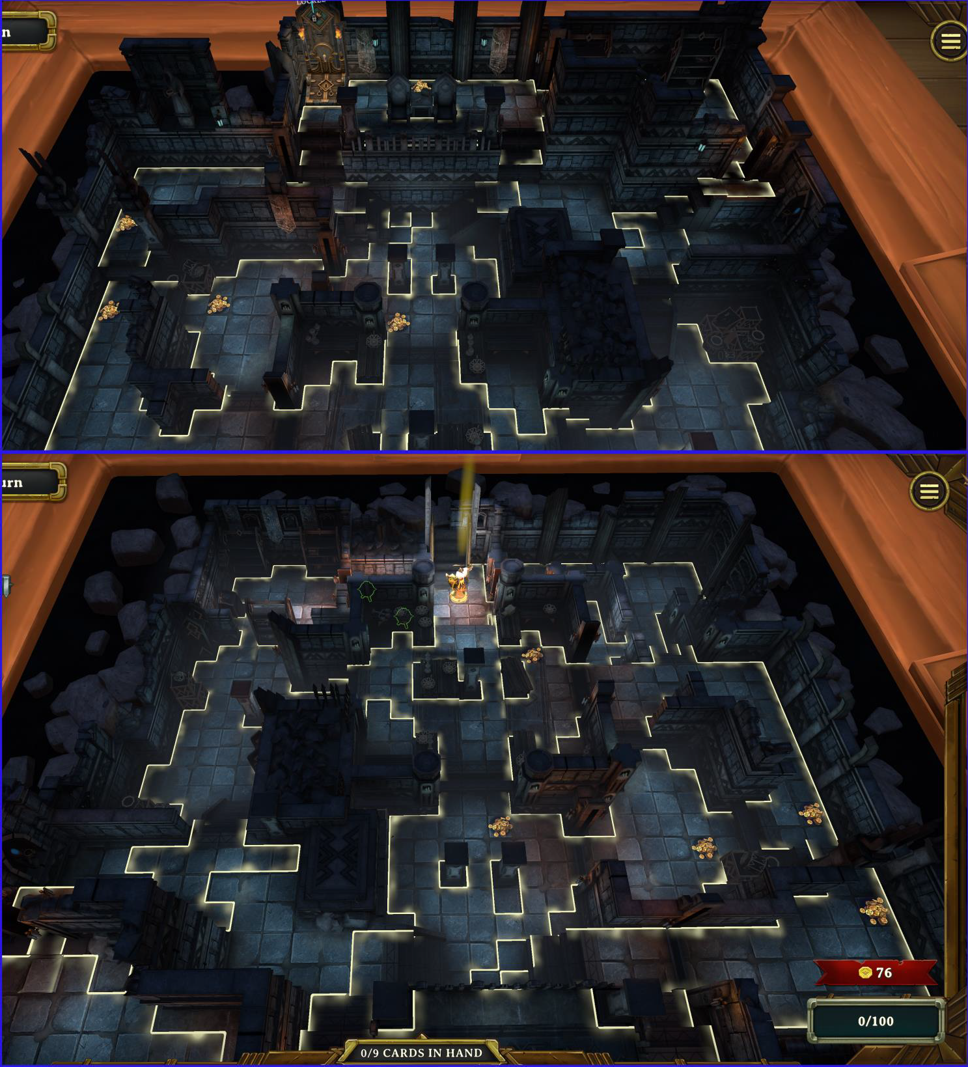

[Follow Dege in a video tour of BLACK SARCOPHAGUS Floor 6 (Narrated 3 -12)](https://www.youtube.com/watch?v=k99B_Q-hy38) [Take a video tour of BLACK SARCOPHAGUS Floor 6](https://www.youtube.com/watch?v=t4Q6ydH3tJY) (No Narration)

# P1964#yIS1BLACK SARCOPHAGUS - ELVEN MAP FLOOR 7

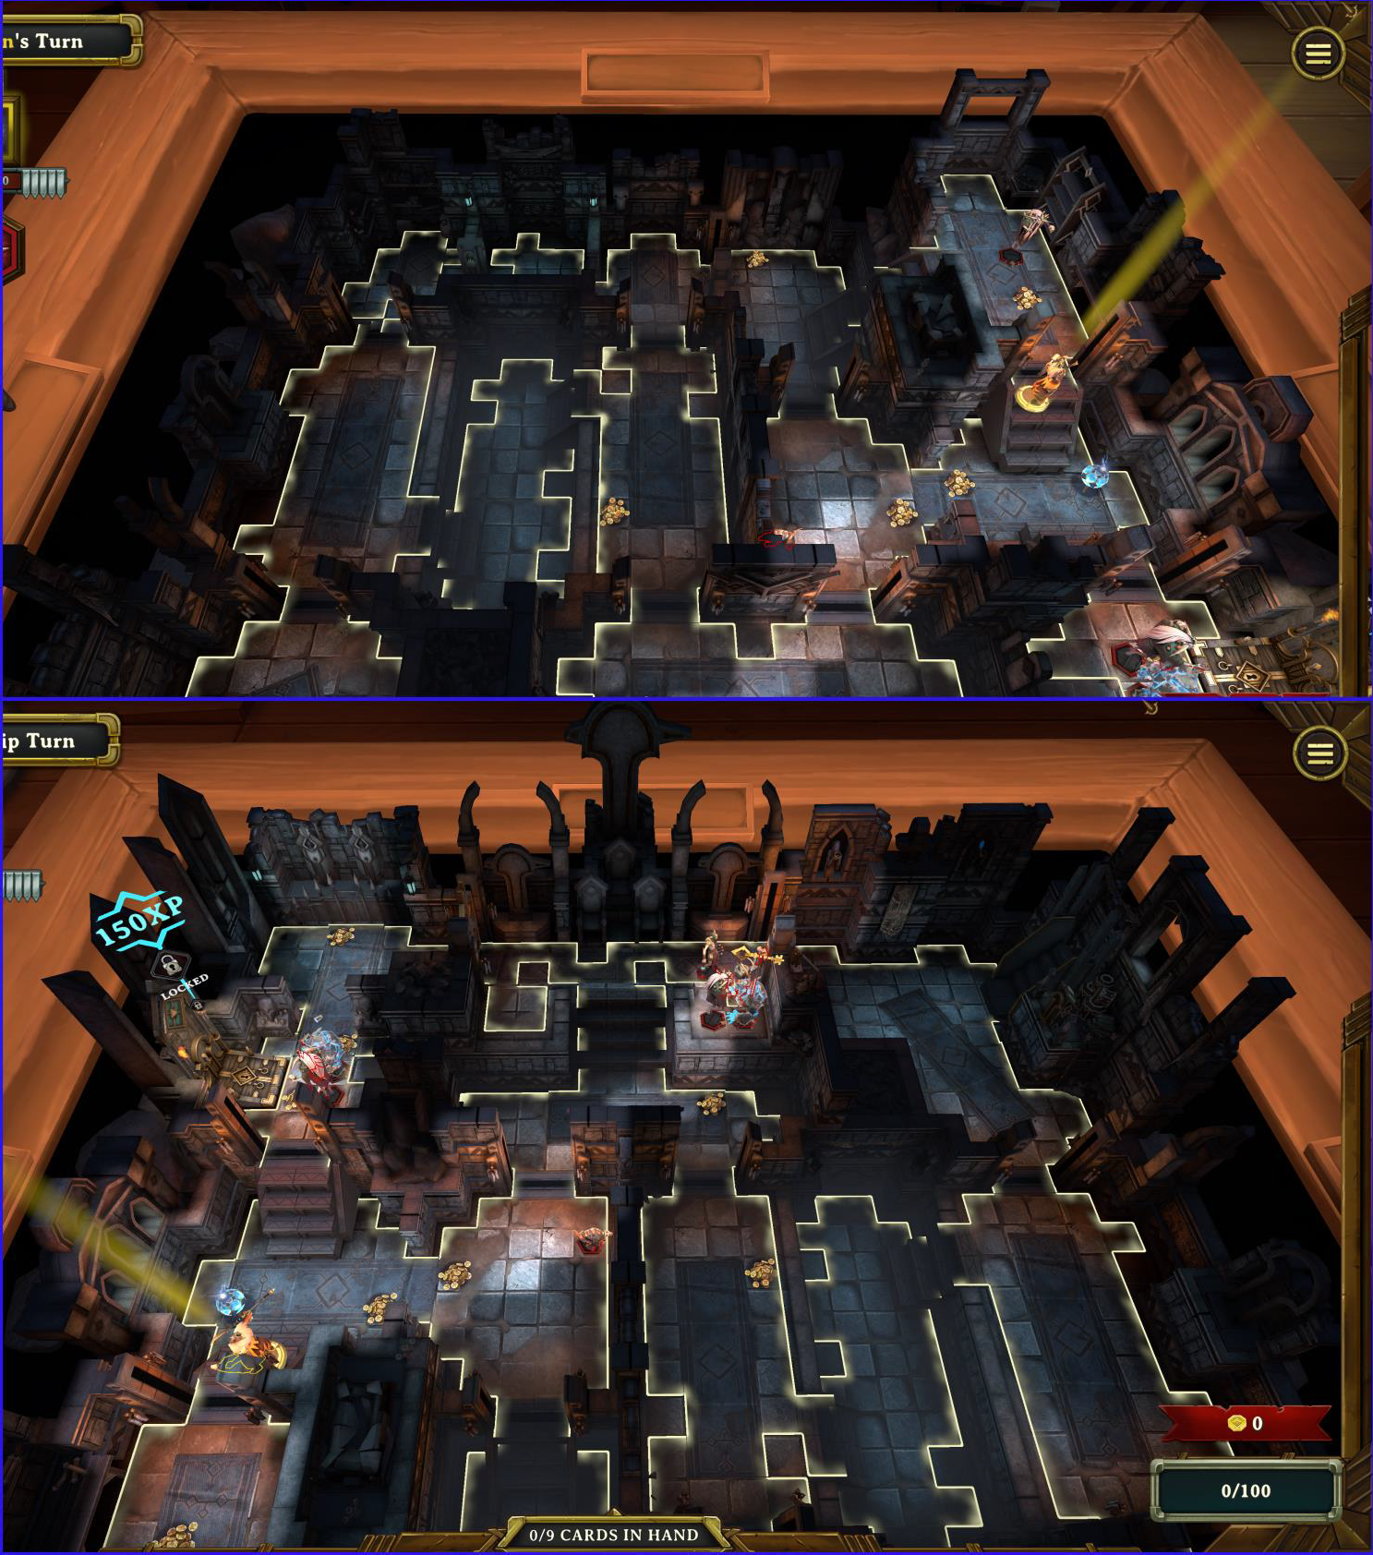

[Follow Dege in a video tour of BLACK SARCOPHAGUS Floor 7 (Narrated 4 -04)](https://www.youtube.com/watch?v=wlohMwJH9-g) [Take a video tour of BLACK SARCOPHAGUS Floor 7](https://www.youtube.com/watch?v=m_OyYH09P3g) (No Narration)

# P1967#yIS1BLACK SARCOPHAGUS - ELVEN MAP FLOOR 8

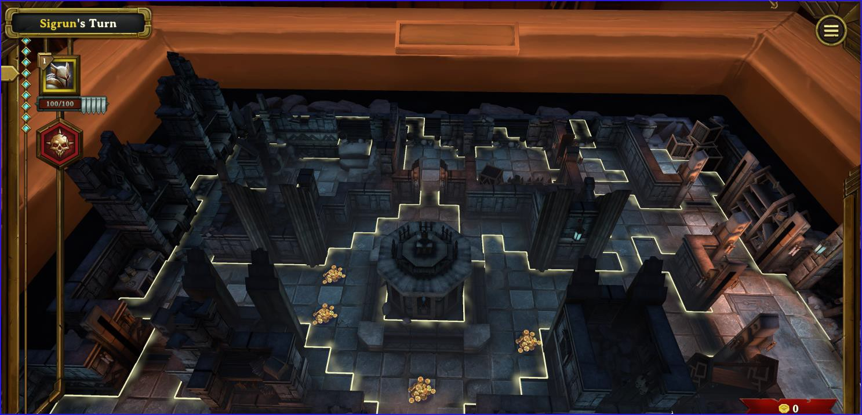

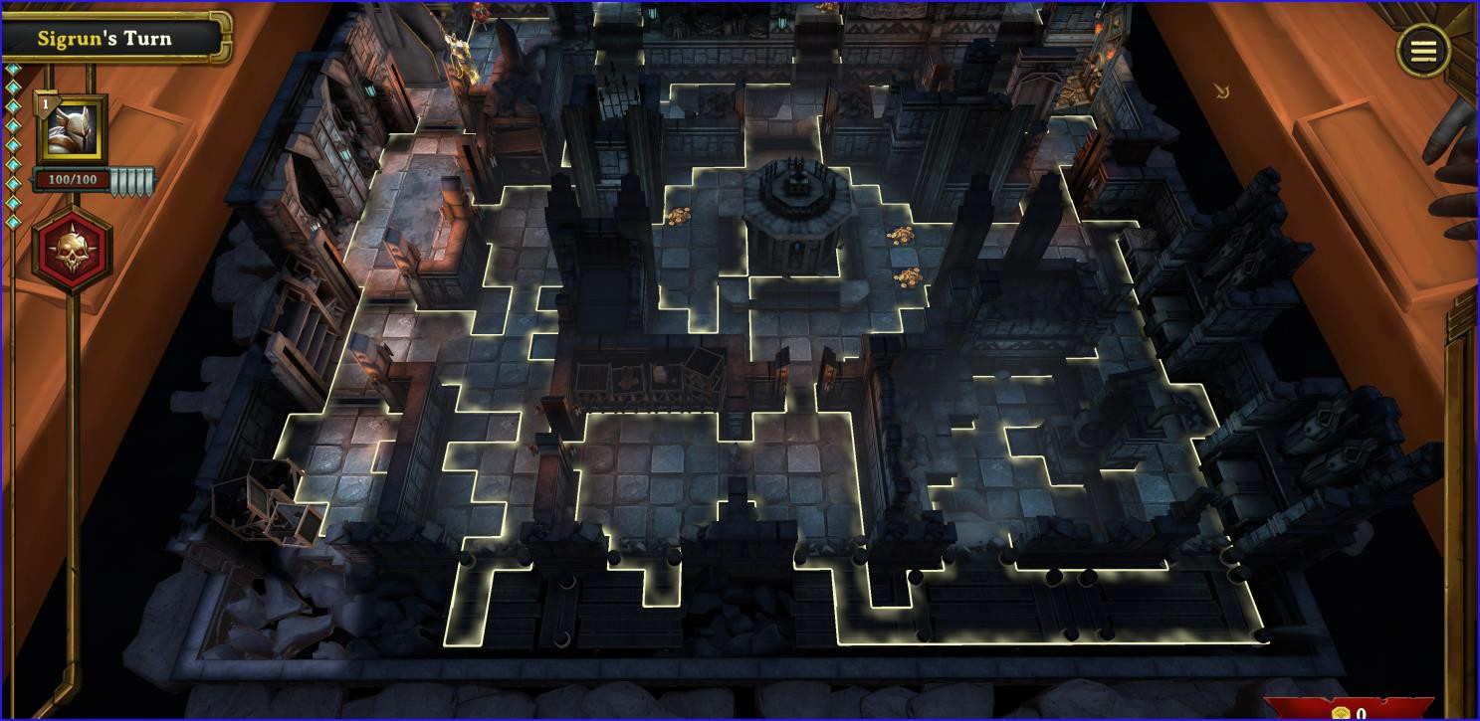

[Take a video tour of BLACK SARCOPHAGUS Floor 8 (No Narration)](https://www.youtube.com/watch?v=sOWB3Y490Og)

# BLACK SARCOPHAGUS - ELVEN MAP FLOOR 9

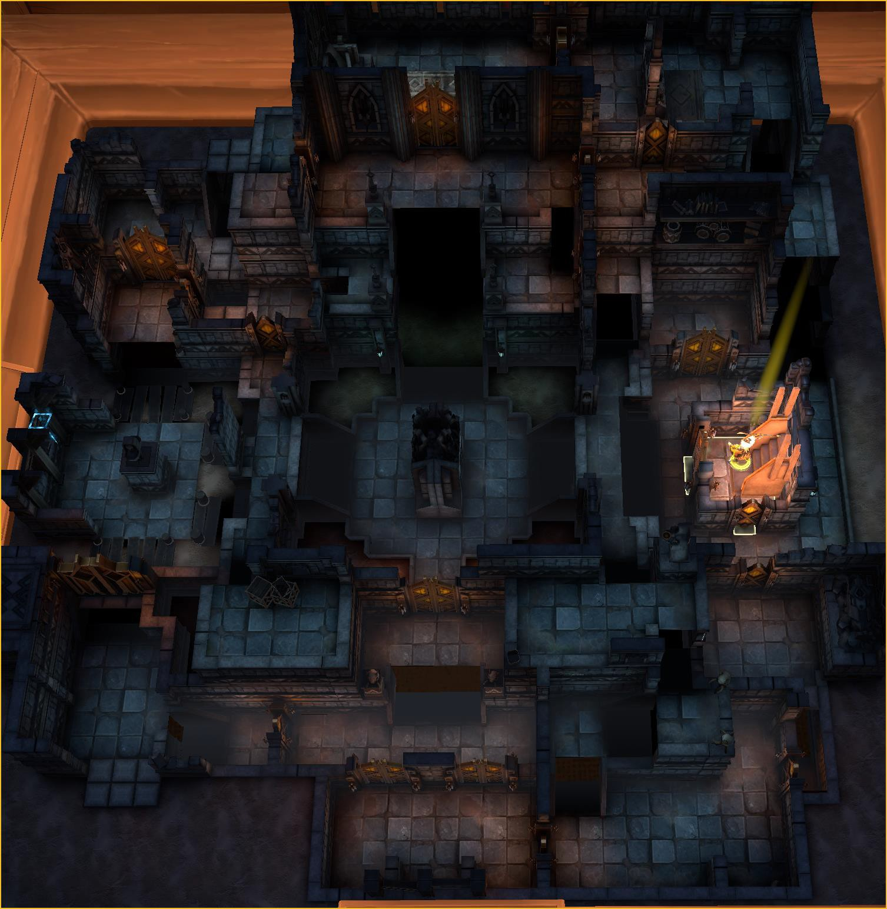

[Take a video tour of BLACK SARCOPHAGUS Floor 9](https://www.youtube.com/watch?v=jbUoQS_rkGE) (No Narration)

# BLACK SARCOPHAGUS - ELVEN MAP FLOOR 10

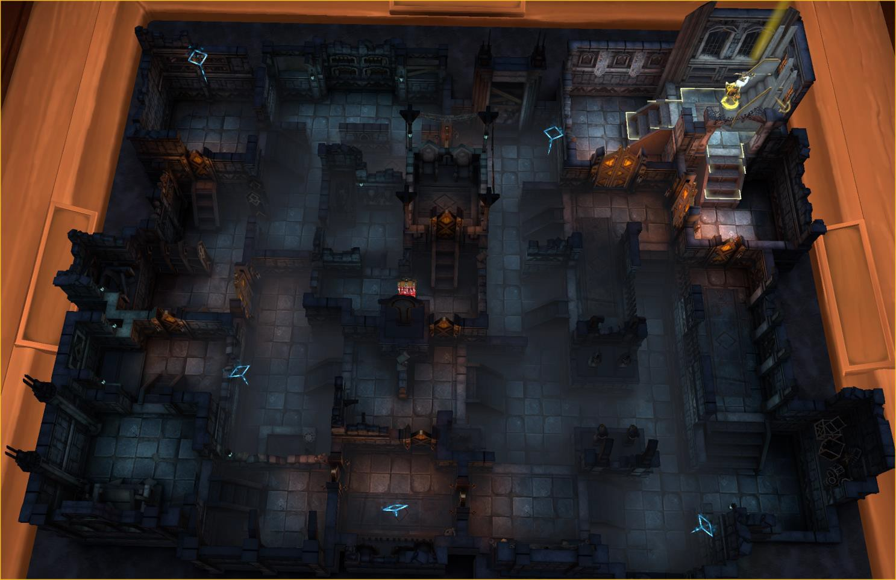

[**Take a video tour of BLACK SARCOPHAGUS Floor 10**](https://www.youtube.com/watch?v=jzGW7KZ_h1U)

# BLACK SARCOPHAGUS - ELVEN MAP FLOOR 11

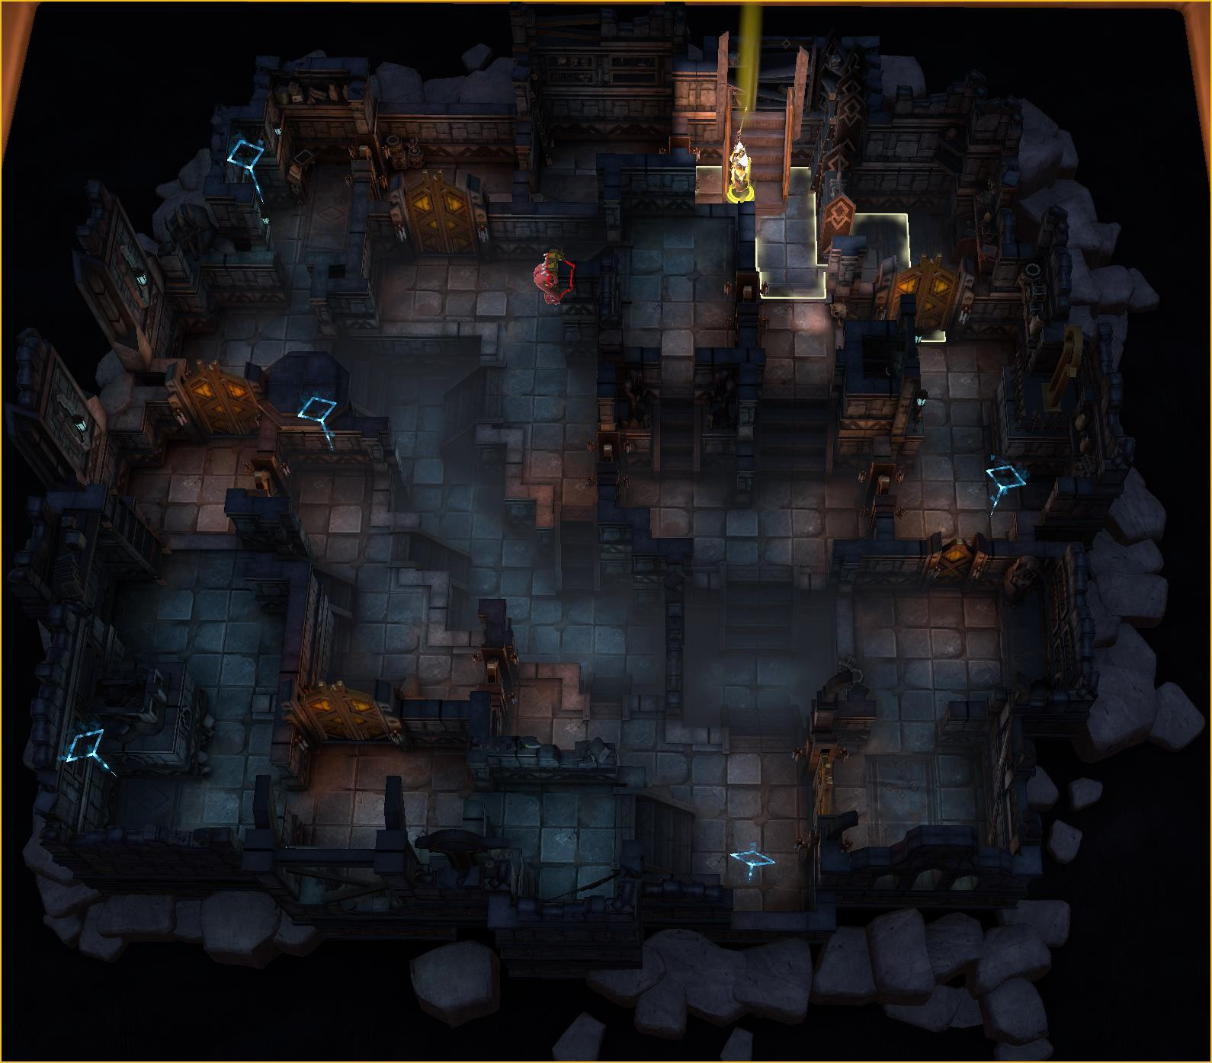

[**Take a video tour of BLACK SARCOPHAGUS Floor 11**](https://www.youtube.com/watch?v=SJF8CrHAnNc)

# P1984#yIS1BLACK SARCOPHAGUS - ELVEN MAP FLOOR 12

**Take a video tour of BLACK SARCOPHAGUS Floor 12 (Pending)**

# P1988#yIS1BLACK SARCOPHAGUS - ELVEN MAP FLOOR 13

**Take a video tour of BLACK SARCOPHAGUS Floor 13 (Pending)**

# P1992#yIS1BLACK SARCOPHAGUS - ELVEN MAP FLOOR 14

**Take a video tour of BLACK SARCOPHAGUS Floor 14 (Pending)**

# P1996#yIS1BLACK SARCOPHAGUS - ELVEN MAP FLOOR 15

**Take a video tour of BLACK SARCOPHAGUS Floor 15 (Pending)**

# P2000#yIS1BLACK SARCOPHAGUS - ELVEN MAP FLOOR 16

**Take a video tour of BLACK SARCOPHAGUS Floor 16 (Pending)**

# P2004#yIS1BLACK SARCOPHAGUS - ELVEN MAP FLOOR 17

**Take a video tour of BLACK SARCOPHAGUS Floor 17 (Pending)**

# RAT KING – ENTRANCE

There are 7 floors available for the Rat King. They are not in sequential order, so don’t be confused that we missed any floors. These maps introduce “reveal” to all tiles as they appear. There are two really important things to know about maps. Every time you start a map, the entrance and exit are randomized. The base map is exactly as it is shown with those two exceptions. The tiles have been lit up, allowing you to see as much detail to the map as possible.

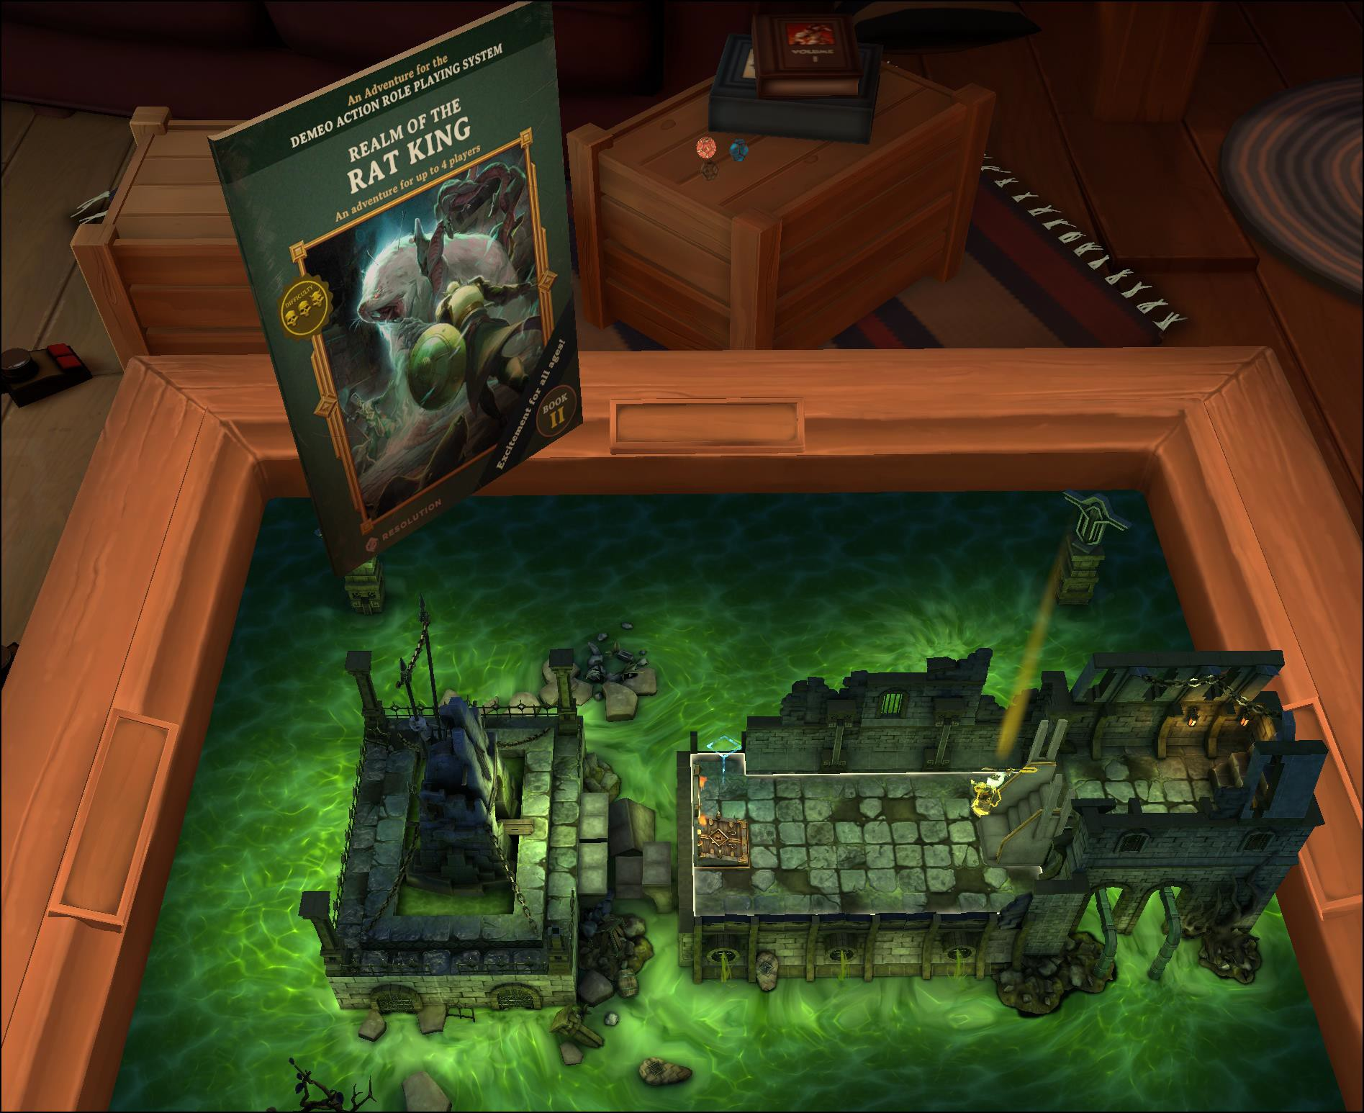

# RAT KING – SEWERS FLOOR 1

This is a small map. It doesn’t take up the entire land footprint. It contains 16 doors.

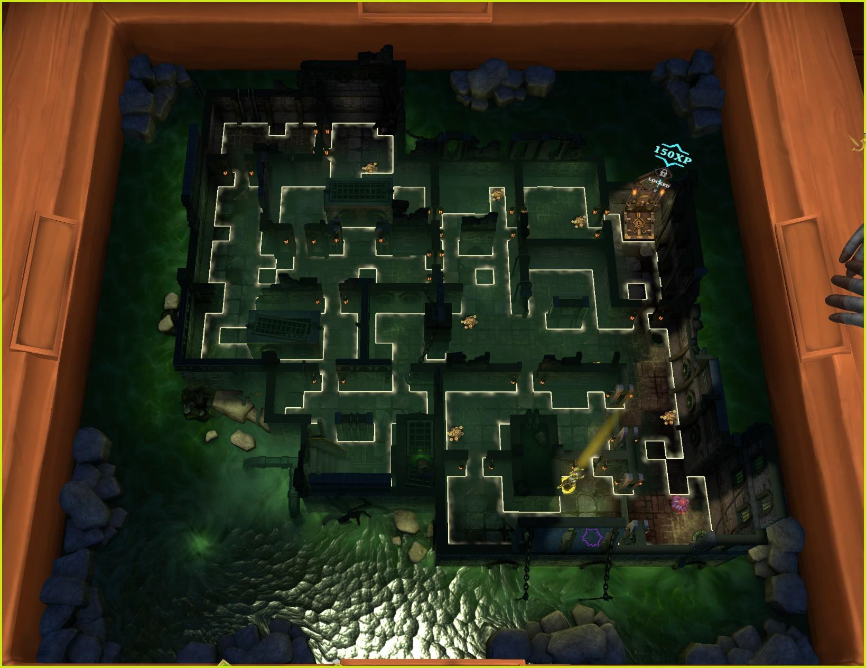

# RAT KING – SEWERS FLOOR 7

This is a medium map. A little bigger than Floor 1. It contains 12 doors.

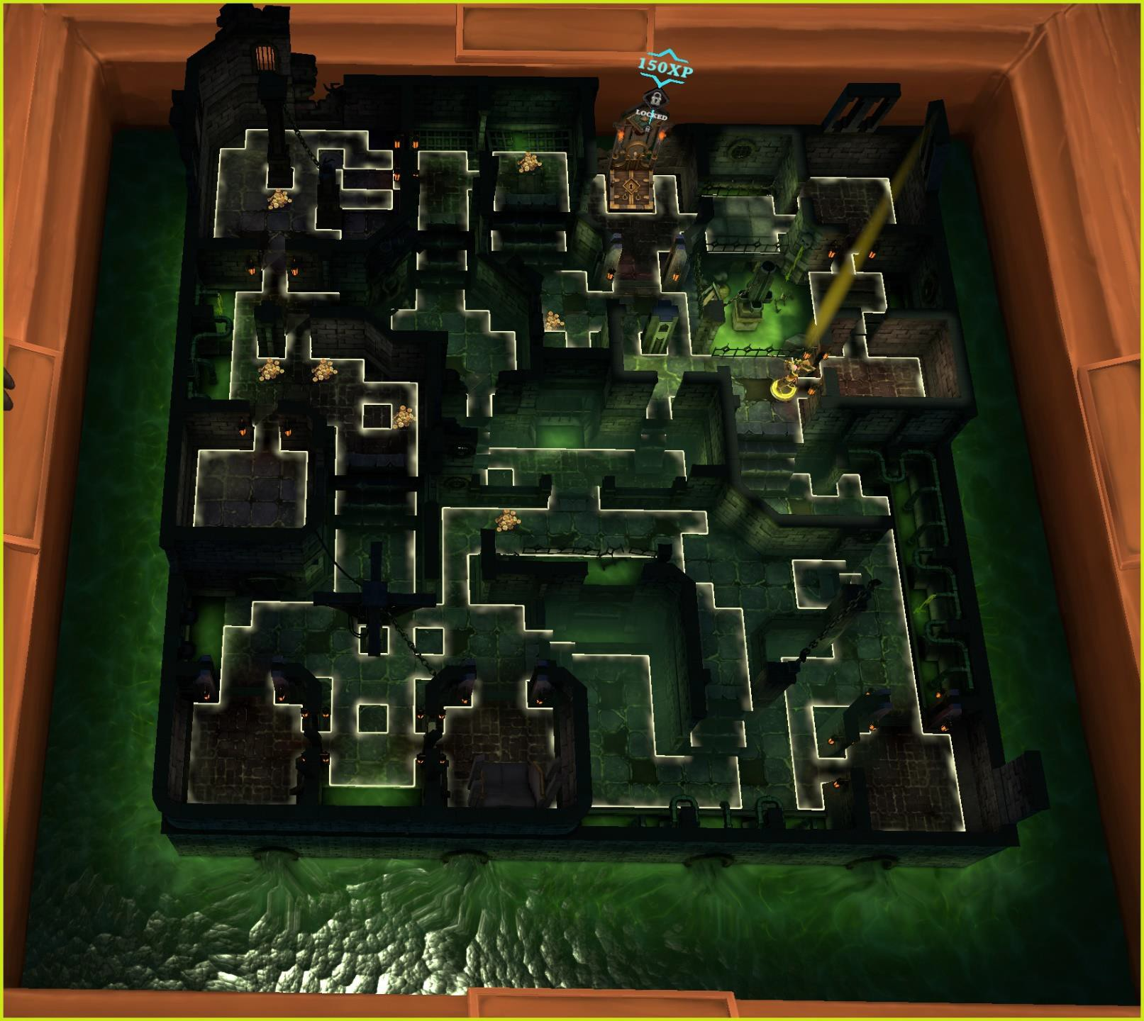

# RAT KING – SEWERS FLOOR 8

This is a large map. It has a whopping 37 doors.

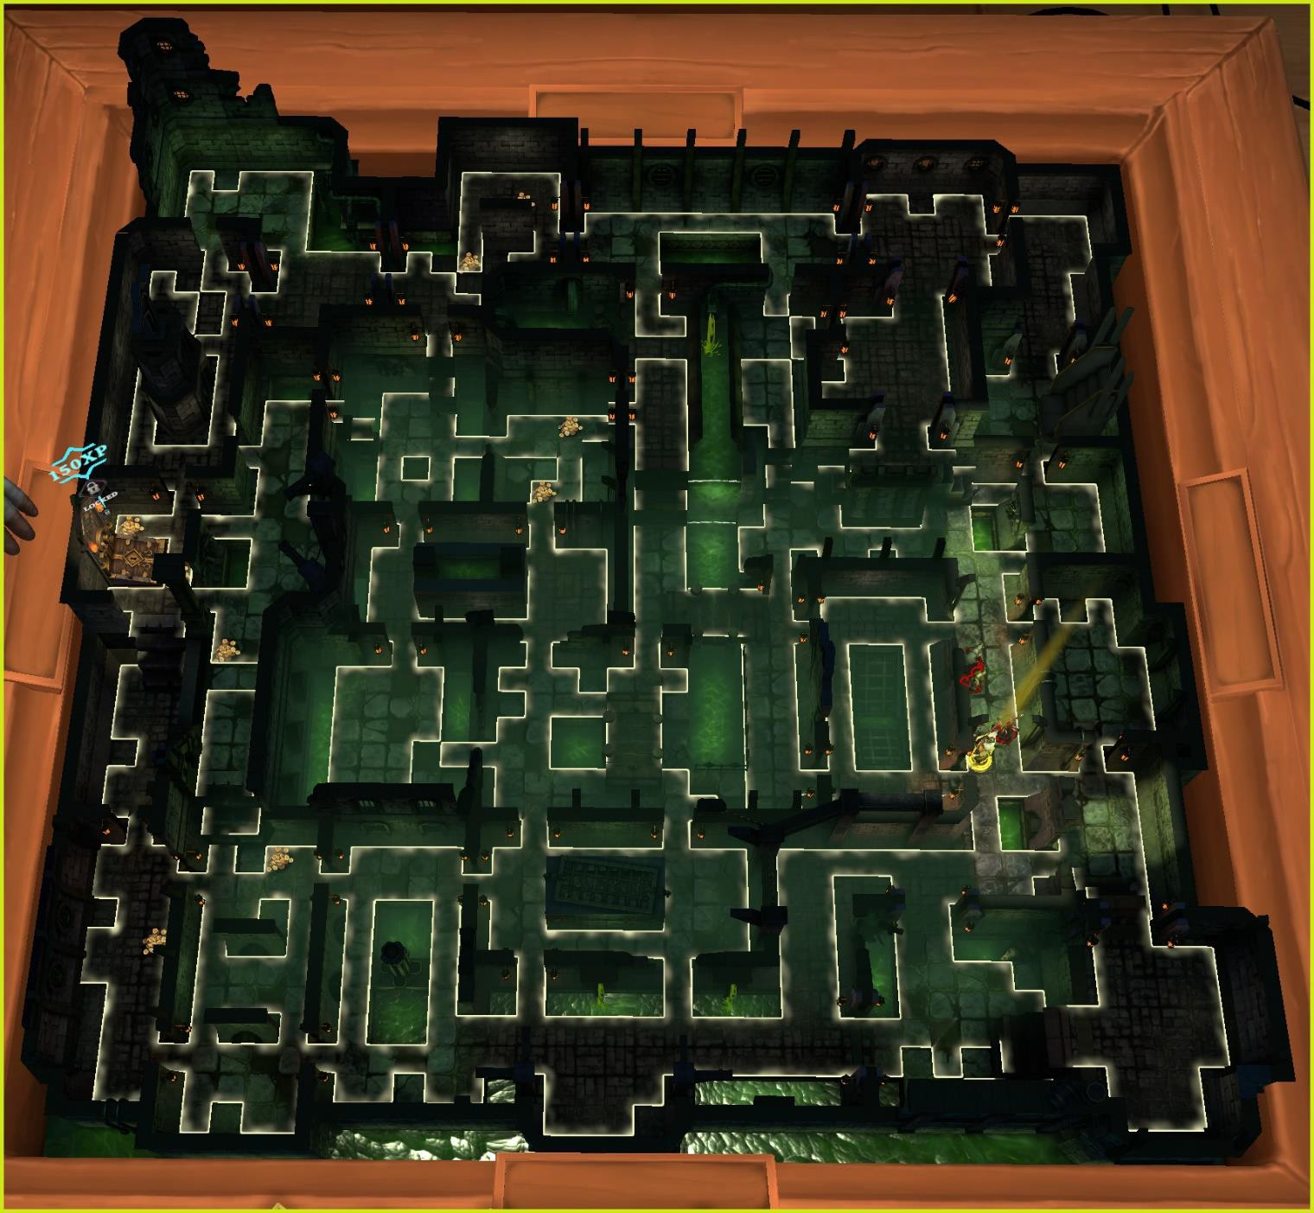

# RAT KING – SEWERS FLOOR 9

This is a small map that has six doors.

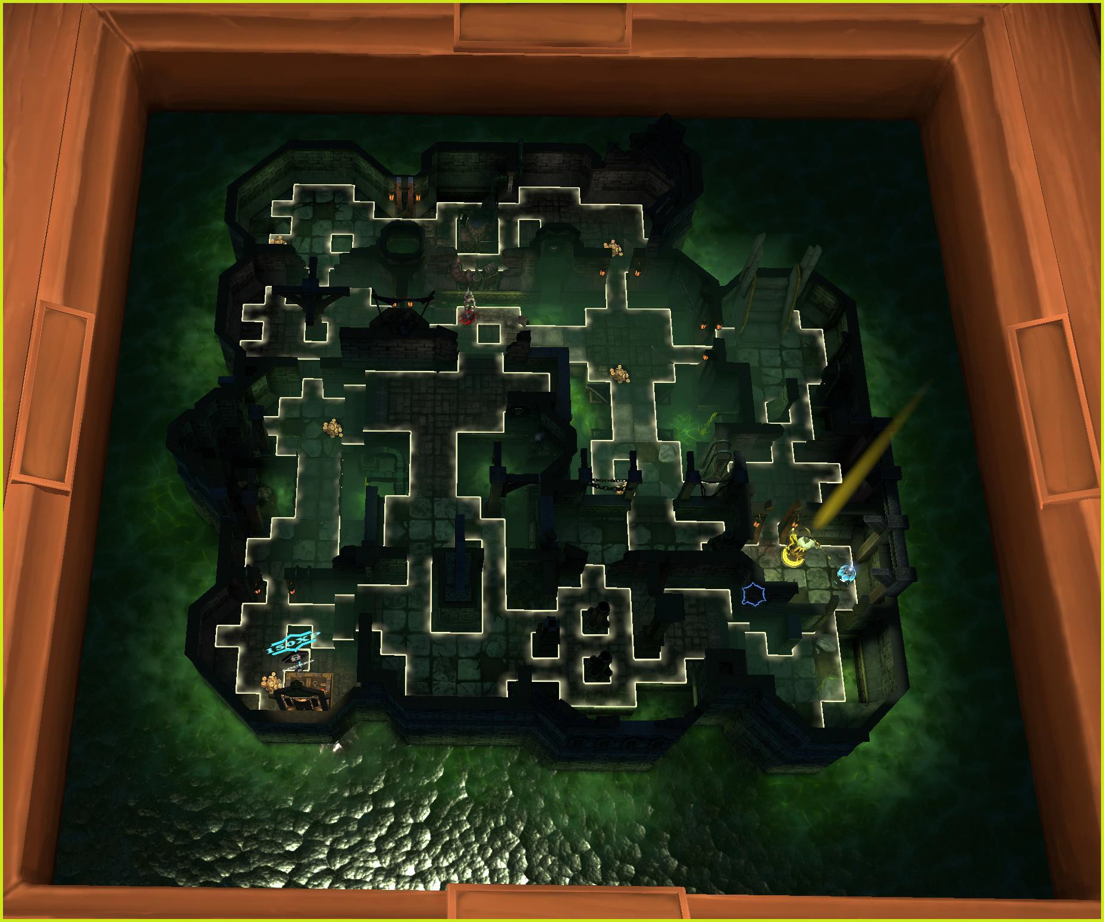

# RAT KING – SEWERS FLOOR 10

This is a medium map that has 11 doors.

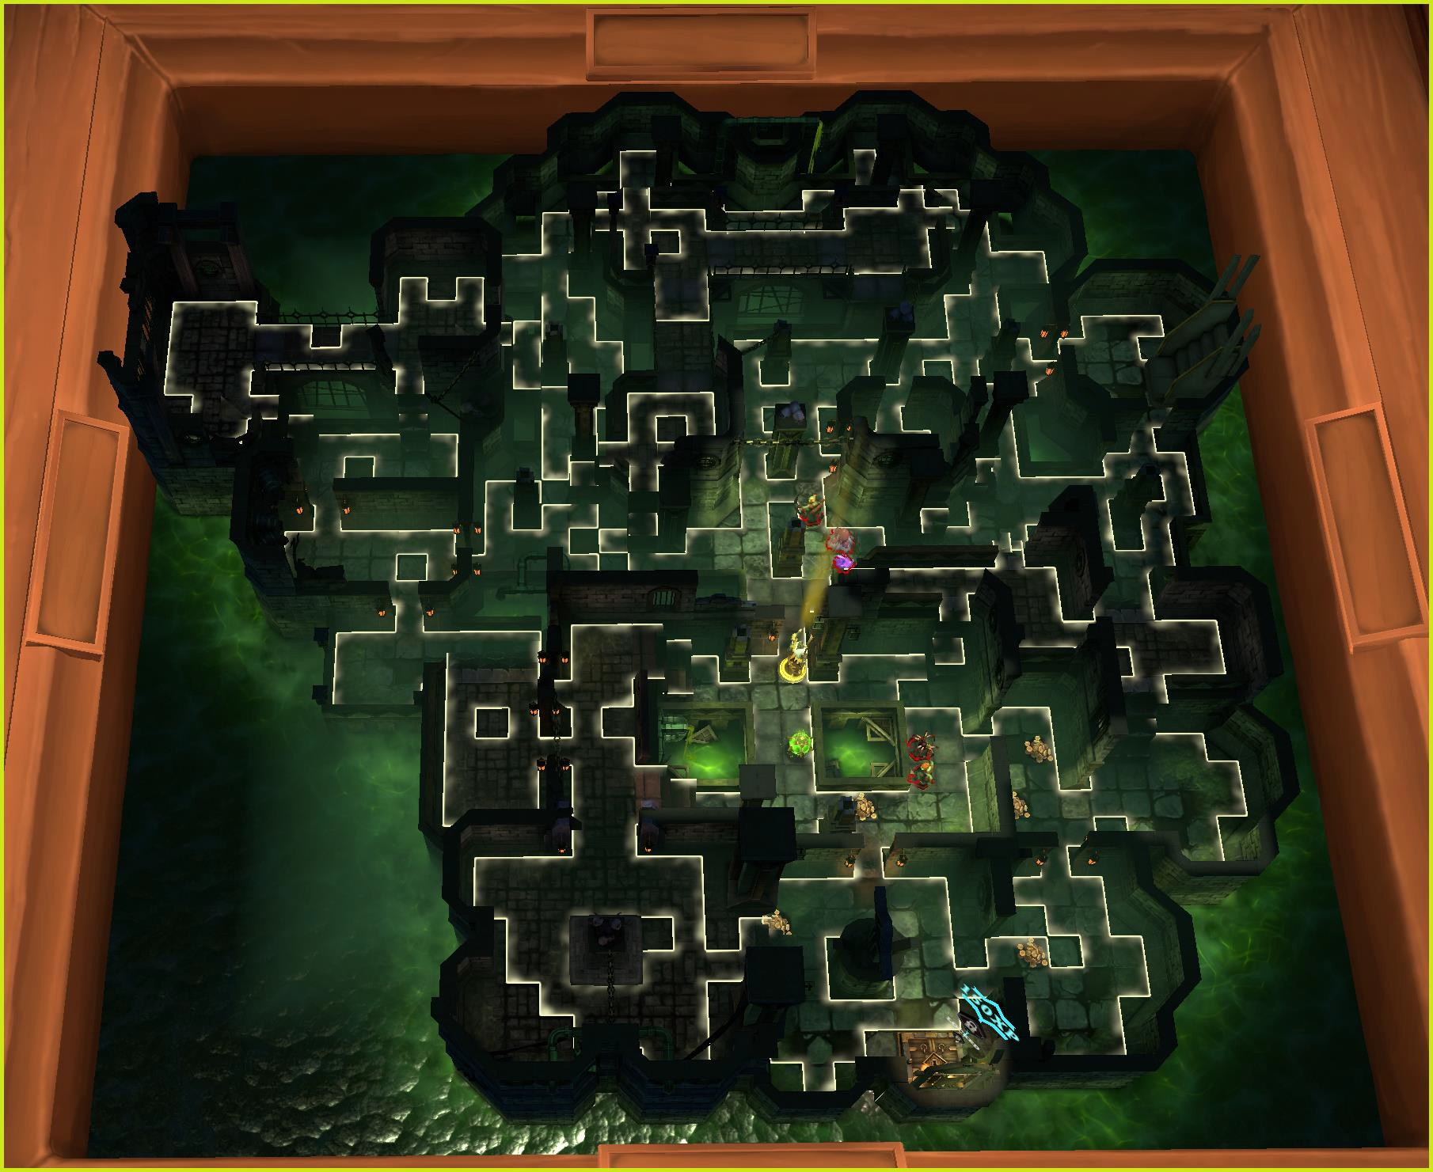

# RAT KING – SEWERS FLOOR 11

This is a small map that has 7 doors.

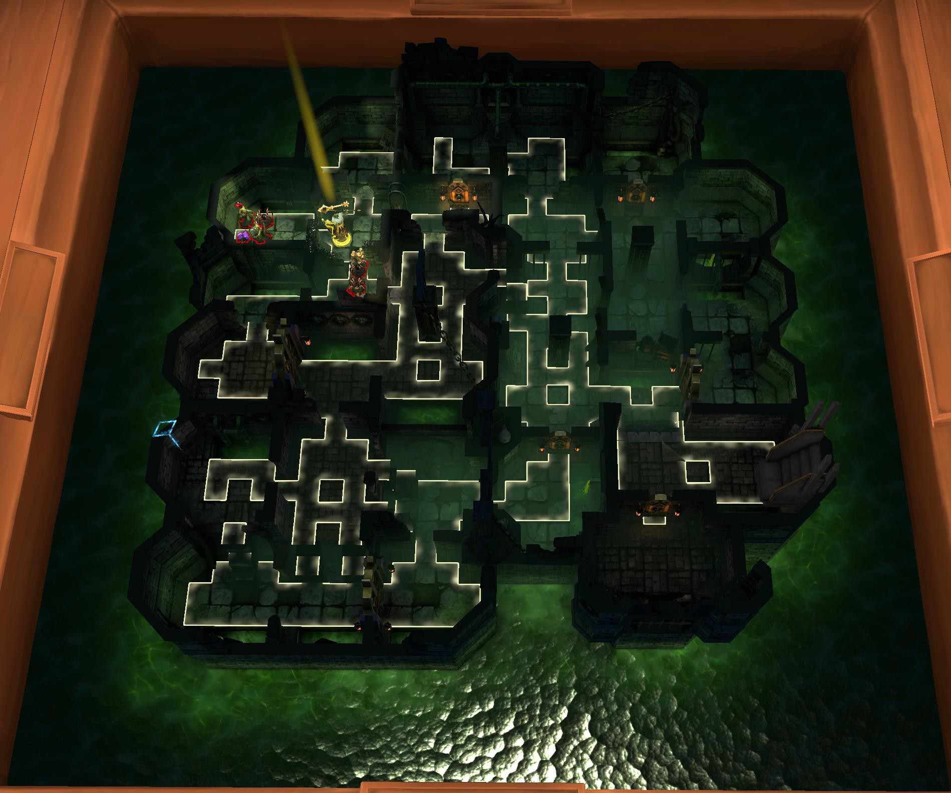

# RAT KING – SEWERS FLOOR 12

This is a medium-sized map that has 4 doors.

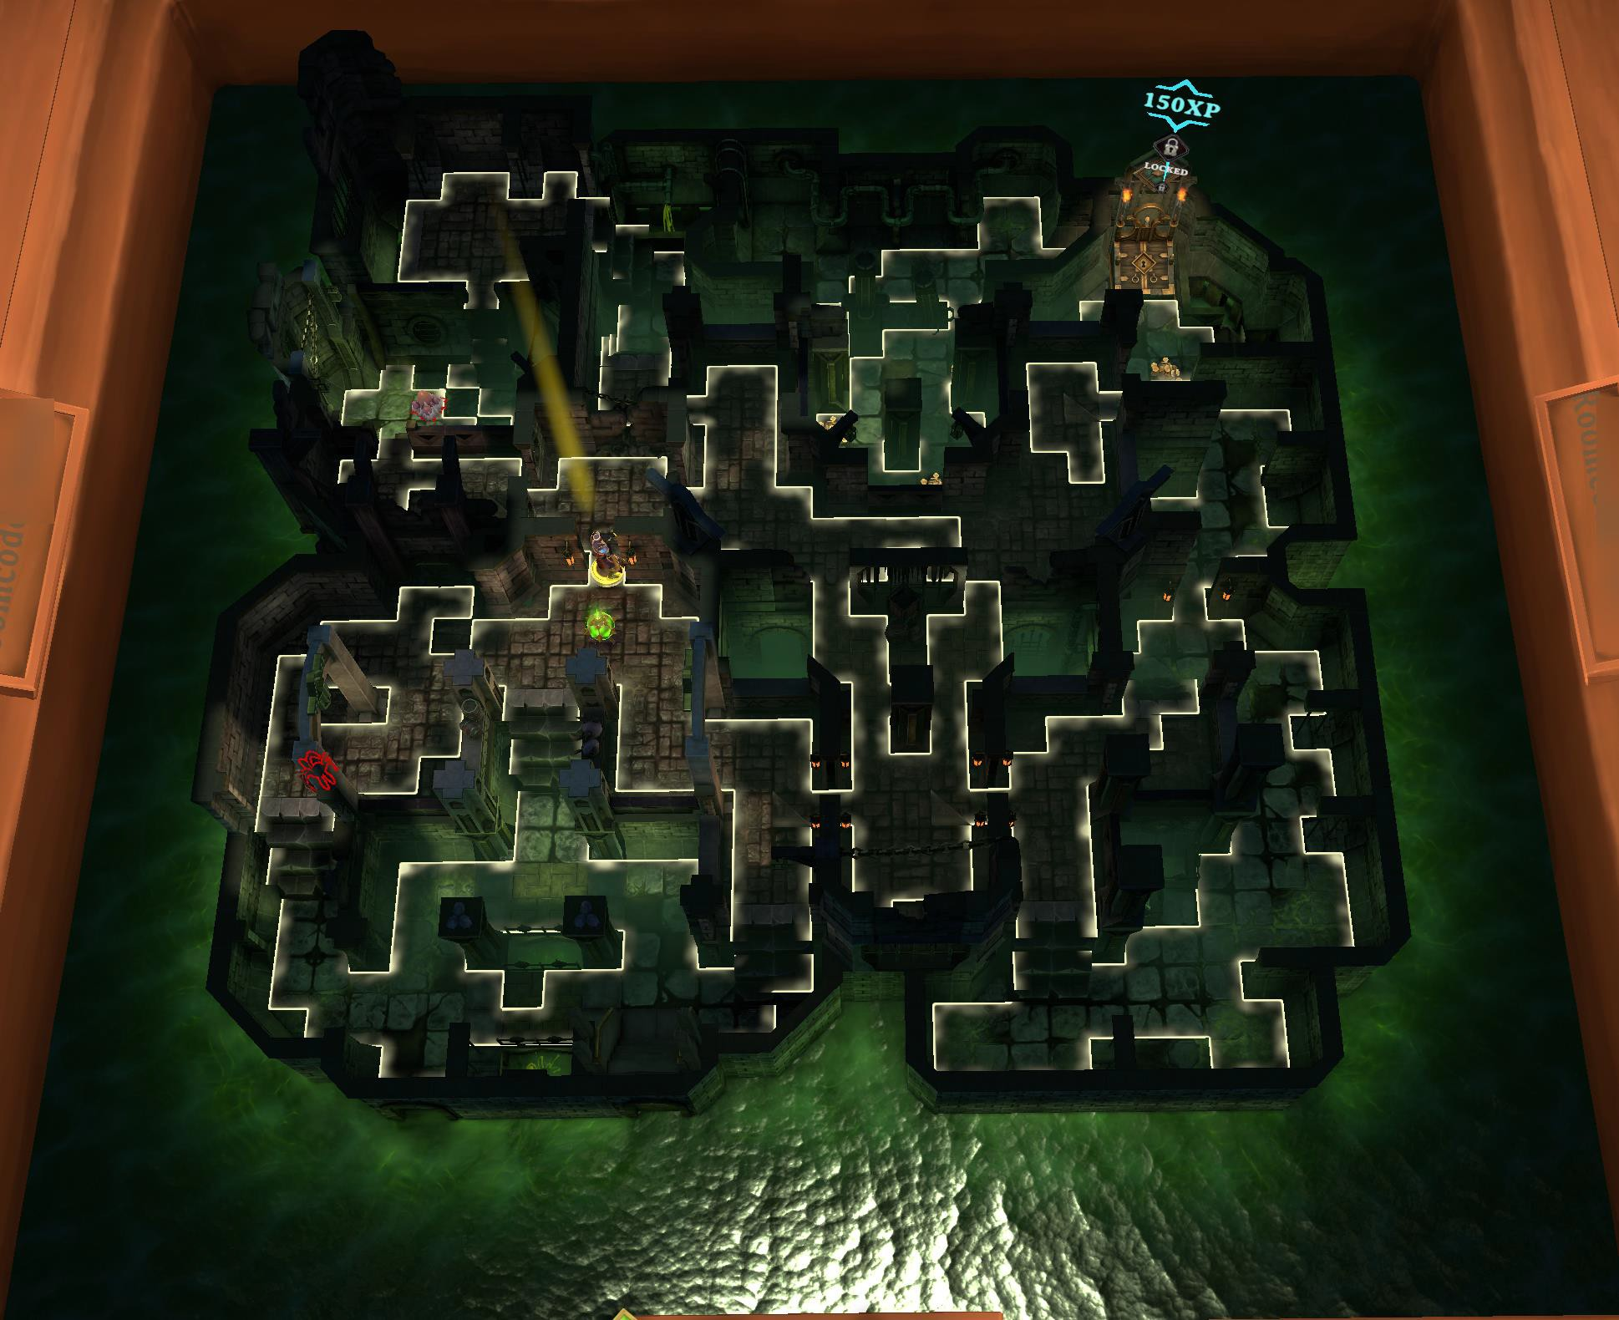

# ROOTS OF EVIL – ENTRANCE

There are 9 floors available for ROOTS OF EVIL. There are two really important things to know about maps. Every time you start a map, the entrance and exit are randomized. The base map is exactly as it is shown with those two exceptions. The tiles have been lit up, allowing you to see as much detail to the map as possible.

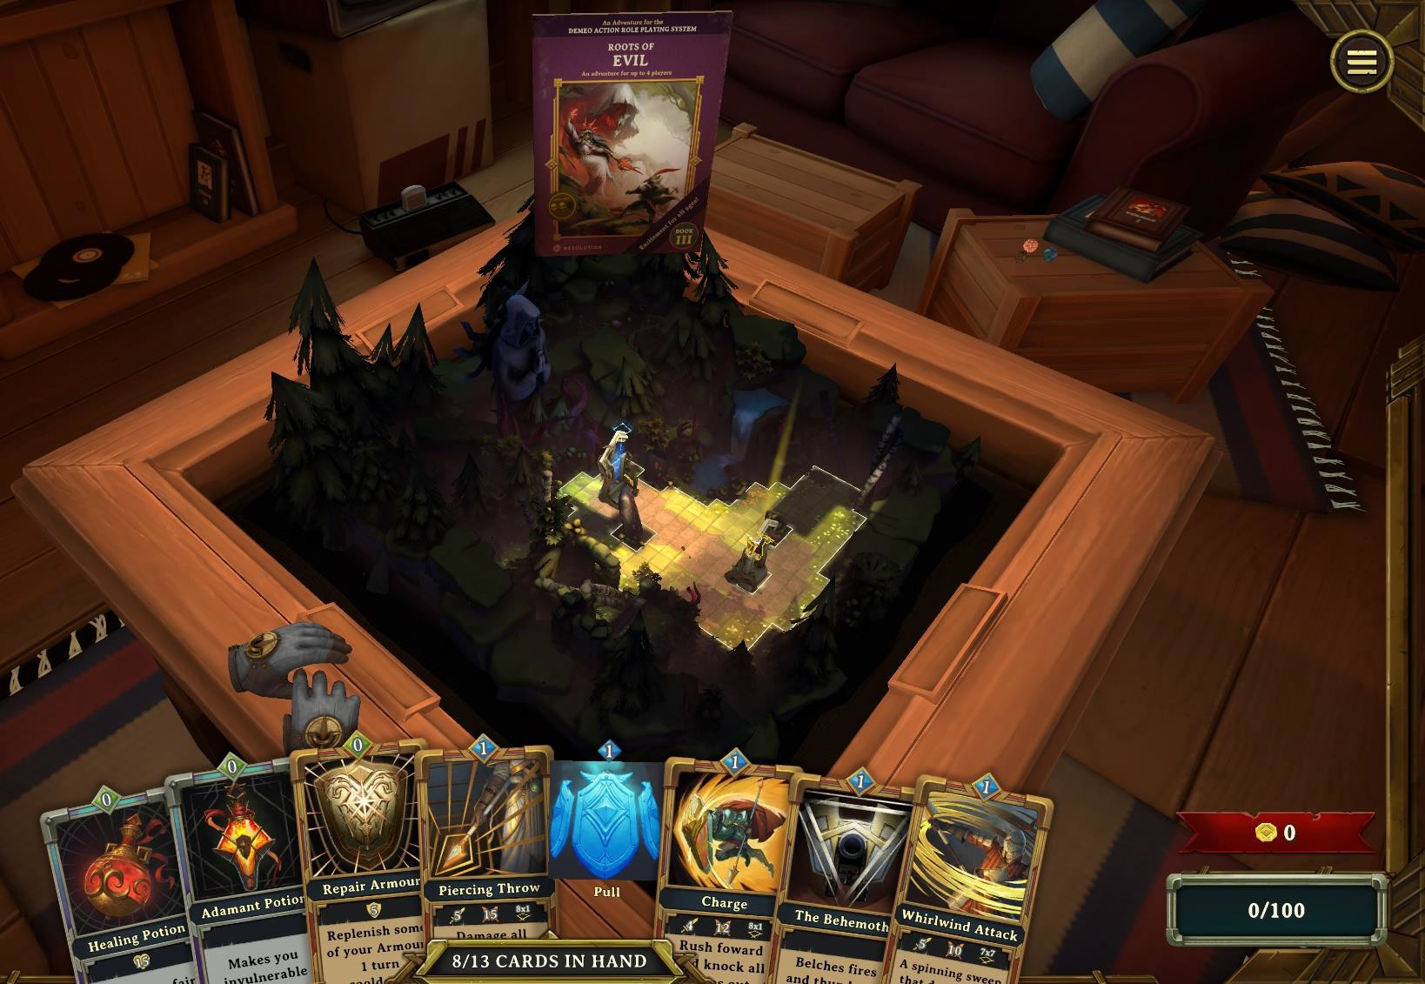

# ROOTS OF EVIL – Forest Floor 1

This is a medium sized floor. You will find 11 doors on Floor 1. There are two really important things to know about maps. Every time you start a map, the entrance and exit are randomized. The base map is exactly as it is shown with those two exceptions. The tiles have been lit up, allowing you to see as much detail to the map as possible.

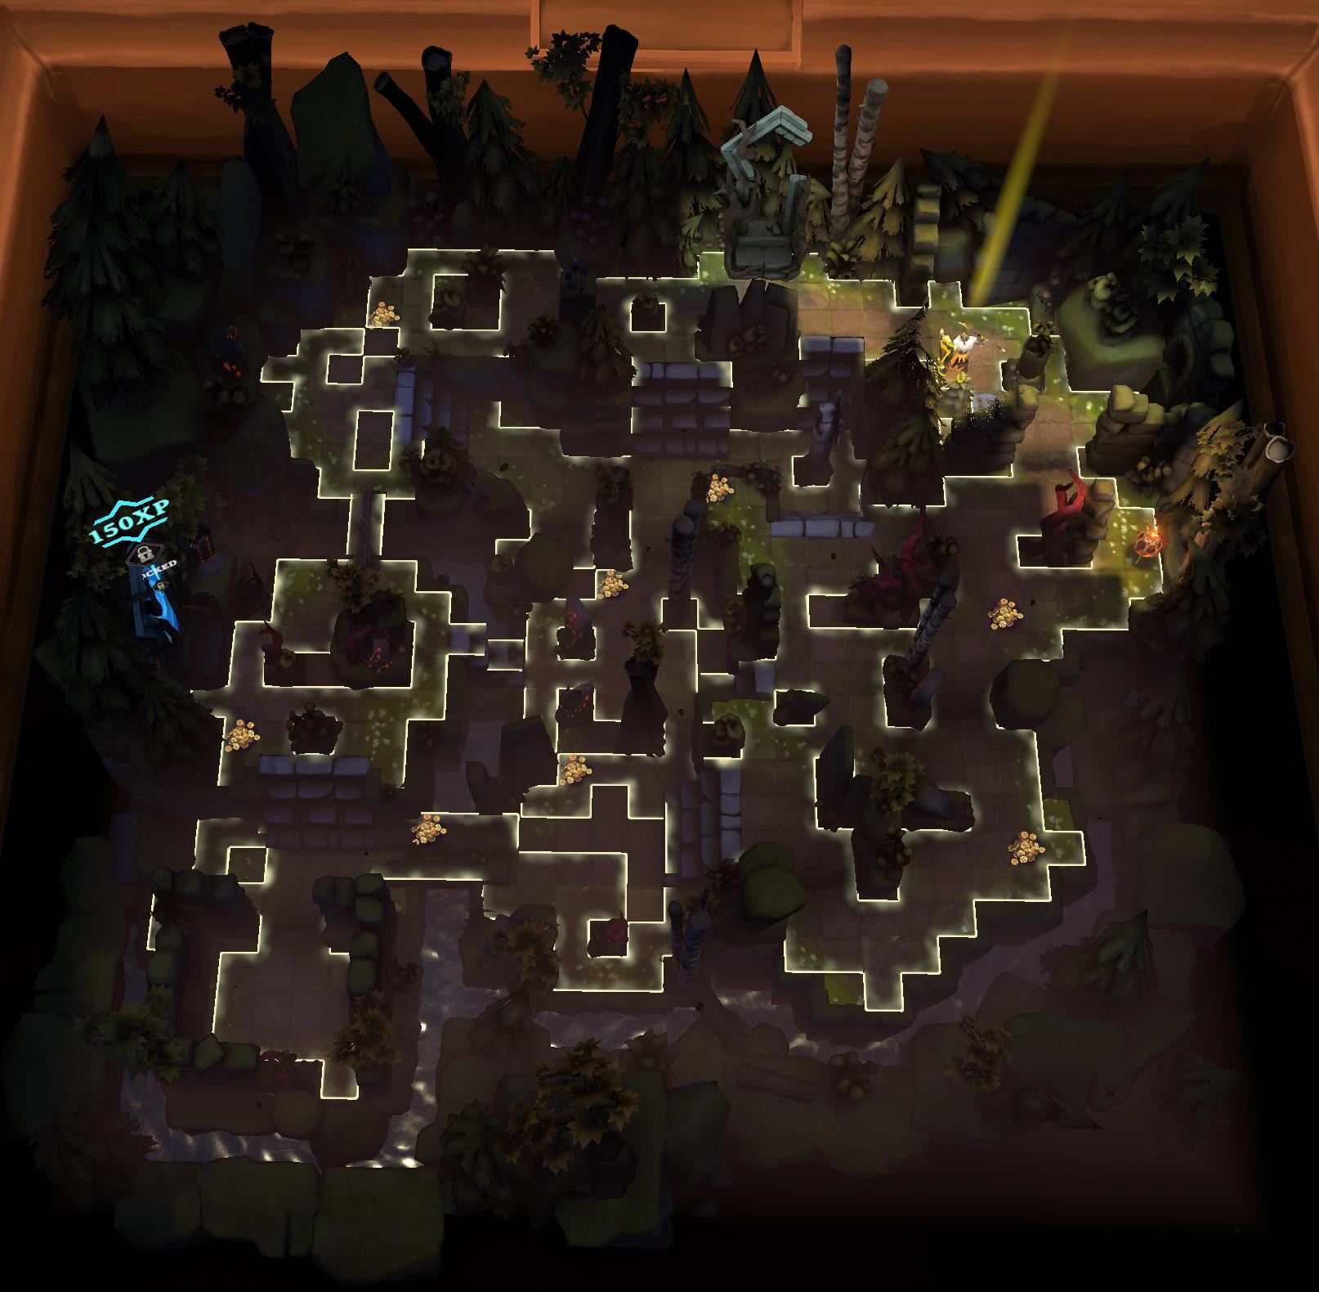

# ROOTS OF EVIL – Forest Floor 2

This is a medium sized floor. You will find 12 doors on Floor 2. There are two really important things to know about maps. Every time you start a map, the entrance and exit are randomized. The base map is exactly as it is shown with those two exceptions. The tiles have been lit up, allowing you to see as much detail to the map as possible.

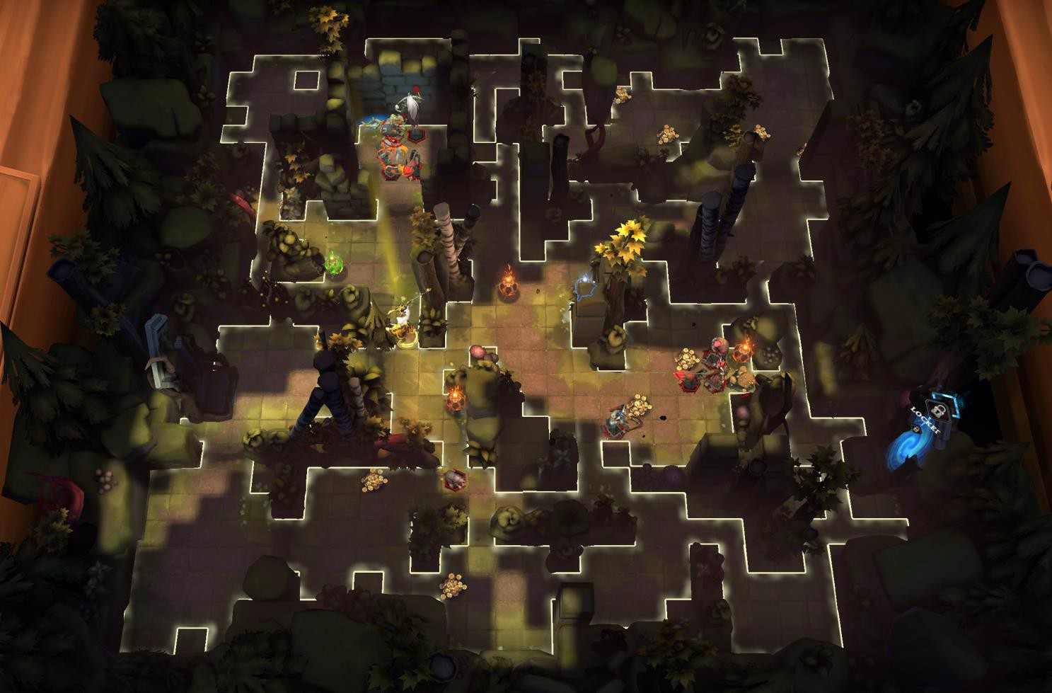

# ROOTS OF EVIL – Forest Floor 3

This is a medium sized floor. You will find 13 doors on Floor 3. There are two really important things to know about maps. Every time you start a map, the entrance and exit are randomized. The base map is exactly as it is shown with those two exceptions. The tiles have been lit up, allowing you to see as much detail to the map as possible.

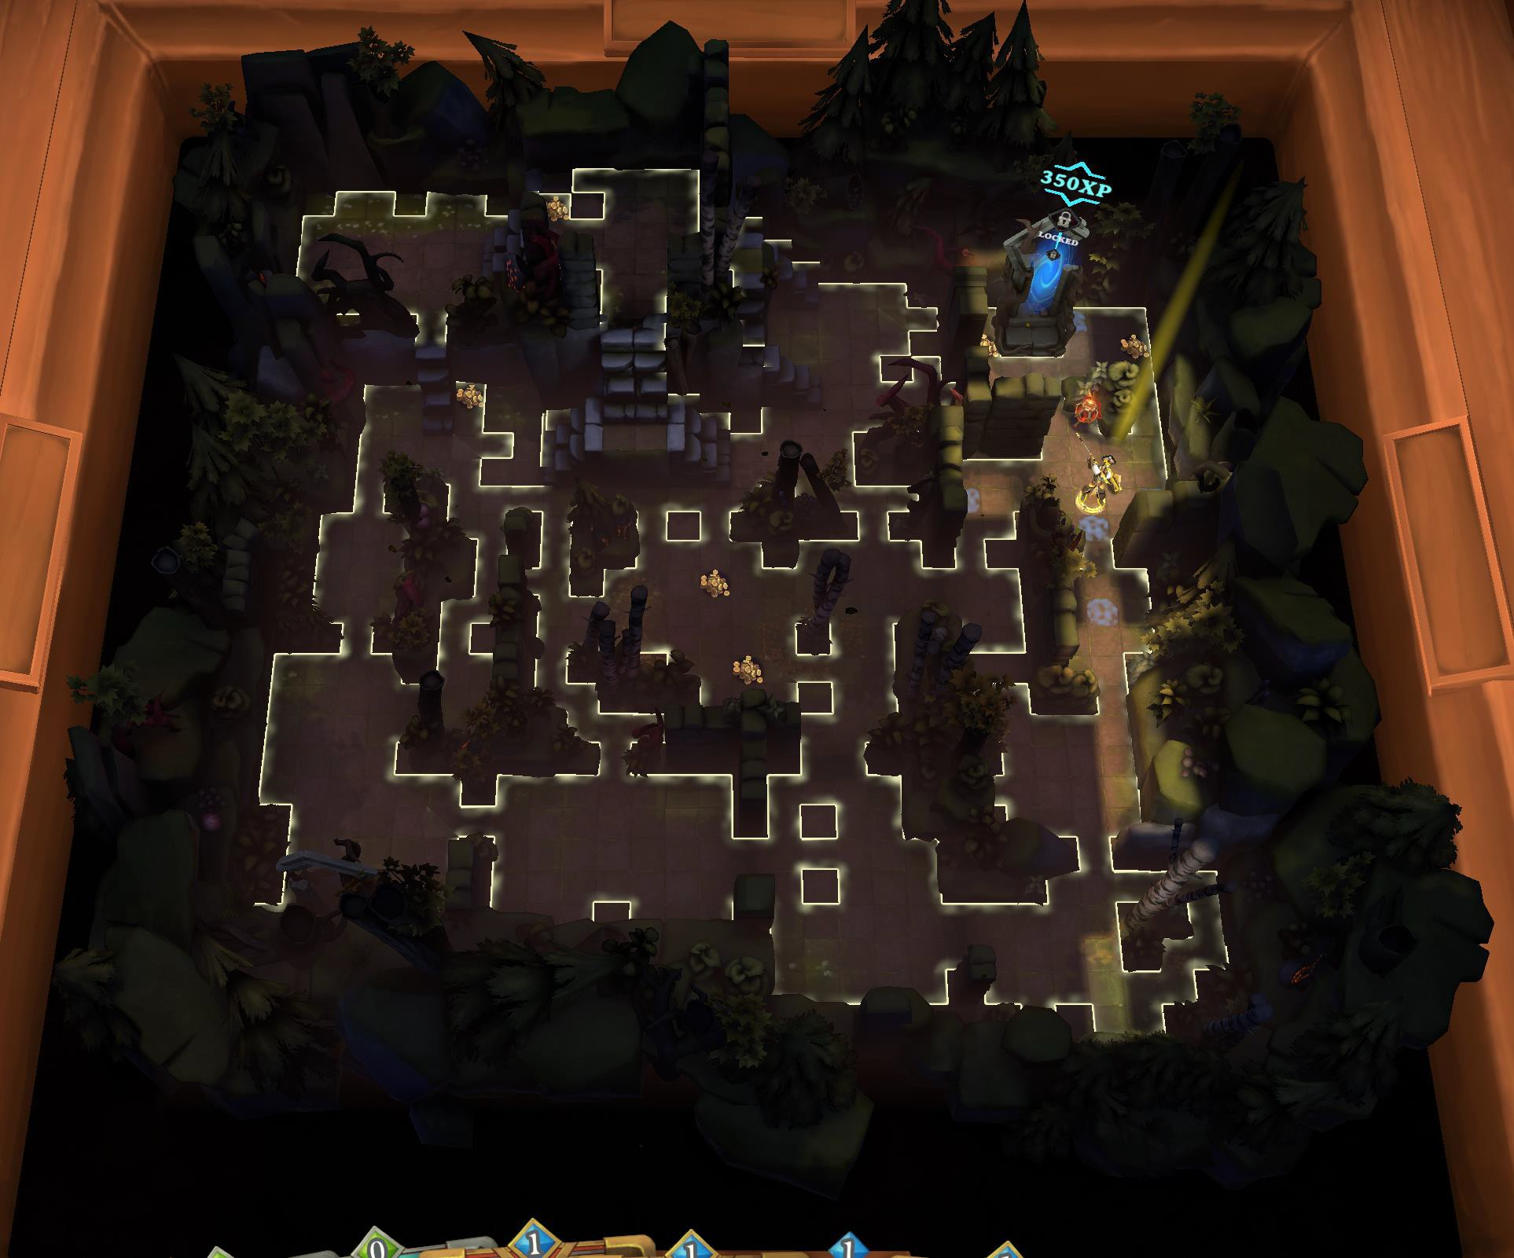

# ROOTS OF EVIL – Forest Floor 4

This is a medium sized floor. You will find 11 doors on Floor 4. There are two really important things to know about maps. Every time you start a map, the entrance and exit are randomized. The base map is exactly as it is shown with those two exceptions. The tiles have been lit up, allowing you to see as much detail to the map as possible.

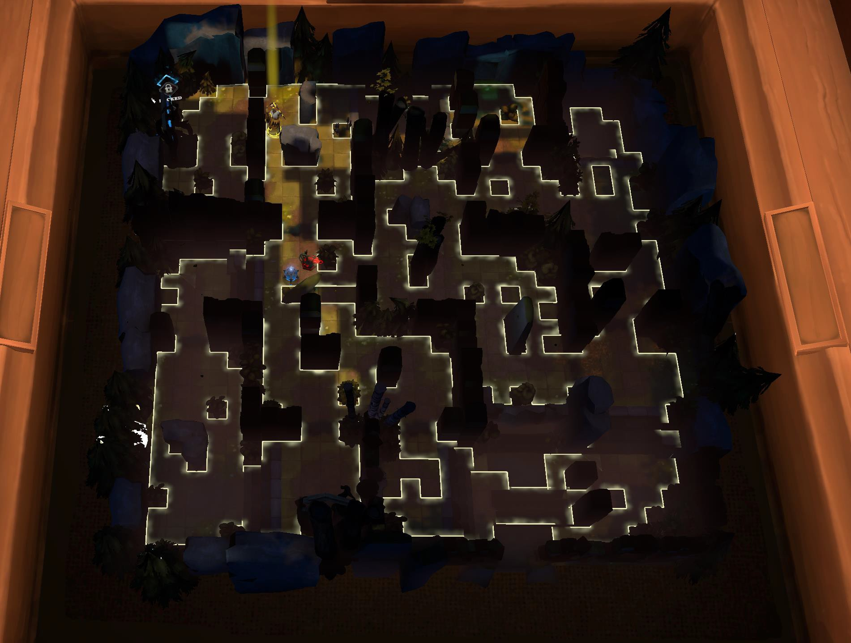

# ROOTS OF EVIL – Forest Floor 5

This is a large sized floor. You will find 28 doors on Floor 5. There are two really important things to know about maps. Every time you start a map, the entrance and exit are randomized. The base map is exactly as it is shown with those two exceptions. The tiles have been lit up, allowing you to see as much detail to the map as possible.

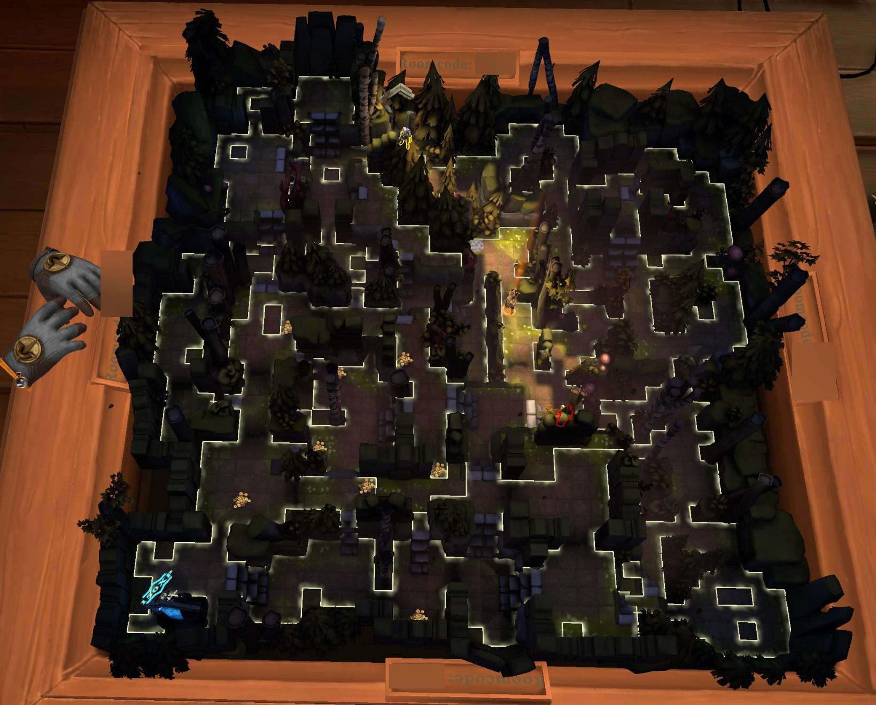

# ROOTS OF EVIL – Forest Floor 6

This is a large sized floor. You will find 7 doors on Floor 6. There are two really important things to know about maps. Every time you start a map, the entrance and exit are randomized. The base map is exactly as it is shown with those two exceptions. The tiles have been lit up, allowing you to see as much detail to the map as possible.

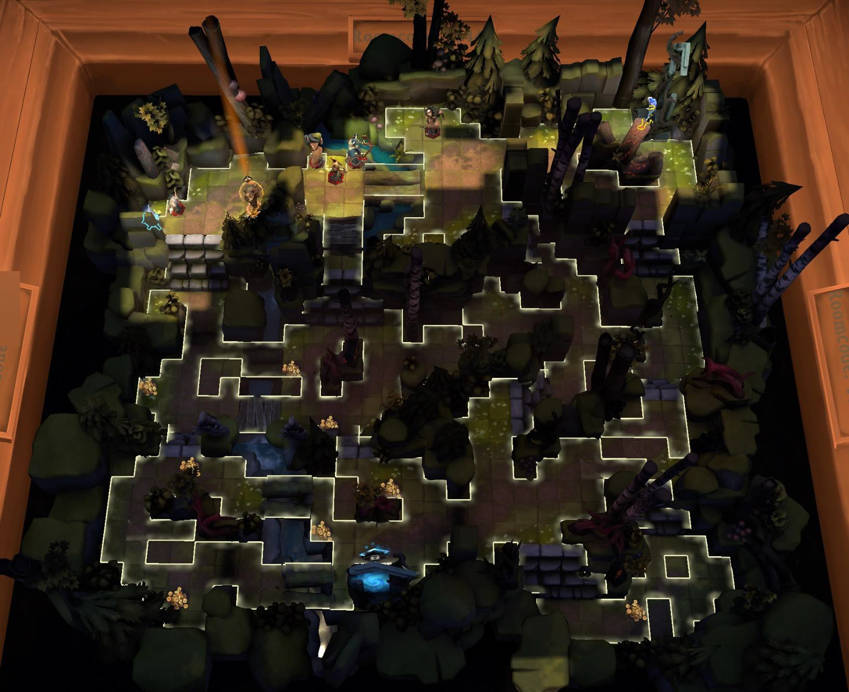

# ROOTS OF EVIL – Forest Floor 7

This is a medium sized floor. You will find 8 doors on Floor 7. There are two really important things to know about maps. Every time you start a map, the entrance and exit are randomized. The base map is exactly as it is shown with those two exceptions. The tiles have been lit up, allowing you to see as much detail to the map as possible.

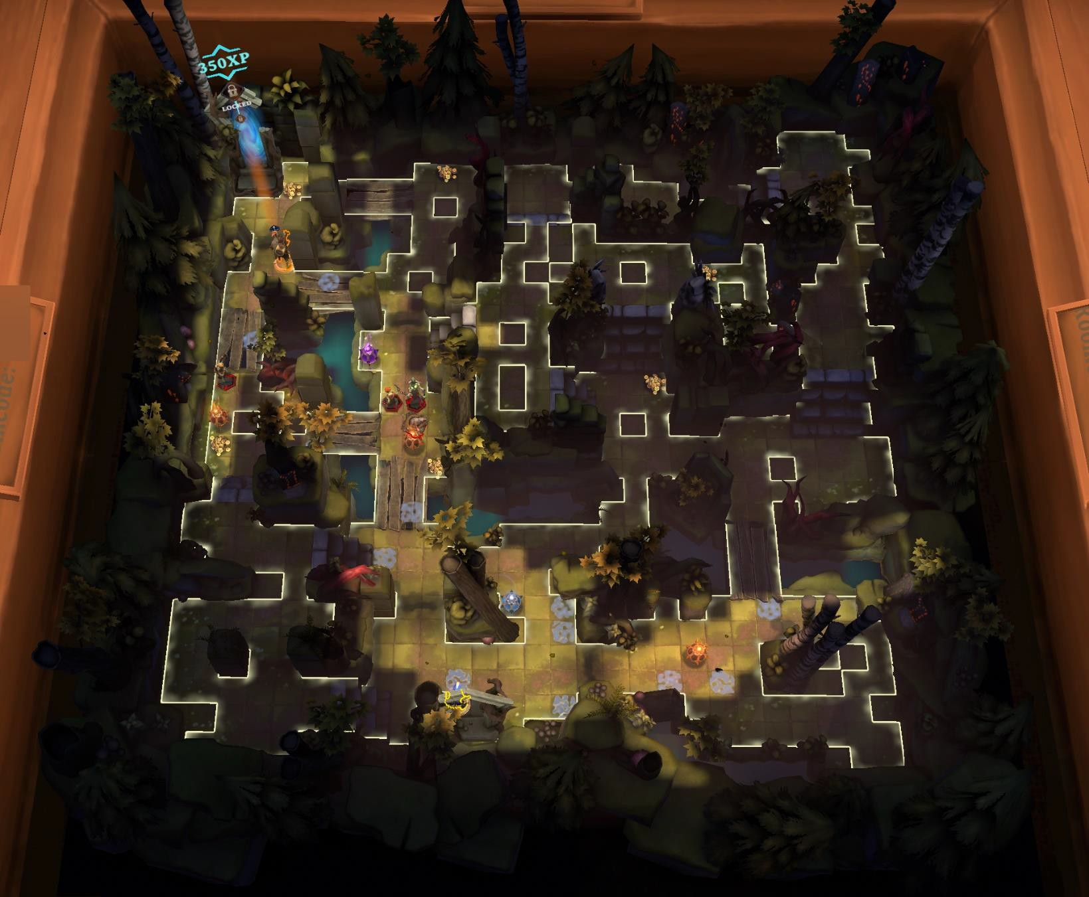

# ROOTS OF EVIL – Forest Floor 8

This is a medium sized floor. You will find 8 doors on Floor 8. There are two really important things to know about maps. Every time you start a map, the entrance and exit are randomized. The base map is exactly as it is shown with those two exceptions. The tiles have been lit up, allowing you to see as much detail to the map as possible.

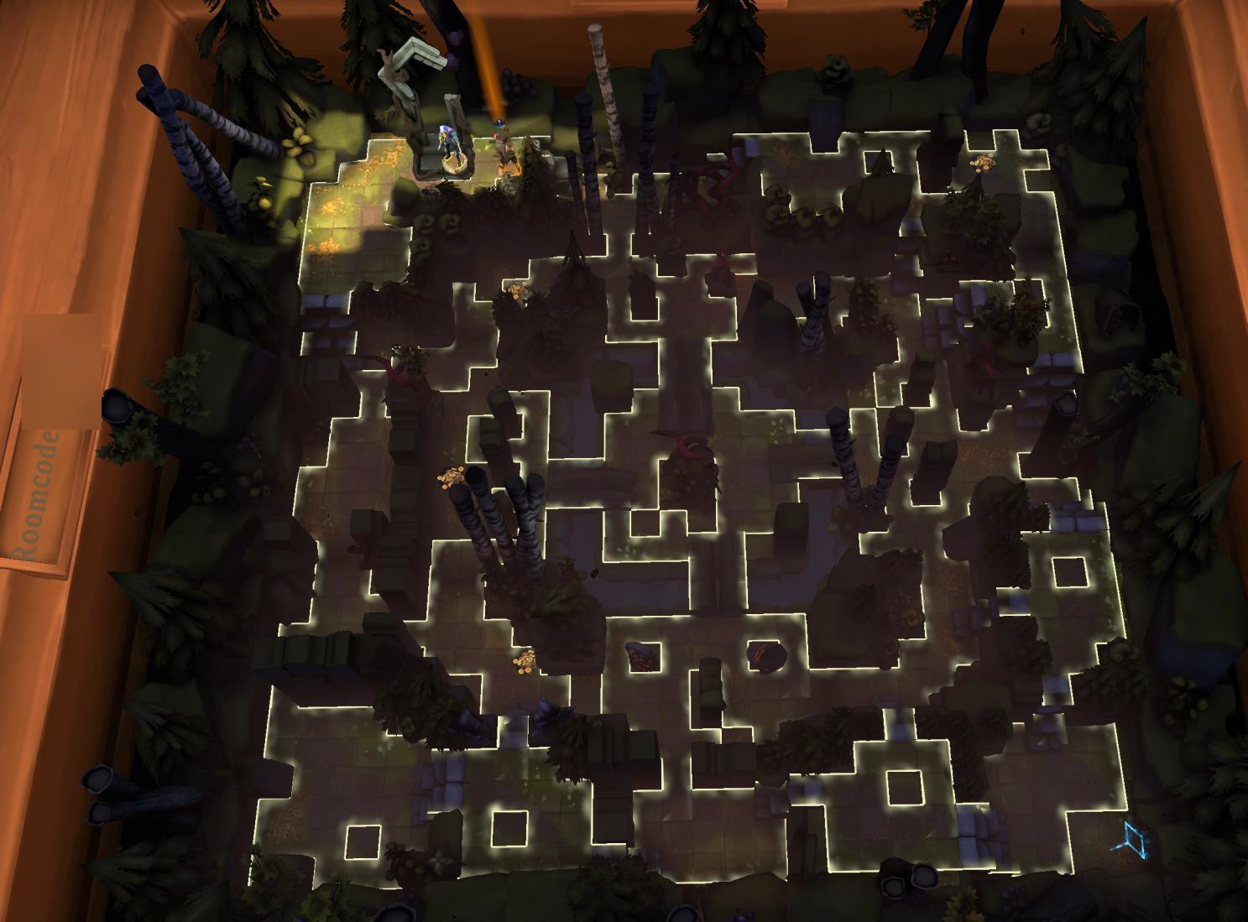

# ROOTS OF EVIL – Forest Floor 9

This is a large sized floor. You will find 9 doors on Floor 9. There are two really important things to know about maps. Every time you start a map, the entrance and exit are randomized. The base map is exactly as it is shown with those two exceptions. The tiles have been lit up, allowing you to see as much detail to the map as possible.

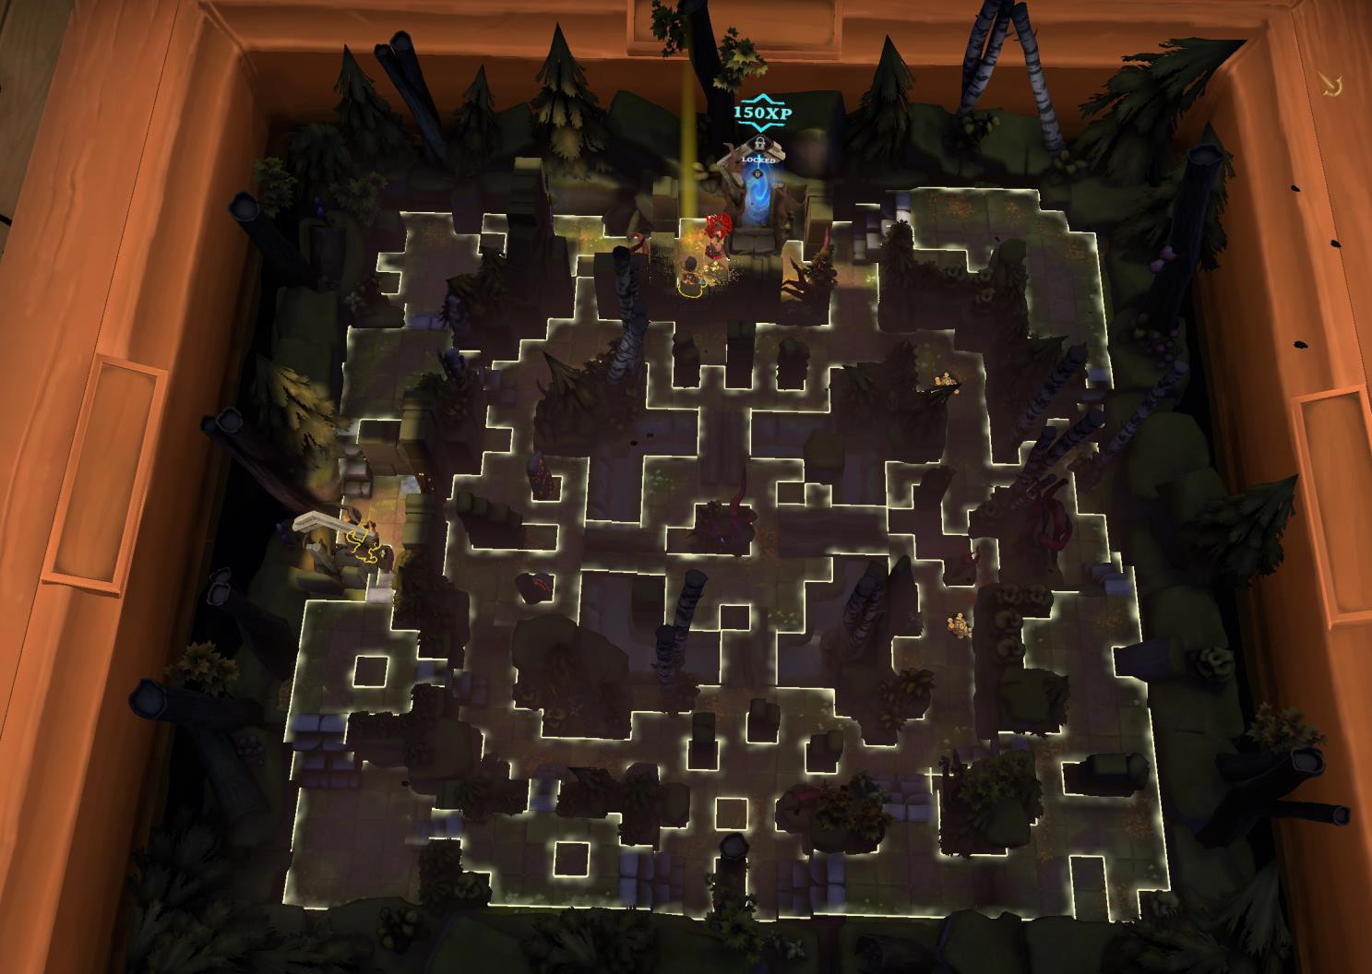

# Shop Floors

The shop floors are used within the LevelSequenceOverridden rule. Its primary purpose is to provide an opportunity to pay for cards after accumulating money from a previously played level. In the example shown below, the first level that you will begin to play is the Black Sarcophagus (ElvenFloor01) map. When you get to the exit you will go into the next map. Notice that in this example you will play three maps and then be given an option to buy cards in the Forest Shopfloor. After you purchase your cards, you will have one more level.

"Rule" - "LevelSequenceOverridden", "Config" - [ "ElvenFloor01", "SewersFloor07", "ForestFloor09", "ForestShopFloor", "ElvenFloor08" ]

Here is a screen capture from a typical shop floor. One thing I noticed is that the other shop floors have no number after its name. In the example below all of the cards will dim if you have no money to purchase, otherwise they are lit up in bright card colors. The audible narrative is different for each shop floor, but the screen shown is the same for all shop floors. There are numerous audio tracks that will greet you upon enter the shop floor and they are randomized. Some of the tracks are -

* As you step into the sarcophagus your reminded of your quest. Release the trapped Elven spirits by destroying their corrupt keeper far below.
* Hello, hello! You got the gold I’ve got the wares.
* You entered the second floor Necropolis, ready to fight.
* Here are some of those tracks and more – [Click Here to hear audio tracks](https://github.com/Degederon/HouseRulesGuide/blob/main/Shop%20Floor%20Tracks.mp4)

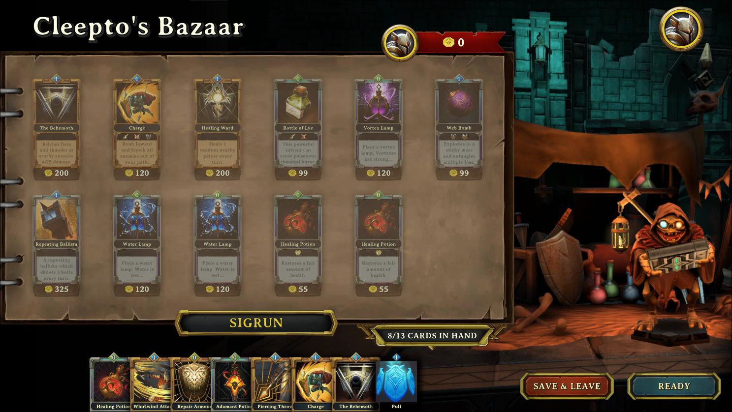

# Cool Links

This section was fun to research. It will point you to links that you may not have seen before. Hover on links below and click!

* [Resolution Games](https://www.resolutiongames.com/demeo)
* [Are Demeo Servers Up\Down](https://www.gamebezz.com/status/demeo/)
* [Demeo (@DemeoGame) / Twitter](https://twitter.com/demeogame?lang=en)
* [Steam Community - Demeo](https://steamcommunity.com/app/1484280)
* [Demeo - The Ultimate RPG Board Game Experience (reddit.com)](https://www.reddit.com/r/Demeo/)
* [A boat load of links worth knowing!](https://www.facebook.com/groups/demeo/posts/297374565464399/) – Facebook
* [Demeo Wiki | Fandom](https://demeo.fandom.com/wiki/A_Players_Handbook)
* [Discord – Modders Channel](https://discord.com/invite/N9DZB5ebmj)
* Send feedback and your test rulesets to [demeo@epomd.com](mailto:demeo@epomd.com).

# Steam Achievements

There are 38 Steam achievement’s you can attain. You should check out how many you have achieved on Steam.

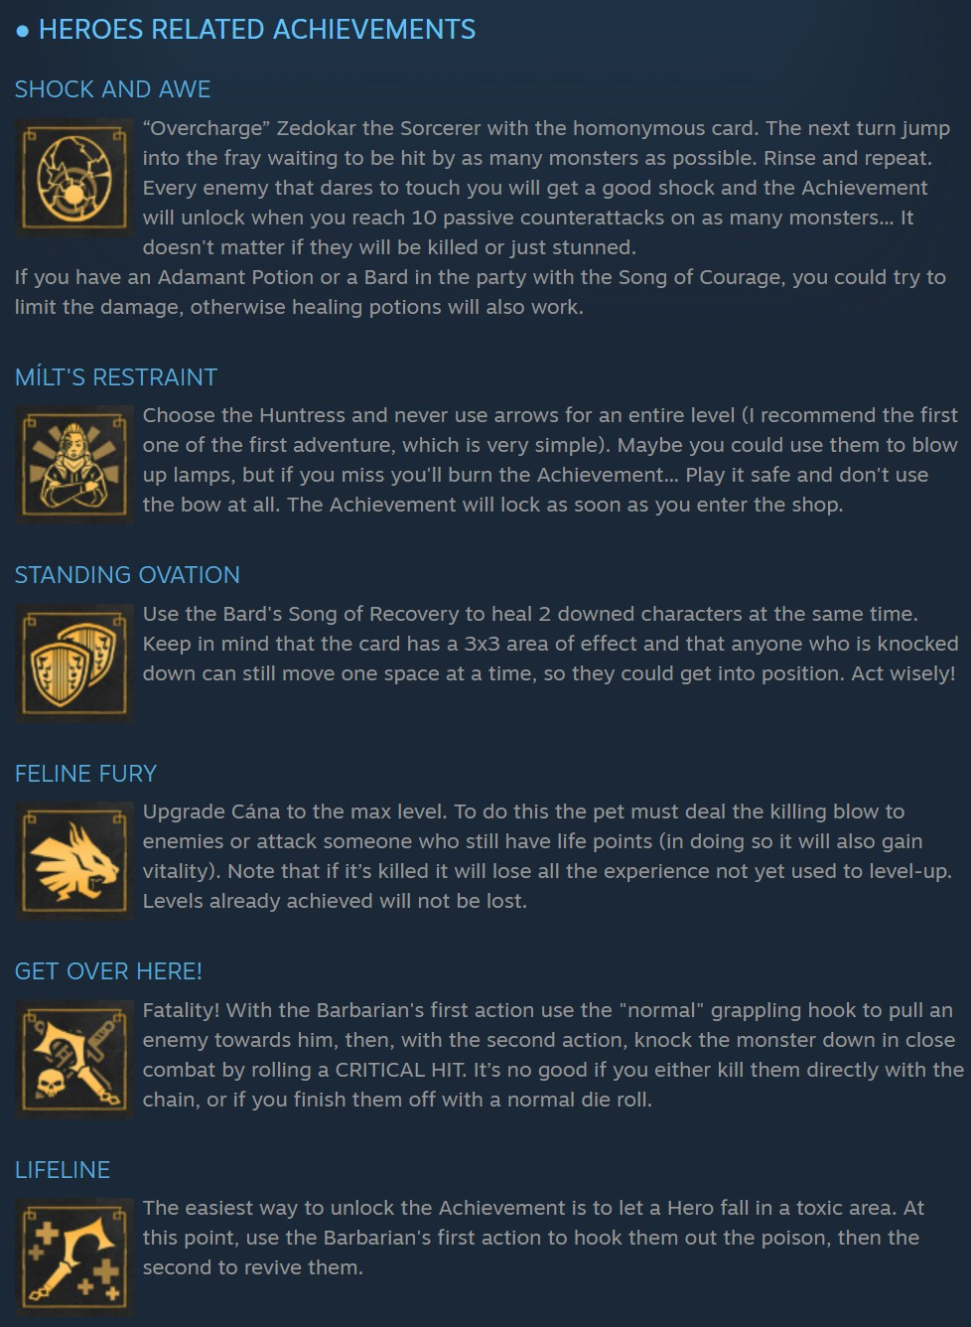



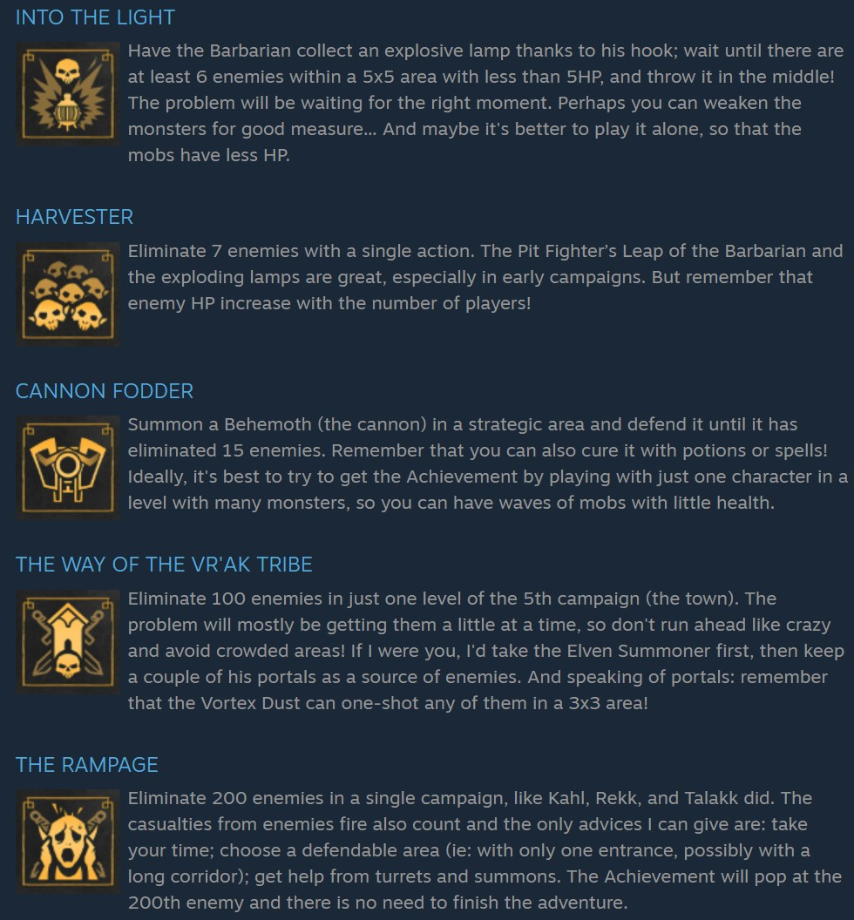

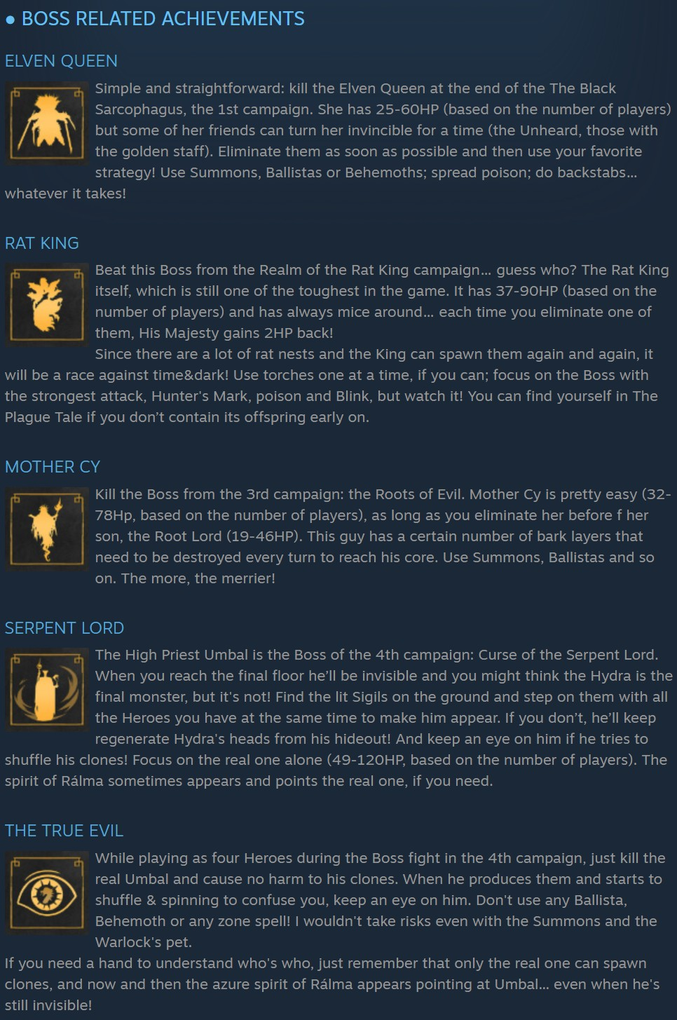

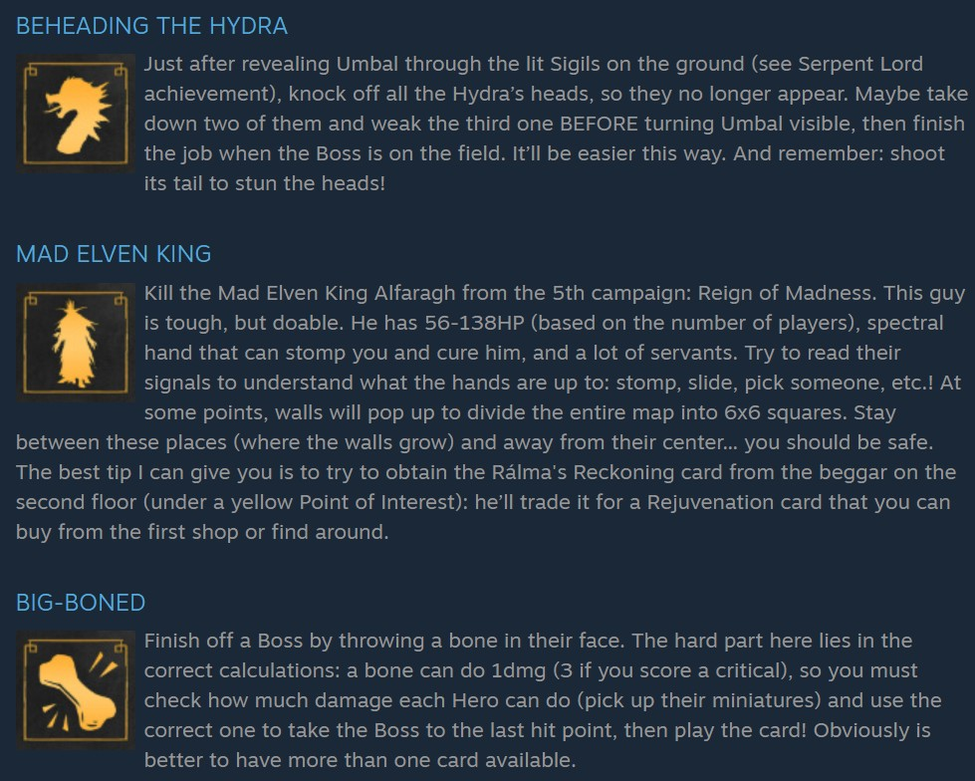

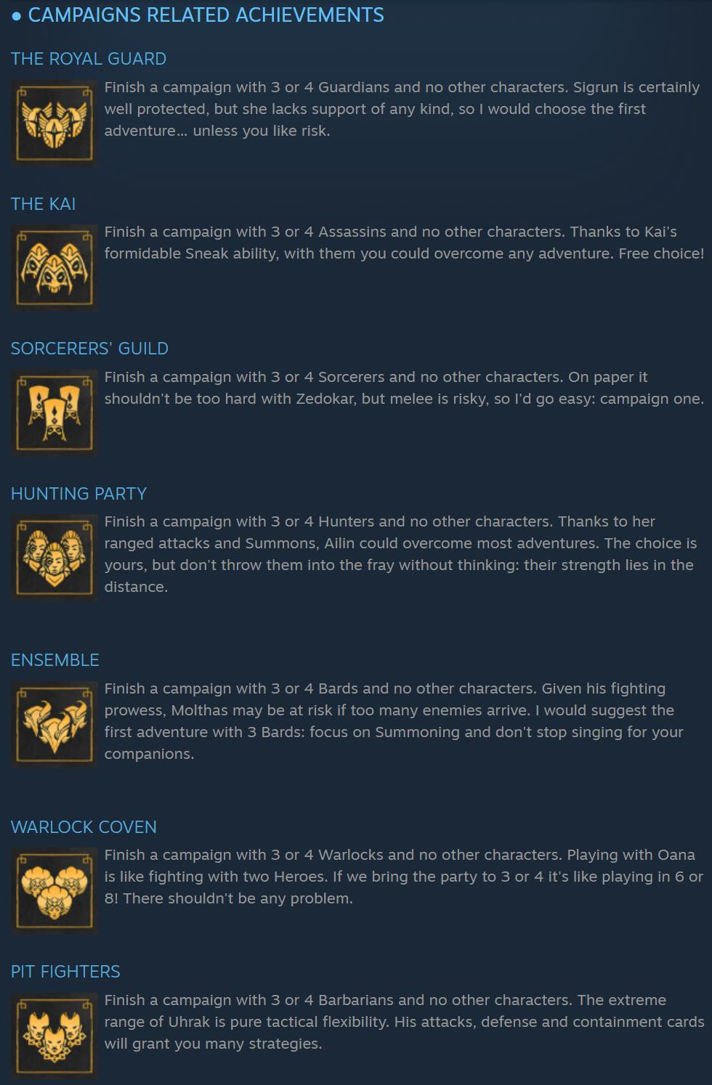

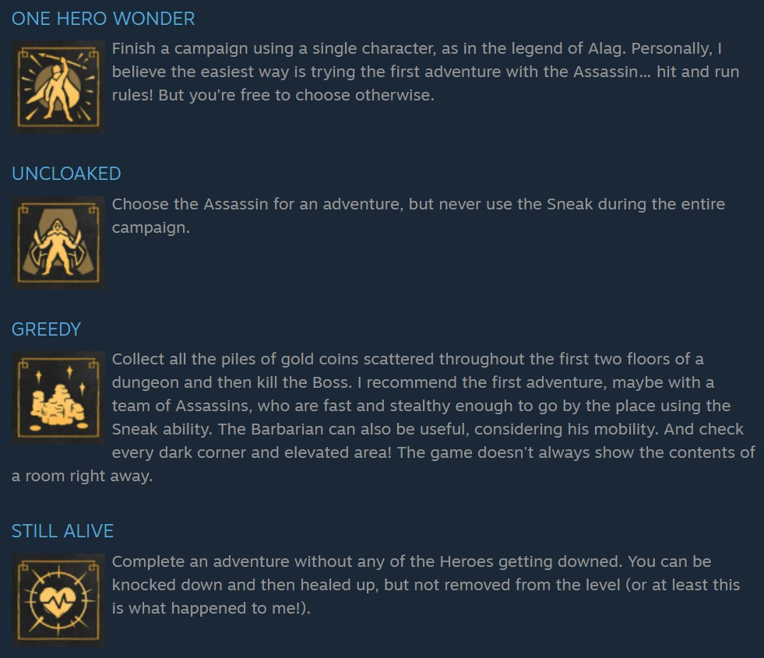

# Custome RuleSets for House Rules

This section, created by Dege, aims to help both new and experienced modders. It breaks down each custom ruleset in simple terms, explaining what each part does and how you can use it. The goal is to save you time by testing different methods to see what works and what doesn’t. Every ruleset is thoroughly played through on all levels to ensure it functions well. After creation, it’s analyzed by various AI tools to check for balance and playability. However, you should carefully review the AI-provided syntax and commands for your custom rulesets, as they may not always be accurate or reliable by AI.

# Custom Scenario 1 – Arcane Mastery

"Arcane Mastery" is a spell-centric Demeo campaign where all classes wield tailored magical abilities, featuring enhanced spell damage, free casts on critical hits, increased gold (1.25x), reduced enemy health (0.85x), and enemies unable to open doors. It spans two levels: "Level_ElvenQueen" (mystical forest) and "Level_RealmOfTheRatKing" (underground hordes), delivering a fast-paced, magical adventure.

**Number of Players** - Optimized for 2-4 players. Two players (e.g., Sorcerer/Bard) offer strong synergy; 3-4 players maximize spell variety. Solo play is viable but tough due to limited sustain.

**Player Roles**

* HeroSorcerer (AoE Damage): Wields "Fireball" ([8,16], free on crit), "Zap" ([4,8], free on crit), and "Heal" (10). Clears groups and sustains party.
* HeroBard (Support/Healer): Uses "Heal" (10) and "HealingLight" (12) for strong healing. Supports from backline, lacks direct damage spells.
* HeroGuardian (Tank/Magic): Has "Fireball" ([8,16]), "Whirlwind" ([5,10]), and "Heal" (10). Tanks and deals AoE damage.
* HeroBarbarian (Melee Magic): Uses "Whirlwind" ([5,10]) for melee AoE. No healing, focuses on close-range damage.
* HeroHunter (Precision Damage): Wields "Zap" ([4,8]) and "HunterArrow" ([6,12], free on crit). Excels at single-target damage and crit chains.
* HeroRogue (Stealth/Precision): Uses "Zap" ([4,8]) and "HunterArrow" ([6,12]). Combines stealth with precise spell attacks.
* HeroWarlock (Flexible Magic): Relies on default deck, potentially underpowered without specific spell overrides.

**Strategy -** General: Pair Sorcerer (AoE) with Bard (healing); add Guardian (tanking) or Hunter (precision) for 3-4 players. Use doors to control pacing, group enemies for "Fireball"/"Whirlwind", and chain crits for free casts.

* Level_ElvenQueen: Clear with "Fireball"; Bard heals. Buy potions with extra gold (1.25x).
* Level_RealmOfTheRatKing: Use AoE for hordes; Hunter/Rogue focus crits. Save "HealingLight" for boss.
* Tips - Prioritize crits for free spells. Guardian blocks chokepoints. Manage action points for "Zap" spam. Expect 1–2-hour sessions. Revive quickly with heals to avoid wipes.

Download the very commented ruleset called Shield and Verse from Dege’s [Github](https://github.com/Degederon/HouseRulesGuide/tree/main/Ruleset%20-%20Scenarios%20Here).

# Custom Scenario 2 – Heroic Abyss

"Heroic Abyss" is a high-intensity Demeo campaign for four players (HeroSorcerer, HeroGuardian, HeroBard, HeroHunter), navigating a five-floor abyssal dungeon (ElvenFloor10, ElvenFloor14, ElvenFloor15, ElvenFloor16, ElvenFloor17). It features enhanced spells/healing, free abilities, scaled enemies (1.25x attack, 1.2x health), and scarce resources. Keyholders (Mimic, Wyvern, Gorgon, SilentSentinel) gate progression, culminating in a boss fight against BigBoiMutant/ServantOfAlfaragh.

**Number of Players**

Optimized for **4 players**. The ruleset balances four heroes’ roles for the challenging five-floor gauntlet. Fewer players struggle with enemy scaling and resource limits; solo play is nearly impossible.

**Player Roles**

* **HeroSorcerer (AoE Damage)** - Health 12.0, attack 4.0, crit 8.0, move 6.0, AP 4.0. Uses "Fireball" ([10,16]), "Zap" ([6,12]), "Heal" (12). Clears groups, minor healing. Immune to "Diseased".
* **HeroGuardian (Tank/Melee)** - Health 18.0, attack 5.0, crit 10.0, move 4.0, AP 5.0. Uses "WhirlWind" ([6,12]), "ReplenishArmor" (free), "PiercingSpear" ([7,14]), "Heal" (12). Tanks and deals AoE. Immune to weakening.
* **HeroBard (Support/Healer)** - Health 12.0, attack 3.0, crit 6.0, move 6.0, AP 4.0. Uses "Heal" (x2, 12), "TurretHealProjectile" (12), "StrengthenCourage" (free), "Tornado" ([5,10]). Heals and controls crowds. Immune to "Diseased".
* **HeroHunter (Precision Damage)** - Health 14.0, attack 4.0, crit 8.0, move 5.0, AP 4.0. Uses "HunterArrow" ([5,10]), "Zap" ([6,12]), "Heal" (12). Snipes key targets. Immune to "Poisoned".

**Strategy**

* **General** - Coordinate Guardian (tanking), Sorcerer (AoE), Bard (healing), Hunter (precision). Stock potions on Floor 1 (2 fountains, 5 chests). Use free abilities for combos, manage energy (0.80x attack, 0.75x recycling).
* **Floor 1** - Clear Mimic with Hunter/Sorcerer damage; Bard heals.
* **Floor 2** - Target Wyvern with "Zap"/"PiercingSpear"; Bard sustains.
* **Floor 3** - Focus Gorgon; Sorcerer clears adds.
* **Floor 4** - Eliminate SilentSentinel; Bard controls with "Tornado".
* **Floor 5** - Guardian tanks bosses, Sorcerer clears adds, Hunter snipes, Bard heals with "Rejuvenation".
* **Tips** - Chain Sorcerer’s "Fireball" with Bard’s buffs. Guardian blocks chokepoints. Recycle cards for energy. Revive with heals if needed. Expect 2-3 hours.

Download the very commented ruleset called Shield and Verse from Dege’s [Github](https://github.com/Degederon/HouseRulesGuide/tree/main/Ruleset%20-%20Scenarios%20Here).

# Custom Scenario 3 – Shield and Verse

"Shield and Verse" is a Demeo campaign for two players (HeroBard, HeroGuardian), navigating a five-floor abyssal dungeon (ElvenFloor10, ElvenFloor14, ElvenFloor15, ElvenFloor16, ElvenFloor17). It emphasizes Bard’s healing/buffs and Guardian’s tanking/damage, with enhanced abilities, free actions, scaled enemies (1.25x attack, 1.2x health), no respawns, and scarce resources. Keyholders (Mimic, Wyvern, SilentSentinel) gate progression, leading to a boss fight against Brookmare.

**Number of Players**

Designed for **2 players** (HeroBard, HeroGuardian). The duet balances roles for the challenging five floors. Solo play is too hard; 3-4 players trivialize scaling and resources.

**Player Roles**

* **HeroBard (Support/Healer)** - Health 12.0, attack 3.0, crit 6.0, move 6.0, AP 4.0. Uses "Heal" (x2, 12), "TurretHealProjectile" (12), "StrengthenCourage" (free), "Tornado" ([5,10]), "ShatteringVoice" ([5,10]). Heals and controls crowds. Immune to "Diseased".
* **HeroGuardian (Tank/Melee)** - Health 18.0, attack 5.0, crit 10.0, move 4.0, AP 5.0. Uses "Heal" (12), "WhirlWind" ([6,12]), "ReplenishArmor" (x2, free), "PiercingSpear" ([7,14]), "Charge" ([6,12]). Tanks and deals AoE. Immune to weakening.

**Strategy**

* **General** - Coordinate Bard’s heals/buffs with Guardian’s tanking. Stock potions on Floor 1 (2 fountains, 5 chests). Use free abilities, manage energy (0.80x attack, 0.75x recycling), avoid hazards (Water 8 turns).
* **Floor 1** - Clear Mimic with "PiercingSpear"/"Tornado"; Bard heals.
* **Floor 2** - Target Wyvern with "Charge"/"ShatteringVoice"; use "HealingSong".
* **Floor 3** - Focus Gorgon; Bard debuffs with "NotesOfConfusion".
* **Floor 4** - Eliminate SilentSentinel; Bard heals with "Rejuvenation".
* **Floor 5** - Guardian tanks Brookmare, Bard sustains with "Heal".
* **Tips** - Chain buffs with "WhirlWind". Guardian blocks chokepoints. Recycle cards for energy. Revive with heals. Expect 2-3 hours. Restart if keyholders miss.

Download the very commented ruleset called Shield and Verse from Dege’s [Github](https://github.com/Degederon/HouseRulesGuide/tree/main/Ruleset%20-%20Scenarios%20Here).

# Ruleset Library

This is a link to the detailed C sharp code used by author for the custom rule sets.

|  |  |  |  |
| --- | --- | --- | --- |
| [AoePotionsAndBuffs](https://github.com/orendain/DemeoMods/blob/main/HouseRules.Essentials/Rulesets/AoePotionsAndBuffsRuleset.cs) | [Difficulty Easy](https://github.com/orendain/DemeoMods/blob/main/HouseRules.Essentials/Rulesets/DifficultyEasyRuleset.cs) | [Hard Core](https://github.com/orendain/DemeoMods/blob/main/HouseRules.Essentials/Rulesets/HardcoreRuleset.cs) | [NakedRun](https://github.com/orendain/DemeoMods/blob/main/HouseRules.Essentials/Rulesets/NakedRunRuleset.cs) |
| [Arachnophobia (Custom)](https://github.com/orendain/DemeoMods/blob/main/HouseRules.Essentials/Rulesets/Arachnophobia.cs) | [Difficulty Hard](https://github.com/orendain/DemeoMods/blob/main/HouseRules.Essentials/Rulesets/DifficultyHardRuleset.cs) | [Hoarders](https://github.com/orendain/DemeoMods/blob/main/HouseRules.Essentials/Rulesets/HoardersRuleset.cs) | [No Surprises](https://github.com/orendain/DemeoMods/blob/main/HouseRules.Essentials/Rulesets/NoSurprisesRuleset.cs) |
| [Beat the Clock (Custom)](https://github.com/orendain/DemeoMods/blob/main/HouseRules.Essentials/Rulesets/BeatTheClockRuleset.cs) | [Difficulty Legendary](https://github.com/orendain/DemeoMods/blob/main/HouseRules.Essentials/Rulesets/DifficultyLegendaryRuleset.cs) | [Hunters Paradise](https://github.com/orendain/DemeoMods/blob/main/HouseRules.Essentials/Rulesets/HuntersParadiseRuleset.cs) | [Potion Commotion](https://github.com/orendain/DemeoMods/blob/main/HouseRules.Essentials/Rulesets/PotionCommotionRuleset.cs) |
| [Better Sorcerer (Custom)](https://github.com/orendain/DemeoMods/blob/main/HouseRules.Essentials/Rulesets/BetterSorcererRuleset.cs) | [Earth, Wind and Fire](https://github.com/orendain/DemeoMods/blob/main/HouseRules.Essentials/Rulesets/EarthWindAndFire.cs) | [It’s a Trap](https://github.com/orendain/DemeoMods/blob/main/HouseRules.Essentials/Rulesets/ItsATrapRuleset.cs) | [Quick and Dead](https://github.com/orendain/DemeoMods/blob/main/HouseRules.Essentials/Rulesets/QuickAndDeadRuleset.cs) |
| [Demeo Reloaded](https://github.com/orendain/DemeoMods/blob/main/HouseRules.Essentials/Rulesets/DemeoReloaded.cs) | [Flipping Out](https://github.com/orendain/DemeoMods/blob/main/HouseRules.Essentials/Rulesets/FlippingOut.cs) | [Lucky Dip](https://github.com/orendain/DemeoMods/blob/main/HouseRules_Essentials/Rulesets/LuckyDip.cs) | [The Swirl](https://github.com/orendain/DemeoMods/blob/main/HouseRules.Essentials/Rulesets/TheSwirlRuleset.cs) |

# Credits

This section is for giving credit where credit is due. Thanks to the following for their contribution through direct feedback or through user forums.

**The Gray Alien**. Please send corrections and recommendations to [demeo@epomd.com.](mailto:demeo@epomd.com.)

# History

081325 Degederon Version 3.0

Updating entire guide

081725 Degederon Version 3.1

Corrected rule syntax so that modders could cut/paste. Removed rule screen captures and added example text. Adding new scenarios for rules so that new modders could see how rules are used. Ruleset Library section is updated to correct dead hyperlinks. Added missing rulesets now available.

081925 Degederon Version 3.2

Section 25 has been created to create json ruleset scenarios to be downloaded from Dege’s Github repository.

082425 Degederon Version 3.3

Expanding Section 25 for custom campaigns and commentary in all json examples moving forward to educate new and seasoned modders. This version adds a new two player scenario. A Bard and Guardian are the stars in “Shield and Verse”. The model was created by hand and then submitted to AI for balance. The comments added to the json ruleset will reveal what AI thought would provide better balance. It’s very interesting to get another point of view even if it isn’t “human”. Parsing AI is required in order to generate a more acceptable json for House Rules.